(Photo credit: Mark Surridge)

Sennheiser Spectera on the road with Ed Sheeran’s ‘The Loop’ global stadium tour
Monitor engineer and RF tech Dave White puts Sennheiser’s wideband wireless ecosystem to the test in demanding live conditions

Wedemark, Germany, April 2026 - The hotly anticipated launch of Ed Sheeran’s ‘The Loop’ tour has already seen a massive run of stadium shows starting in New Zealand at the beginning of January, then on to Australia, with the production set to continue across South America and the United States later this year. On a show of this scale, Sennheiser’s Spectera takes centre stage in the global star’s audio system, dramatically reducing RF set-up time, solving key workflow challenges and delivering a clear improvement in audio quality according to monitor engineer and RF tech Dave White.

Years of Sennheiser evolution, now with Spectera
White has been working with Sheeran since 2014 and is a seasoned Sennheiser user. When he started, it was just Ed on stage with his guitars and a loop pedal, but as the sets have grown and become more complex, and the number of musicians has increased, so too has the equipment list. That means more audio channels and more RF.

Ed Sheeran’s ‘The Loop’ tour launched in Auckland on 16 January 2026, before rolling on to Australia for a major stadium run  (Photo credit: Mark Surridge) | 

“We’ve gone through quite a few generations of Sennheiser products over the last 12 years,” White recalls. “We always keep updated to get the best sound quality we can and work with new equipment as and when it’s appropriate. Over the years, we’ve moved from Sennheiser’s 2000 series to Digital 9000, before switching to Digital 6000 for the ‘Mathematics’ tour.”

With each change, there was a noticeable difference in sound quality, and smaller bodypacks such as the SK 6012 transmitter have also proved advantageous. “I love things that are small; I don’t want to see technology, I just want it to work,” White continues. “We went to the tiny theatre-style micro belt packs on the stadium show with the SKM 6000, and it was really good for us. It was nice and scalable. 16 channels of Digital 6000 and 16 channels of 2000 Series IEM was our main rig for the Mathematics tour, and for the fly-pack shows, we went down to four channels of each.”

Monitor engineer and RF tech Dave White has worked with Ed Sheeran since 2014. He now relies on Spectera, which is at the heart of the tour’s expanding audio and RF setup
(Photo credit: Mark Surridge)

When White heard about Spectera, he was excited. Finally, a product had been developed that would not only reduce the number of transmitters and receivers required on stage, but would also solve issues with artists switching stages, which could otherwise result in bumpy transitions in and out of range. The promise of an off-the-shelf product that could do exactly what he needed was too enticing, and he couldn’t wait for the release date.

One show, two stages, no awkward hand-offs
“We had seen some small demos and I knew, with the stage design of ‘The Loop’, that Spectera would be perfect for us,” he says. “We are covering such a large area; Ed is on the main stage and then seamlessly transitions through to a B stage. If we were managing that with standard analogue IEMs, it would be quite a complicated system with lots of switching and over-gaining amplifiers to get even coverage. It can be done, but with Spectera, everything is off-the-shelf and designed for the job. I’m pretty sure that giving a pre-pre-release product to a major artist doing a tour could have been nerve-racking for the Sennheiser team, but I knew it would be fine. They’re very good at what they do.”

During ‘The Loop’ Tour, Spectera helps Ed Sheeran cover the large area of main stage and B stage
(Photo credit: Mark Surridge)

Sennheiser’s reliability and quality have allowed White to concentrate on fine-tuning his set-up, while constantly assessing new technologies ensures the team always has the very best tools for the job. However, unless there is an issue that needs immediate attention, White will not change equipment during a tour cycle, so the move to Spectera was made at the beginning of this year.

A change the whole team could hear
“Integrating a new piece of technology, especially one that’s brand-new, requires a level of testing, so for the move to Spectera, we spent a lot of time comparing IEMs, and tuning the system for the handhelds and guitar packs,” White continues. “The big difference with Spectera is that even though on paper the dynamic range and volume response should be the same, it’s not. You audibly get far more depth of dynamic range. Ed seems happy with the technology and, in terms of how it works for the show moving forward, the transition was pretty seamless. The techs are happy, too, and said, ‘we can actually hear things now’. There’s definitely a depth and a clarity we didn’t have before.”

The move to Spectera involved extensive testing, with detailed IEM comparisons and careful system tuning for handhelds and guitar packs  (Photo credit: Mark Surridge) | 

White notes that beta-testing a brand-new product is something that divides the pro-audio industry. “Some engineers like me love using the very latest technology, while others prefer to wait until every possible test has been run,” he says. He emphasises that Sennheiser’s testing covers all areas of resilience required by equipment, especially personal devices like IEMs and radio transmitters.

FOH perspective
The move to Spectera has also made a strong impression at front of house, where sonic transparency, dynamic range and consistency are critical in a show built almost entirely around Sheeran’s live vocal and guitar performance.

“Working with Spectera has been great so far,” says FOH engineer Simon Kemp. “Moving from 6000 to Spectera has been a real sonic improvement. The sound of Ed’s guitars has become even more transparent, and the dynamic range has really helped him move from very quiet, gentle songs to loud, in-your-face moments.”

FOH engineer Simon Kemp says the move from Digital 6000 to Spectera has delivered a clear sonic improvement, bringing greater transparency to Ed’s guitars and enhanced dynamic range across the show
(Photo credit: Mark Surridge)

Kemp also highlights the way the system handles the highly percussive nature of the artist’s playing style. “Ed uses his guitar for percussion and kick drum-like beats, and the pack has been great at handling that while staying very transparent-sounding,” he explains.

For Kemp, reliability is just as important as sound quality. “Ed’s show is unique and has specific requirements from a wireless system, one of them being reliability even in the most challenging outdoor conditions,” he says. “We’ve had no issues so far. We’ve had shows where we’ve emptied water out of his guitar and microphone and still had no problems.”

 | Chosen for its suitability to Ed Sheeran’s voice, the Sennheiser MM 445 capsule helps deliver clear, natural vocals in a stadium show  (Photo credit: Mark Surridge)

He adds that the vocal chain is equally exposed on a production of this kind. “We’re using the MM 445 capsule, which really suits Ed’s vocal. The show has no playback or auto-tune; it’s very much a singer-songwriter on his own in a huge stadium. There’s no hiding behind anything, so I’ve been very impressed with the clarity the mic delivers, combined with the signal chain being fully digital from the transmitter right through to the speakers. We’ve managed to achieve clear, present vocals all over the stadium.”

From torrential rain in Auckland to extreme outdoor conditions on tour, Spectera proved its resilience in demanding live environments, maintaining stable RF performance with no handheld or bodypack failure
(Photo credit: Mark Surridge)

Singing in the rain, still holding RF
One thing all engineers can agree on is that water absorbs RF energy. RF can drop significantly when a bodypack is placed on a performer who is exposed to rain and humidity. Such extremes can be particularly challenging, not only because of liquid ingress and its effect on electronics, but also because humidity can affect the strength of RF signals between packs and receivers or transmitters. White found that, when using Spectera, this was not an issue; even in an Auckland downpour, his equipment kept going.

“The packs have been extremely resilient. We started this tour in Auckland and the only way I can describe it is the rain was biblical; it just didn’t stop. It’s the first time I’ve seen Ed perform in a raincoat,” he exclaims. “We didn’t have any failures at all with any of the handhelds or the bodypacks. We had five guitars die just due to water ingress, which seemed fair enough, but we didn’t have any RF problems. You don’t really get much of a harsher environment than out here in Australia. One minute it’s 40-45 degree heat, the next minute it’s torrential rain.”

Another challenge for RF is LED video walls in stage design, and White has been grateful for the robust coverage offered by Spectera. For ‘The Loop’ tour, he utilises Spectera’s DAD antennas over media converters, which provided best coverage.

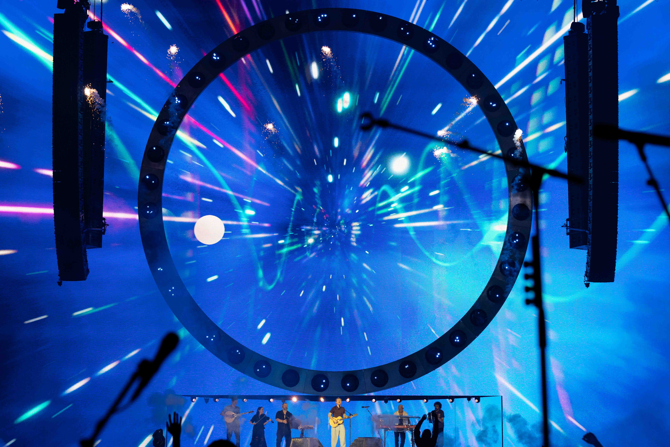 | With large LED video walls presenting an added RF challenge, White relies on Spectera’s DAD antennas over media converters to deliver the strong, consistent coverage required across ‘The Loop’ tour’s complex stage design  (Photo credit: Mark Surridge)

Less time coordinating, more time finessing
“We are using 11 antennas. We have Stage Left side hang, Stage Right side hang, and B stage for each resource,” White explains. “We have a 50 by 18-metre video wall; in fact, the whole stage is one big video screen, and we have a set of antennas upstage just to cover that area. Pretty much every port is used on every Spectera unit, but it does mean we have seamless hand-off and coverage from right the way backstage to halfway down the stadium.”

When designing the system, the Spectera workflow helped to reduce White’s workload. The software delivers remote access and virtual setup for Windows and Mac OS, while the 1U Base Station offers up to 32 simultaneous I/O and completely flexible configuration.

“I must admit, when they released the technology, I felt a little bit like my RF coordination knowledge was obsolete,” White laughs. “This innovation has shown that, in the future, understanding intermodulation and frequency mapping is going to be a little bit redundant. If you have 30 channels, for example, with a standard narrowband system, you would have to calculate and tune each one individually. With Spectera, you select a centre frequency, and it does all of them for you. You don’t need to worry about intermodulation, or about trying to pack in 30 channels – you just say, this 6 or 8 MHz block, this is me. I think it will make wireless far more accessible for people who might previously have been wary of RF. With standard narrowband carriers, a lot of things can happen and if you don’t understand the basic maths behind it, it’s very easy to get confused. With Spectera wireless is massively simplified. As long as there is a chunk of spectrum to find, you’ll be fine.”

White notes that beta-testing a brand-new product can divide the pro-audio industry. While some engineers are keen to adopt the latest technology, others prefer to wait until every possible test has been completed
(Photo credit: Mark Surridge)

Wideband systems like Spectera are designed to dramatically reduce the workload of RF engineers like White. As pressure on wireless continues to grow, Sennheiser is delivering solutions that not only work better in increasingly congested RF conditions, but also simplify workflow. For White, this means less time coordinating and setting up, and more time finessing.

“We currently run three Spectera Base Stations over three RF carriers for the show, one of which is a complete backup,” notes White. “I just need to find three 6 or 8 MHz holes in the frequency spectrum. Previously that would have taken me half an hour to coordinate, but now I’m probably down to seven minutes, even if I go slowly. It’s remarkably quick!”

More flexibility for complex stage set-ups
White uses Spectera for all of Ed’s vocal mics and guitars, plus regular collaborators Beoga. The Irish folk band co-wrote the hits ‘Galway Girl’ and ‘Nancy Mulligan’ and have been performing as part of the tour. The Spectera system has been especially useful for Eamon Murry, the bodhrán player in the band. For him, the addition of a Spectera bodypack provides a completely mobile solution, not just for the acoustic sound of the bodhrán, but also for the sampled sounds triggering snare and kick drum sounds offstage.

“It has been interesting working with Beoga; they’re not your standard rock band or pop band. They’ve got two accordions, a bouzouki, fiddle, keys and the bodhrán,” White explains. “Eamon has a snare trigger on his bodhrán that goes straight out of his Roland trigger into a Spectera bodypack and then feeds through to a triggers rack offstage, generates a sample, and comes back in. And we do that with the kick pedal, too, so he can have a kick drum and a snare trigger as well as his drum, but still be pretty much completely mobile. The only thing he’s got to pick up is the kick pedal. The sound you get from Beoga is totally different. Spectera has been really handy because most musicians have at least one instrument output and one IEM input. With Spectera being a transceiver, we can get away with using half the number of bodypacks we usually would on any other system.”

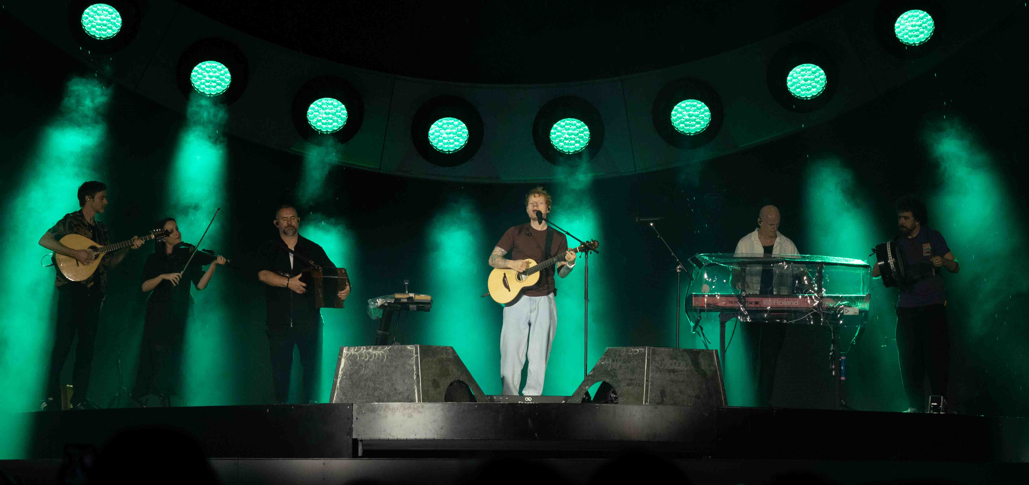
White uses Spectera across all of Ed Sheeran’s vocal microphones and guitars, as well as for regular collaborators Beoga, the Irish folk band whose appearances on the tour add further depth to the live setup
(Photo credit: Mark Surridge)

Monitoring Spectera is also easy with WebUI, Sennheiser’s web-based monitoring interface. WebUI offers remote control and access to essential monitoring functions like battery status, IEM volume, RF status and much more. As White explains, such tools are non-negotiable for a setup of this size.

“I like the WebUI because it gives you more live data quickly, so that’s what I use,” he says. “I have every single channel and I watch it throughout the show. If there’s a problem, I need to be able to see whether it’s a Spectera issue or an instrument issue, and I need to define that really quickly. So, I’m constantly looking at the back end of the Spectera units to check out all the level qualities in RSSI and everything else that’s going on. Another benefit of the flexibility of Spectera is that I need fewer spare bodypacks. Any bodypack can pick up any stream, so if something goes wrong with one of Ed’s bodypacks and his dedicated spare isn’t there for whatever reason, a tech can give him another bodypack, I can pick up that MADI stream, and it will switch within seconds.”

New for 2026 is the Spectera handheld, which White has also been beta testing. For him, a handheld microphone was the missing piece in the puzzle. As part of that process, White and the team have been in close contact with Sennheiser’s development teams, feeding back directly on both hardware and software as the system continues to evolve in real-world touring conditions. Marcus Blight, Technical Application Engineer at Sennheiser, has been White’s key technical contact throughout, with additional support from Peter Craig and Pierre Morant of Sennheiser’s Relationship Management.

Manufacturing samples of the upcoming Spectera handheld are used on ‘The Loop’ global stadium tour, providing what White describes as “the missing piece of the puzzle” while enabling direct real-world feedback to Sennheiser’s development team
(Photo credit: Mark Surridge)

“Spectera has truly made my life in RF so much easier and more manageable, and reduced freight costs,” White admits. “On the last tour, our RF rack for all of the in-ears, the combiners and the amplifiers, was a 32U rack. I’ve completely got rid of that rack and put three Spectera units, with all the chargers, within our existing monitoring equipment. It’s cut down on freight costs and it’s much more streamlined, which is exactly the way the industry should be going. It’s a very good system.”

Long-term trust, built on performance and support
Good equipment is just one factor in White’s continuing relationship with Sennheiser. The team behind these products work tirelessly to ensure that each user has the best experience possible.

“Clarity and reliability have always been present with Sennheiser,” he concludes. “The working relationship is another aspect. If there is a problem, there is such a wealth of knowledge within the company and they’re always very happy to come and help us out or field our queries. I’ve learnt so much from them.

Built on 14 years of trust, performance and innovation, Dave White’s long-standing relationship with Sennheiser reflects a shared commitment to delivering the best possible audio for Ed Sheeran’s live show
(Photo credit: Mark Surridge)

“Part of my job is to keep up to date with everything that’s happening in the industry, and we’ve always said that, although we love working with Sennheiser, if there was a better product, we would probably move to it. Our job is to give the artist the most stable and best audio quality. It just happens to be that, for the last 14 years, that has been Sennheiser. And they keep bringing out good new products. It’s one of the reasons we’ve stuck with Sennheiser for so long, and why we’re very happy to keep going with the relationship!”

(Ends)

The high-resolution images accompanying this media release plus additional photos can be downloaded here. Please make sure to credit Mark Surridge – thank you.

About the Sennheiser brand
We live and breathe audio. We are driven by the passion to create audio solutions that make a difference. Building the future of audio and bringing remarkable sound experiences to our customers – this is what the Sennheiser brand has represented for 80 years. While professional audio solutions such as microphones, meeting solutions, streaming technologies and monitoring systems are part of the business of Sennheiser electronic SE & Co. KG, the business with consumer devices such as headphones, soundbars and speech-enhanced hearables is operated by Sonova Holding AG under the license of Sennheiser.

www.sennheiser.com
www.sennheiser-hearing.com

Global Pro Audio Press Contact
Stephanie Schmidt
stephanie.schmidt@sennheiser.com
+49 (5130) 600 – 1275

