**List of Signatories**

**[Europe]**





|  |  |  |  |
| --- | --- | --- | --- |
| Médecins Sans Frontières (MSF) | SOS Méditerranée | ACT Alliance EU | Action Against Hunger |

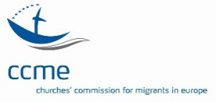

|  |  |  |  |
| --- | --- | --- | --- |
| Caritas Europa | Churches´ Commission for Migrants in Europe (CCME) | Danish Refugee Council | Emmaus International |

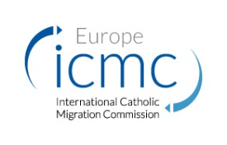



|  |  |  |  |
| --- | --- | --- | --- |
| The European Council on Refugees and Exiles | European Evangelical Alliance | Human Rights Watch | The International Catholic Migration Commission (ICMC) |

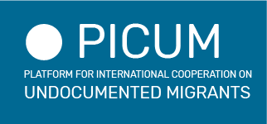

|  |  |  |  |
| --- | --- | --- | --- |
|  |  |  |  |
| Missing Children Europe | Mixed Migration Centre | Oxfam | The Platform for International Cooperation on Undocumented Migrants (PICUM) |

**[Belgium]**

|  |  |  |  |
| --- | --- | --- | --- |
| 11.11.11. | CIRÉÛ | Médecins Sans Frontières | Oxfam Solidarité |

**[France]**

|  |  |  |  |
| --- | --- | --- | --- |
| Action Contre la Faim France | CCFD-Terre Solidaire | Centre de Recherche et d’Information pour le Développement (CRID) | Coordination Sud |
| Emmaus France | Fédération des Tunisiens citoyens des deux rives (FTCR) | Groupe d’information et de soutien des immigré.e.s (GISTI) | Oxfam France |
| Organisation pour une citoyenneté universelle | Réseau IDD (Immigration, Développement, Démocration) | Ritimo |  |

**[Germany]**

|  |  |  |  |
| --- | --- | --- | --- |
| Aktion Gegen den Hunger (ACF Germany) | Ärzte Ohne Grenzen (MSF Germany) | Oxfam Deutschland | PRO ASYL |

**[Italy]**

|  |  |  |  |
| --- | --- | --- | --- |
| ACRA | ActionAid | AIDOS - Associazione Italiana Donne per lo Sviluppo | Amici dei Popoli |
| AOI | Arcs | CEFA Onlus | COMI |
| Concord Italia | Consorzio Ong Piemontesi | Focsiv | Gcap Italia |
| IPSIA-ACLI | Legambiente | Mani Tese | Marche Solidali (regional network) |
| Oxfam Italia | Sonia per un mondo nuovo e giusto | Terra Nuova Centro per il Volontariato |  |

**[Malta]**

|  |  |  |  |
| --- | --- | --- | --- |
| African Media Association Malta | Blue Door English | Kopin | Malta Microfinance |
| SKOP |  |  |  |

**[The Netherlands]**

|  |  |  |  |
| --- | --- | --- | --- |
| Dutch Refugee Council | Oxfam Novib | PAX |  |

**[Spain]**

La Coordinadora

**cc:**

- EU member states’ Ministers of Justice and Home Affairs

- President of the European Council, Donald Tusk

- President of the European Commission, Jean-Claude Juncker

- High Representative of the Union for Foreign Affairs and Security Policy / Vice-President of the Commission, Federica Mogherini

- European Commissioner for Migration, Home Affairs and Citizenship, Dimitris Avramopoulos

- Chair of the European Parliament Committee on Civil Liberties, Justice and Home Affairs, Claude Moraes