**For Immediate Release**

**AIR Music Tech Unveils The Creative FX Collection 2 - The Sound of Legends**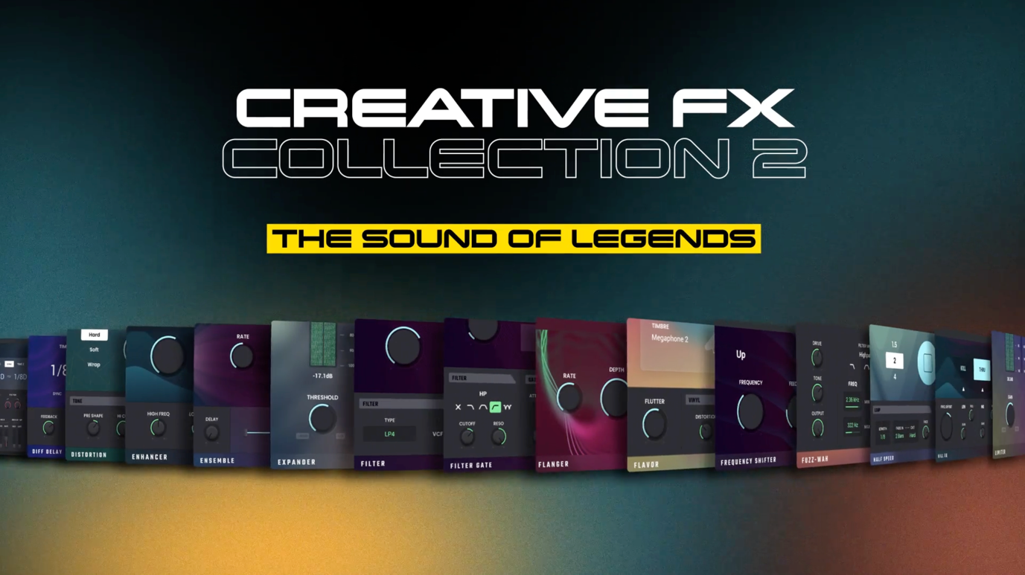

**Cumberland, RI, July 16th, 2024 — AIR Music Tech, a leader in music production software, announces the release of the AIR Creative FX Collection 2. This comprehensive suite includes 40 high-caliber audio tools, among them 12 newly developed plugins, designed to meet the rigorous demands of today's music producers.**

Building on a decade-long history of innovation, the AIR Creative FX Collection 2 has been instrumental in shaping the sound of numerous hit records. Leveraging its roots in industry-leading platforms like Pro Tools and AKAI MPC, AIR’s effects have become respected tools in professional music production.

The collection covers all aspects of music production, from the initial idea to the final touches of mastering, offering quality and flexibility.. Each of the over 40 plugins is meticulously crafted, making the suite ideal for a wide range of genres including rock, hip-hop, pop, and EDM. Key tools such as Amp Sim for classic guitar tones and Half Speed for contemporary down-tempo effects exemplify its versatility.

**Advanced Mixing and Mastering Tools**  
The AIR Creative FX Collection 2 simplifies the mixing process with the AIR Channel Strip, an all-in-one solution for both basic and advanced mixing needs. Dynamic control is made easy with the AIR Compressor, Transient Designer, and Gate, while the AIR EQ Series provides precise sound shaping. The collection also features widely used plugins like AIR Delay Pro, known for its extensive delay options, and Flavor, which adds authentic vinyl textures to tracks.

Equally equipped for mastering, the collection includes tools like AIR Maximizer and AIR Limiter, ensuring loud and clear final outputs. The AIR Stereo Width expands the stereo field while maintaining phase coherence, and AIR Tube Drive introduces analog warmth to digital masters.

**Included Plugins:**

* AIR Amp
* AIR Channel Strip
* AIR Chorus
* AIR Compressor
* AIR Delay Pro
* AIR Delay
* AIR Diff Delay
* AIR Diode Clip
* AIR Distortion
* AIR Enhancer
* AIR Ensemble
* AIR Expander
* AIR Filter Gate
* AIR Filter
* AIR Flanger
* AIR Flavor
* AIR Frequency Shifter
* AIR Fuzz-Wah
* AIR Half Speed
* AIR Kill EQ
* AIR Limiter
* AIR Lo-Fi
* AIR Maximizer
* AIR Multi-Chorus
* AIR Multitap Delay
* AIR Noise Gate
* AIR Nonlin Reverb
* AIR Para EQ
* AIR Phaser
* AIR Pitch Shifter
* AIR Pumper
* AIR Reverb
* AIR Spectral
* AIR Spring Reverb
* AIR Stereo Width
* AIR Stutter
* AIR Talk Box
* AIR Transient
* AIR Tube Drive
* AIR Vintage Filter

**Formats**

macOS: AU, VST, VST3, AAX. Windows: VST, VST3, AAX.

**Pricing & Demo**

AIR Creative FX Collection 2 is $129.99 and has an introductory promo price of $77.99 until August 6th.

**A 10-day demo can be downloaded from** [**www.airmusictech.com/effects/air-creative-fx-collection-2**](http://www.airmusictech.com/effects/air-creative-fx-collection-2)

**About AIR Music Tech**One of the earliest pioneers in virtual instrument technology, AIR is dedicated to creating the world’s most advanced and easy-to-use virtual instruments. Our team is responsible for the core of much of the effects offerings in Avid’s Pro Tools ® software.

###

Hunter Williams

+1 (518) 534-9170

hunter@hummingbirdmedia.com