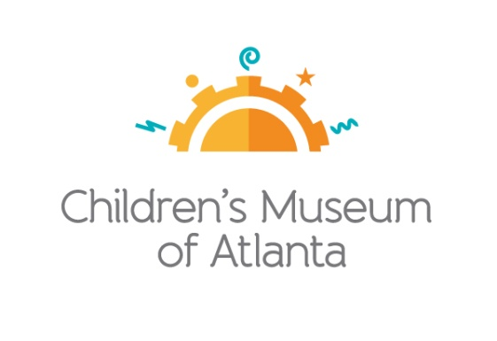

CONTACT
Becca Meyer/Jennifer Walker
BRAVE Public Relations
404.233.3993
bmeyer@bravepublicrelations.com/
jwalker@bravepublicrelations.com

*MEDIA ADVISORY*
Ring in the New Year with Children’s Museum of Atlanta’s Bubble Bash, December 31
Museum offers two opportunities for little ones to celebrate 2018
ATLANTA (December 7, 2017) – Why wait until midnight to celebrate? Children’s Museum of Atlanta is getting the party started early with two chances to ring in 2018. On Sunday, December 31, families can attend Bubble Bash from 10 a.m.-12:30 p.m. or 2 p.m.-4:30 p.m. for extra festive New Year’s fun. The New Year’s Eve celebration will include a family-friendly DJ, dancing, party favors and lots of bubbles!

WHAT: New Year’s Bubble Bash
Celebrate 2018 with music, dancing and bubbles galore!

WHEN: Sunday, December 31
10 a.m.-12:30 p.m.
2 p.m.-4:30 p.m.
*The Museum will be closed to general admission to celebrate the New Year’s Bubble Bash
WHERE: Children’s Museum of Atlanta
275 Centennial Olympic Park Drive, NW
Atlanta, GA 30313

HOW: Tickets are $8 (members) or $18 (non-members) and must be purchased in advance online at childrensmuseumatlanta.org or by calling 404-527-3693. Tickets prices will increase after December 24. The Museum will be closed for General Admission and tickets will not be sold on the door.

For more information or to support Children's Museum of Atlanta, visit childrensmuseumatlanta.org
or call 404.659.KIDS [5437]

###

