ANNA BARROCA

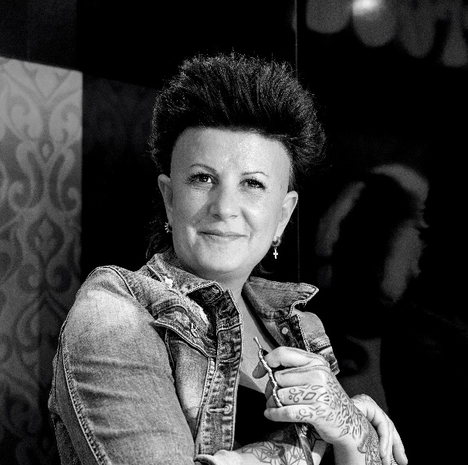
Anna Barroca is the result of 25 years of experience in the hairdressing sector. At just 14 years old, she began her training, and considers herself a hairdresser by vocation. From the moment she set foot in a hairdressing, she dreamed of dedicating herself to the profession, not to be just another hairdresser, but one of the best hairdressers in the world. To this day, she continues working to achieve her dream.

One of the stylists who had a striking influence in her adolescence was Lluis Llongueras, with whom she had the opportunity to work in one of his salons in Barcelona. In the city of Andorra La Vella, the first Salon Anna Barroca was born in 1999, a brand with a strong image of hairdressing, urban and accessible to any type of people that breaks against all odds the conventional style of hairdressing salons in Andorra, creating a difference both in spirit, as in style and image. The salon has been recognized with the highest distinction of theQhair, and holds the 3 stars awarded by the Quality Guide for Spanish Hairdressing.

In that same year, along with the opening of her salon, when the stylist established an alliance with Redken and became Artistic Director of the firm, as well as Trainers Directors. Her training vocation makes her travel to South America to train as Tran de Trains. Her participation in the Las Vegas Symposium reinforces her capacity as an International trainer and in 2013, seeing the needs of the country in the sector, she decided to open her hairdressing school, where she offers her international experience with her own teaching procedures, with one of the best methods of hair cutting techniques: Pivot Point. Likewise, she became the Educational Director of the brand. In 2018, an agreement was formalized with Montibello, and she became Ambassador and Educational Director of training and method training of the technical team of the brand. Also noteworthy is her position as Ambassador of the prestigious brand of professional scissors SIDCA.

Professionals in the sector can learn from Anna Barroca's savoir faire through her specialized Wig Making trainings, in which a detailed development plan is carried out to produce editorial and catwalk collections.

This training vocation is combined with her participation in important catwalks such as 080 Barcelona and Pasarela Cibeles. In addition, Barroca is passionate about creating hairdressing collections, and for this reason she became a member of the Club Figaro. Anna has done relevant work for Fashion magazines in Spain and her own creations have appeared in national and international magazines: Russia, Italy, Germany, etc. as well as fashion releases on DVD in Spain, France and England. Also noteworthy are her appearences in territorial TV and radio programs, in fashion advice spaces.

The Educational Coach of hairdressing, Anna Barroca, continues to show the enthusiasm and passion she feels for her profession as on the first day, an illusion that is reflected in each of her projects.

Her motto: Perseverance + Sacrifice + Learning + Hard work and passion = SUCCESS

