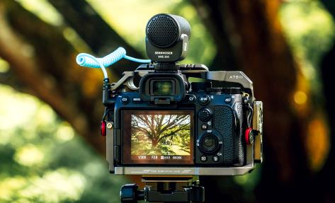

Give the gift of sparkling audio
Forget the flowers! When buying a Mother’s Day gift for the filmmaker in your life, it has to be superior audio from Sennheiser

Wedemark, May 2022 – Whether they’re a passionate amateur looking to add sparkle to vlogs or a keen videographer seeking to bring added professionalism to their latest projects, it’s important not to overlook the way the gift of superior audio brings video to life. Audio specialist Sennheiser has an incredible selection of gifts for Mother’s Day that will show you really care. Whether capturing superior audio with smartphones or camera, monitoring audio when shooting or creating the perfect mix in the studio, Sennheiser has you covered.

Capture incredible audio when filming
The simplest way to truly superior sound: the MKE 200
An external, on-camera mic is a brilliant gift for creators using DSLR and mirrorless cameras or phones. A great mic can overcome the poor sound from built-in mics and transform video with high quality audio. Easy to use and tough enough for creative adventures, Sennheiser’s MKE 200 is the ideal present to help your loved one step up their audio game. The microphone has built-in wind protection and integrated shock absorption to make it as compact as possible.

The compact MKE 200 is the ideal audio upgrade for vloggers and content creators on the move

- Vlogging microphone with built-in wind screen and integrated shock mount: recordings will sound cleaner than ever before
- Rugged and sleek enough for DSLRs, DSLMs, or phones - the ideal take-anywhere audio upgrade
- Directional mic brings presence to your voice - perfect for improving vlogs
- Comes complete with furry windshield, TRS cable for cameras and TRRS cable for smartphones
- Also available as MKE 200 Mobile Kit complete with Sennheiser Smartphone Clamp and Manfrotto PIXI Mini tripod

Capture natural sound with less noise: the MKE 400
Some recording challenges need audio from a specific subject or direction to be captured clearly for a more professional result. An on-camera shotgun mic is the perfect solution. Sennheiser’s MKE 400 is a highly directional on-camera shotgun microphone designed to isolate and enhance the audio for your video. The MKE 400 includes built-in wind protection and integrated shock absorption, and offers additional audio monitoring capabilities, sensitivity selection and low-cut filter settings to ensure the best possible recordings.

- Compact, lightweight mini-shotgun microphone that fits directly onto the camera shoe mount
- Switchable sensitivity for long and short distances ensures versatility, switchable low-cut filter helps to reduce noise
- Approx. 300 hours of operation from a single AAA battery
- Rugged all-metal housing is tough enough to take with you on every creative endeavor
- Comes complete with furry windshield, TRS cable for cameras and TRRS cable for smartphones
- Also available as MKE 400 Mobile Kit with Sennheiser Smartphone Clamp and Manfrotto PIXI Mini tripod

The highly directional MKE 400 microphone will be your rugged companion for every creative endeavor | 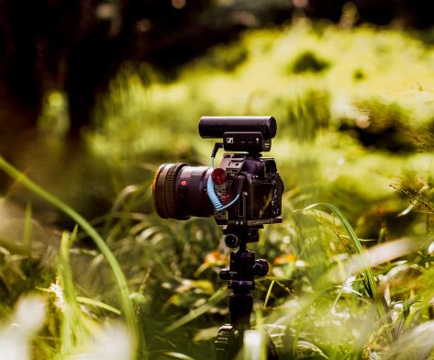

The gift that brings subjects closer: the MKE 600 shotgun mic
For more ambitious video challenges, it’s often necessary to get further away from your subject. A boom mic is the perfect tool for this situation and Sennheiser’s MKE 600 shotgun microphone is an ideal choice: It has a distinct (super-cardioid/lobar) pick-up pattern that ensures maximum possible attenuation of unwanted noise elements from the side – ensuring outstanding performance even in demanding filming situations.

The MKE 600 shotgun mic is a perfect tool for ambitious video challenges

- Shotgun microphone that catches sound with pin-point accuracy even in acoustically unfavorable environments
- Switchable low-cut filter reduces structure-borne noise and wind noise
- Can use phantom or battery power (features low-batt indicator)
- Matching foam windshield, camera shock-mount, battery and XLR3F to TRS cable are included

Get smarter smartphone sound with the XS Lav USB-C
For keen smartphone creators, a dedicated mic can be a great gift to help step up their audio quality. Sennheiser’s XS Lav USB-C is the perfect companion for enhanced dialogue applications on mobile devices and computers. This omnidirectional clip-on microphone produces clear, natural sound for interviews, vlogs, podcasts and more. The 2m (6.6') cable is long enough to hide it out of sight.

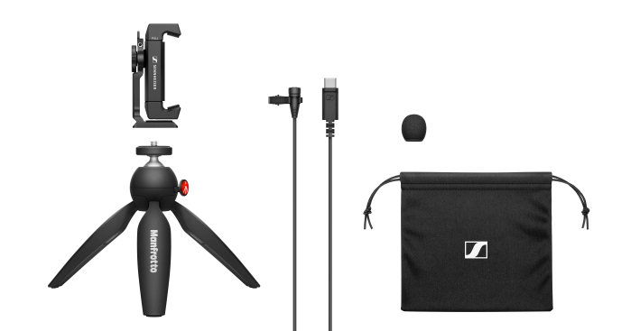 | The XS Lav USB-C Mobile Kit has been developed for smartphone creators and includes a Manfrotto PIXI Mini Tripod and Sennheiser Smartphone Clamp

- Clip-on mic that is ideal for podcast, video and voice-over recordings that require a simple but high-quality set-up
- Omnidirectional microphone capsule provides clear, natural sound
- Accessories include mic clip, windscreen and storage pouch
- USB-C connector for use with mobile devices and computers
- Cable length of 2m (6.6’)
- Also available as XS Lav Mobile with 3.5mm plug for e.g. DSLRs, and as XS Lav USB-C Mobile Kit with a Manfrotto PIXI Mini Tripod and Sennheiser Smartphone Clamp

Reliably monitor your audio
Iconic monitoring headphones: the HD 25
Sennheiser’s iconic HD 25 headphones are a gift that any audio lover will adore. Considered an industry standard for broadcasters and DJs, they deliver exceptional performance in loud environments, combine robust construction with low weight, and offer the option of one-ear listening. Capable of handling very high sound pressure levels and of extremely robust construction, the closed-back HD 25s perform exceptionally well in loud environments where they offer high attenuation of background noise.

Why not get her a monitoring classic to upgrade her audio recordings? The HD 25 are a durable, lightweight and fully pro companion | 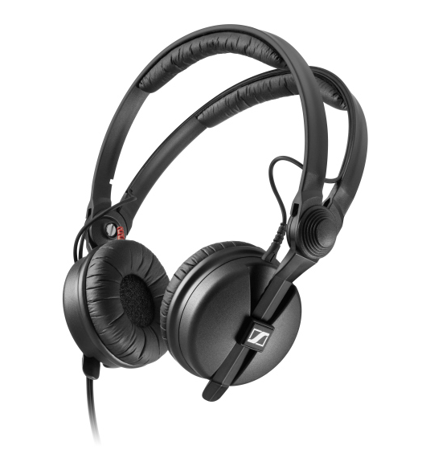

- Rugged and lightweight monitoring headphones
- Split headband for a secure fit during outdoor shoots
- High sensitivity and capable of handling very high sound pressure levels
- Tough, detachable, single-sided cable
- Rotatable capsule for single-ear listening
- Also available as HD 25 LIGHT with the same legendary sound but a simpler headband design

Created for the pros: the HD 280 PRO
An accurate representation of audio is key when monitoring or mixing. When you give the HD 280 PRO, you’re giving them this professional edge. Eloquent lows, a distinct midrange and clear-cut highs are what define the HD 280 PRO, making them the perfect companion for creators. Designed to exceed the demands of the professional environment, the HD 280 PRO boast extremely robust construction combined with the sound quality, modular design and aggressive noise isolation that is necessary in the field. The unique collapsible design, combined with swiveling ear cups, offers maximum flexibility in any application.

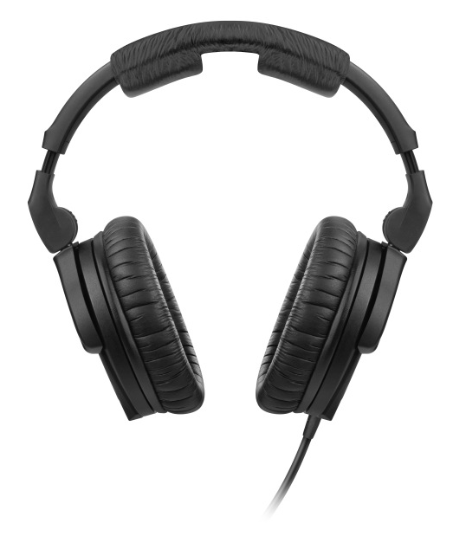 | Give a professional edge with the HD 280 PRO monitoring headphones

- Closed monitoring headphones with accurate, linear sound reproduction – hear it all with the ultimate precision
- High ambient noise attenuation
- Soft earpads for a comfortable fit
- Folding and rotating earcups for space-saving transport
- Tough, single-sided cable

Meticulously natural sound: the HD 300 PRO headphones
The HD 300 PRO is an ideal gift for the exacting creative who appreciates every nuance - and who will really appreciate these very special monitoring headphones. They deliver a linear frequency response - not interpreting sound but ensuring neutral transparency with a remarkable, three-dimensional quality. This natural, delicate sound reproduction is the key to making good audio decisions. The HD 300 PRO represents a smart combination of wearing comfort and ambient noise attenuation. Its circumaural, viscoelastic earpads can barely be felt even after several hours, while the closed ear cup design makes it possible to work with full precision and attention even in loud environments.

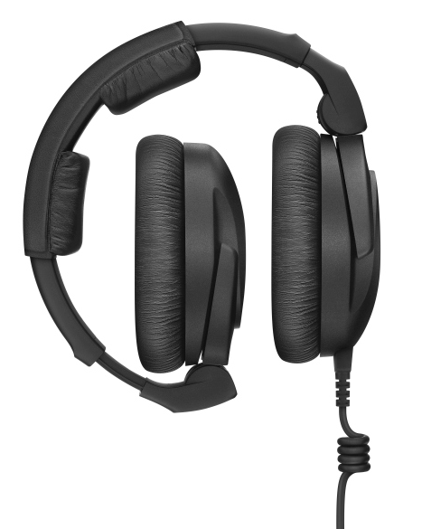 | They fold for easy transport: The HD 300 PRO headphones combine ruggedness with detailed, natural audio reproduction

- Closed-back monitoring headphones offer highest resolution and accurate, linear sound reproduction
- Superior ambient noise attenuation in loud environments
- Comfortable padding and viscoelastic earpads allow for long shoots and sessions
- Perfect companion for your daily work due to long lasting materials and exchangeable cables

Achieve total reliability mixing your audio
Fine-tune your audio tracks with dearVR MIX
Dear Reality’s dearVR MIX turns any pair of studio headphones into a world-class stereo mix room with carefully designed acoustics. Advanced spatial audio technology recreates the sweet spot of an ultimate mixing environment. Recreating multiple virtual reference rooms, this incredible plugin is a brilliant way to gain total confidence when monitoring an audio mix.

The dearVR MIX plugin turns any pair of studio headphones into a world-class mixing environment | 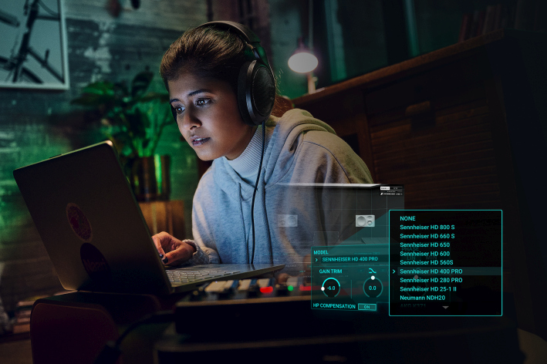

- Stereo headphone mixing plugin (AAX/VST3/AU) suited to all professional studio headphones
- Spatial Headphone Compensation supporting 46 models
- Total reliability judging position, width, reverb & low-end
- Three adjustable virtual world-class reference mix rooms with four mono & stereo loudspeaker positions
- Six additional non-studio listening environments

(Ends)

The images accompanying this press release can be downloaded here.

Pricing information
MKE 200: EUR 99 MSRP
MKE 200 Mobile Kit: EUR 299 MSRP
MKE 400: EUR 199 MSRP
MKE 400 Mobile Kit: EUR 229 MSRP
MKE 600: EUR 299 MSRP
XS Lav USB-C: EUR 59 MSRP
XS Lav USB-C Mobile Kit: EUR 99 MSRP
XS Lav Mobile: EUR 49 MSRP
HD 25: EUR 149 MSRP
HD 25 LIGHT: EUR 99 MSRP
HD 280 PRO: EUR 99 MSRP
HD 300 PRO: EUR 199 MSRP
dearVR MIX: EUR 89 (without VAT)

About the Sennheiser brand
We live and breathe audio. We are driven by the passion to create audio solutions that make a difference. Building the future of audio and bringing remarkable sound experiences to our customers – this is what the Sennheiser brand has represented for more than 75 years. While professional audio solutions such as microphones, meeting solutions, streaming technologies and monitoring systems are part of the business of Sennheiser electronic GmbH & Co. KG, the business with consumer devices such as headphones, soundbars and speech-enhanced hearables is operated by Sonova Holding AG under the license of Sennheiser.

www.sennheiser.com
www.sennheiser-hearing.com

Global Pro Audio Press Contact

Stephanie Schmidt
Stephanie.schmidt@sennheiser.com
+49 (5130) 600 – 1275

