PRESS RELEASE

Mex, Switzerland, 27th July 2022

Malaysia’s Marathon Press reflects on successful decade with BOBST

Breaking into the Malaysian packaging industry is traditionally difficult. The industry remains largely fragmented, with the country’s printing and finishing resources typically focused on commercial printing or publishing. In this context, the success of the Malaysian printer Marathon Press is incredibly impressive.
Founded in 1989, in Melaka (Malacca City), the company has enjoyed significant growth ever since then with a plant situated in an 80,000-square-foot site on the banks of the famous Melaka river. While its continued presence in a difficult sector was impressive, its rapid growth over the last decade is even more so.
Marathon is now turning over RM22m a year, making it one of the successful Malaysian-owned printing companies operating in the country. According to Operations Manager Alvin Teoh, their decision to partner with BOBST in 2012 is a key part of that growth.
“We knew BOBST was – and still is – reputable for being the market leader in packaging machinery,” he explains. “They offered realistic solutions to our needs in terms of their equipment, but also in terms of training and maintenance support.”
This line of thinking led to Marathon’s investment in an AMBITION 106 folder-gluer. This machine’s ease of setting and quick changeover delivered excellent results with the quality and consistency required. “It improved our overall process lead time,” added Teoh.
Following such strong results, it was only a matter of time before the AMBITION 106 was joined by further BOBST solutions. As Marathon’s inventory grew with the addition of a NOVACUT 106 flatbed die-cutter, an EXPERTFOLD 110 folder-gluer with the ACCUCHECK quality control system, and – most recently – a NOVACUT 106 ER flatbed die-cutter, Marathon was able to expand its market offering.
“We now have the capacity to work with pharmaceutical packaging, supermarket retail boxes, offset printed paper or corrugate boxes, and more,” Teoh explains. “We can now serve more sectors than ever – mainly pharmaceuticals, food and beverage, and retail, but recently we have seen a lot of demand in the rubber glove industry specifically.”
The need to serve all these sectors with greater throughput and product quality during the pandemic meant that, in 2021, Marathon required additional high-end die-cutting capability. “Customers are demanding shorter delivery lead times and zero-fault packaging,” Teoh says, reflecting the views of many in the global packaging industry.
He was in no doubt about where to look for a solution. “We knew the EXPERTFOLD 110 with ACCUCHECK was working well for us, so it made sense to invest in the NOVACUT 106 ER as it had perfect synergy with our existing processes to help us achieve our goals.
“With the inline stripping and blanking system, we are able to eliminate manual stripping and improve the overall blank quality of our folding cartons. It operates at an average speed of 7,000 sheets per hour and has more advanced automation features compared to anything else on the market.
“The machine is easy to operate thanks to its simple make-ready system and HMI interface. Both new and existing operators can cope with the new machine easily. All of this has translated into a 36% increase in our productivity.”
Marathon has grown rapidly but, by virtue of its existence in the Malaysian packaging market, still has plenty of headroom to grow further. It is clear that having trusted BOBST to deliver its growth so far, the company will continue to do so in future.
“BOBST machines are precise and durable. BOBST also provides excellent training and after-sales support on all its equipment,” Teoh adds. “It is always innovating and upgrading its technology in order to stay ahead in the packaging business and this means we’re well-placed to venture into the corrugated carton industry to respond to the growing demand for sustainable packaging.”
./.

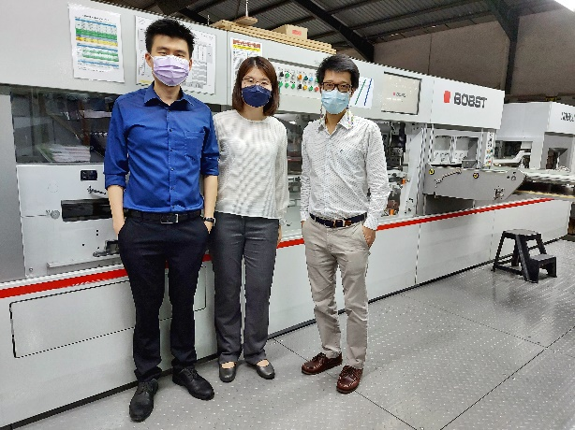
(From left to right)
Mr. Alvin Teoh (Operations Manager)
Ms. Rachel Teoh (Executive Director)
Mr. Naruj Rattanaurachai (Sales Manager Thailand, Malaysia, Singapore)

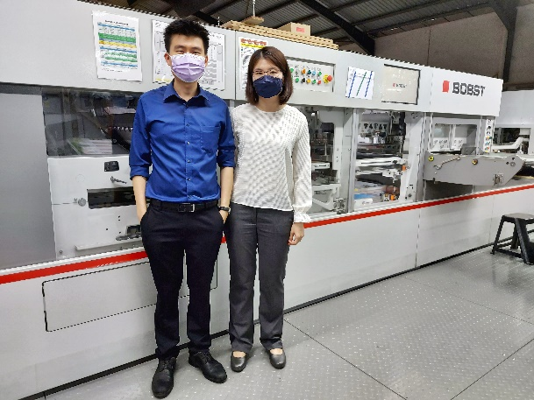
(From left to right)
Mr. Alvin Teoh (Operations Manager)
Ms. Rachel Teoh (Executive Director)

About BOBST

We are one of the world’s leading suppliers of substrate processing, printing and converting equipment and services for the label, flexible packaging, folding carton and corrugated board industries.

Founded in 1890 by Joseph Bobst in Lausanne, Switzerland, BOBST has a presence in more than 50 countries, runs 19 production facilities in 11 countries and employs more than 5 800 people around the world. The firm recorded a consolidated turnover of CHF 1.563 billion for the year ended December 31, 2021.

Press contact:

Gudrun Alex
BOBST PR Representative
Tel.: +49 211 58 58 66 66
Mobile: +49 160 48 41 439
Email: gudrun.alex@bobst.com

Nilobon Chantasombut
Regional Marketing & Communication Manager, South East Asia Pacific
Tel.: +66 2 617 7851 Ext. 52
Mobile: +66 86 345 4428
Email: nilobon.chantasombut@bobst.com

Follow us:

Facebook: www.bobst.com/facebook
LinkedIn: www.bobst.com/linkedin
Twitter: @BOBSTglobal www.bobst.com/twitter
YouTube: www.bobst.com/youtube

