“We have painted the clinic to make it look different, and the nurses don’t wear uniforms”
MSF nurse Fanuel Sifeku describes his work in the ‘adolescent corner’ at the Edith Opperman clinic in Mbare, Harare.
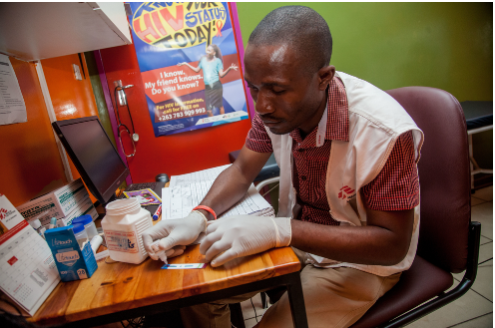 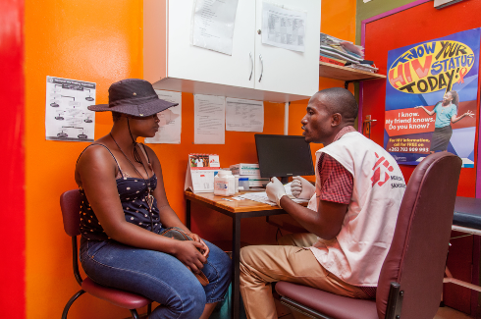 MSF213516, MSF213513
“MSF introduced the adolescent corner after it was discovered that adolescents had a high mortality rate due to HIV and they had issues that made them vulnerable.
Generally adolescents are afraid of going to a clinic to seek treatment, so we have painted the adolescent corner to make it look different from normal clinics, and the nurses don’t wear uniforms.
We have two peer volunteers who are adolescents, to make the clinic as adolescent-friendly as possible. We want adolescents to feel free when they come to the clinic. We want them to meet their peers so that they can discuss any issues freely, and so that they will come back next time.
We have set up indoor games like chess for them to play. We have also put up a gazebo outside where we conduct health club meetings.
Adolescents come to the clinic with different illnesses. We try to offer a comprehensive package that includes testing for HIV, screening for sexually transmitted infections (STIs) and offering family planning to adolescents who are sexually active.
On a day-to-day basis we see two types of adolescents. We see adolescents who are sex workers, and we see adolescents who simply come to seek services.
The sex workers are open. They will come and tell you straight away that they have an STI and want treatment. Others will go in circles. They will tell you, ‘I have a headache or abdominal pain,’ and then you have to probe until they tell you their story. Sometimes you ask them questions and then introduce topics so that they open up.
Many of the adolescents we see are school drop-outs who lack knowledge about their health and who are marginalised. Some do not have the power to negotiate for safe sex because the people they have sex with do not want to have protected sex. So they have unprotected sex so that they can get more money.
With STIs, we discuss how one can acquire STIs, signs and symptoms, treatment and how to use condoms. We also conduct HIV testing and counselling campaigns.
Other activities done at the clinic include weekly health club meetings. We invite adolescents who come for testing to come to the meetings. We discuss issues like family planning, STIs, HIV transmission and prevention. Adolescents from school health clubs come to the clinic for health education talks.
Most adolescents face challenges due to non-disclosure of HIV status by parents. Some adolescents discover when they are sick or when they are already in a relationship that they are HIV-positive. Most find it difficult to accept their status under such circumstances. When this happens we provide counselling, although it will take time for them to accept.
The other challenge is that the age of consent for sex is 16 years, yet in this community, some adolescents become sexually active at an early age, when they 12 or 13. According to clinical guidelines, these adolescents cannot be tested for HIV on their own without the consent of their guardians. If they are sick, that’s when we can apply the ‘best interest of the patient’ concept.
When we see under-16s, we ask them to come with their guardians, but in most instances they do not come back. Parents are reluctant to bring their children for HIV testing. Sometimes we ask our peer volunteers to take consent forms to the parents.
We have succeeded in linking those that test HIV-positive to care. We have also succeeded in giving information. Since we started the adolescent corner, family planning uptake is increasing. There are misconceptions in the community that if you use family planning at an early age, your fertility will be affected. Those misconceptions need to be corrected through health education.
We also aim to ensure that children who test HIV-negative keep their negative status. We send them messages to remind them to come for retesting and to prevent getting HIV and STIs.
Our adolescent corner has helped improve adolescent health-seeking behaviour. When we started the project, we saw 30 adolescents per month but now we are seeing about 200.
MSF, alongside the City of Harare Health Department, has run an adolescent-friendly corner at the Edith Opperman clinic in Mbare, Harare, since November 2015. MSF provides adolescent- friendly services that include general health check-ups, HIV testing and counselling, screening for sexually transmitted infections (STIs), and family planning, all free of charge.

ENDS

