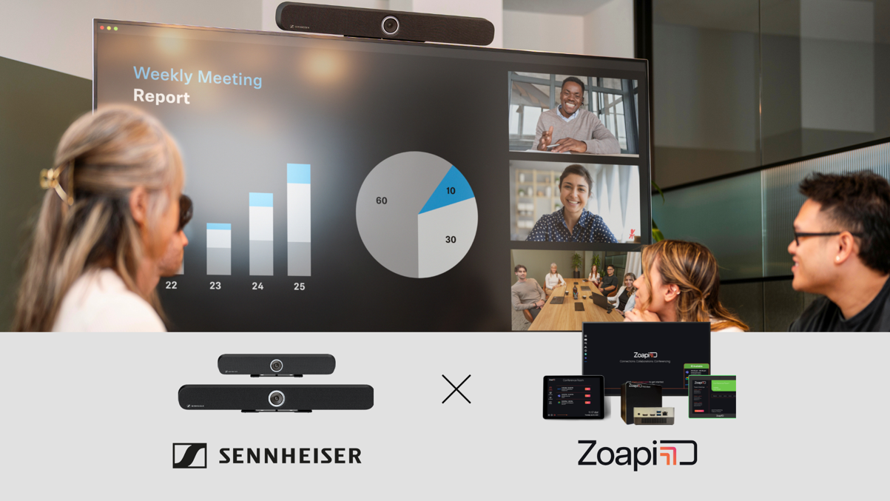

Zoapi Innovations and Sennheiser Partner to simplify Collaboration Spaces

New collaboration combines Zoapi’s intuitive meeting solutions with Sennheiser’s audio and video technology to meet the needs of rapidly evolving workspaces in India and other key global markets.

Wedemark, Germany— April 10, 2025 — Sennheiser, the first choice for advanced audio technology that makes collaboration and learning easier, and Zoapi Innovations, an India-based provider of innovative meeting room solutions, have joined forces to empower wireless collaboration. The partnership combines Zoapi’s intuitive meeting solutions with Sennheiser TeamConnect (TC) Bar Solutions to offer users dynamic control and performance in meeting and collaboration spaces.

Sennheiser’s TC Bars are designed to bring premium audio and dynamic video to small and mid-sized spaces. Available in two models—the TeamConnect Bar S (with four microphones and two speakers) and the TeamConnect Bar M (with six microphones and four speakers)—both devices offer plug-and-play USB connectivity and integrate seamlessly with Zoapi’s wireless conferencing solution.

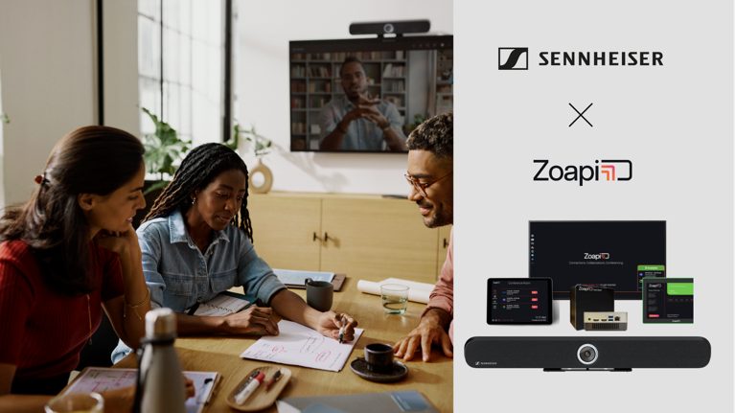
The TC Bars offer flexible and scalable room setups with an onboard Dante port for extension mics and an option to add an external USB camera, catering to rooms requiring broader coverage.

Zoapi’s advanced meeting room solutions are designed to break down barriers and connect teams effortlessly, regardless of their physical location. With Zoapi’s wireless presentation systems, video conferencing tools, and intuitive meeting room booking solutions, the company enables organizations to enhance productivity and streamline communication. The combination of Zoapi solutions and Sennheiser TC Bars provides easy collaboration by enabling wireless video conferencing, resulting in a robust and intuitive solution for modern collaboration environments.

"At Zoapi, we are dedicated to transforming meeting room experiences through simplicity and innovation,” shared Prashanth NS, Cofounder & CEO, Zoapi Innovations. “Partnering with Sennheiser, a global leader in premium audio solutions, is an exciting milestone for us. This collaboration unites Zoapi’s intuitive meeting room solutions with Sennheiser’s advanced video bar cameras and conference technology, enabling a seamless, high-performance solution that redefines productivity and communication for modern businesses."

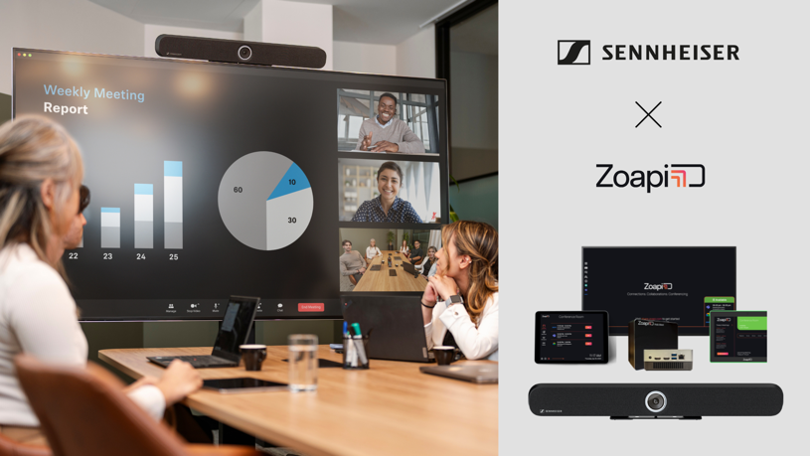
Zoapi’s advanced meeting room solutions are designed to break down barriers and connect teams effortlessly, regardless of their physical location.

Sennheiser’s TC Bars feature integrated beamforming microphone arrays for freedom of movement and smooth transitions between presenters. The full-range stereo speakers ensure natural speech and outstanding intelligibility. Superior audio is complemented by a camera with advanced AI features, including autoframing and person tiling. Additionally, the TC Bars offer flexible and scalable room setups with an onboard Dante port for extension mics and an option to add an external USB camera, catering to rooms requiring broader coverage.

“Sennheiser and Zoapi share the belief that collaboration should feel intuitive, not complicated,” said Charlie Jones, Senior Partner Relations Manager, Business Communications, Sennheiser. “Our partnership brings together technologies that simplify the meeting experience, so users can spend less time managing devices and more time focused on meaningful collaboration. We’re especially excited to support this vision in India’s dynamic and fast-growing technology landscape.”
For more information about Sennheiser and its solutions, visit www.sennheiser.com.
###

About the Sennheiser brand
We live and breathe audio. We are driven by the passion to create audio solutions that make a difference. Building the future of audio and bringing remarkable sound experiences to our customers – this is what the Sennheiser brand has represented for more than 75 years. While professional audio solutions such as microphones, meeting solutions, streaming technologies and monitoring systems are part of the business of Sennheiser electronic GmbH & Co. KG, the business with consumer devices such as headphones, soundbars and speech-enhanced hearables is operated by Sonova Holding AG under the license of Sennheiser.

www.sennheiser.com
www.sennheiser-hearing.com

Global Press Contact

Jeffrey Horan
Global PR/Media Manager Business Communication
jeffrey.horan@sennheiser.com
+1 860-598-7539

