Inspire the Musician in Your Life this Holiday Season with One-of-a-Kind Wallace Detroit Guitars

Handcrafted guitars made from reclaimed wood of Detroit landmarks
will bring years of enjoyment for the music lover in your life

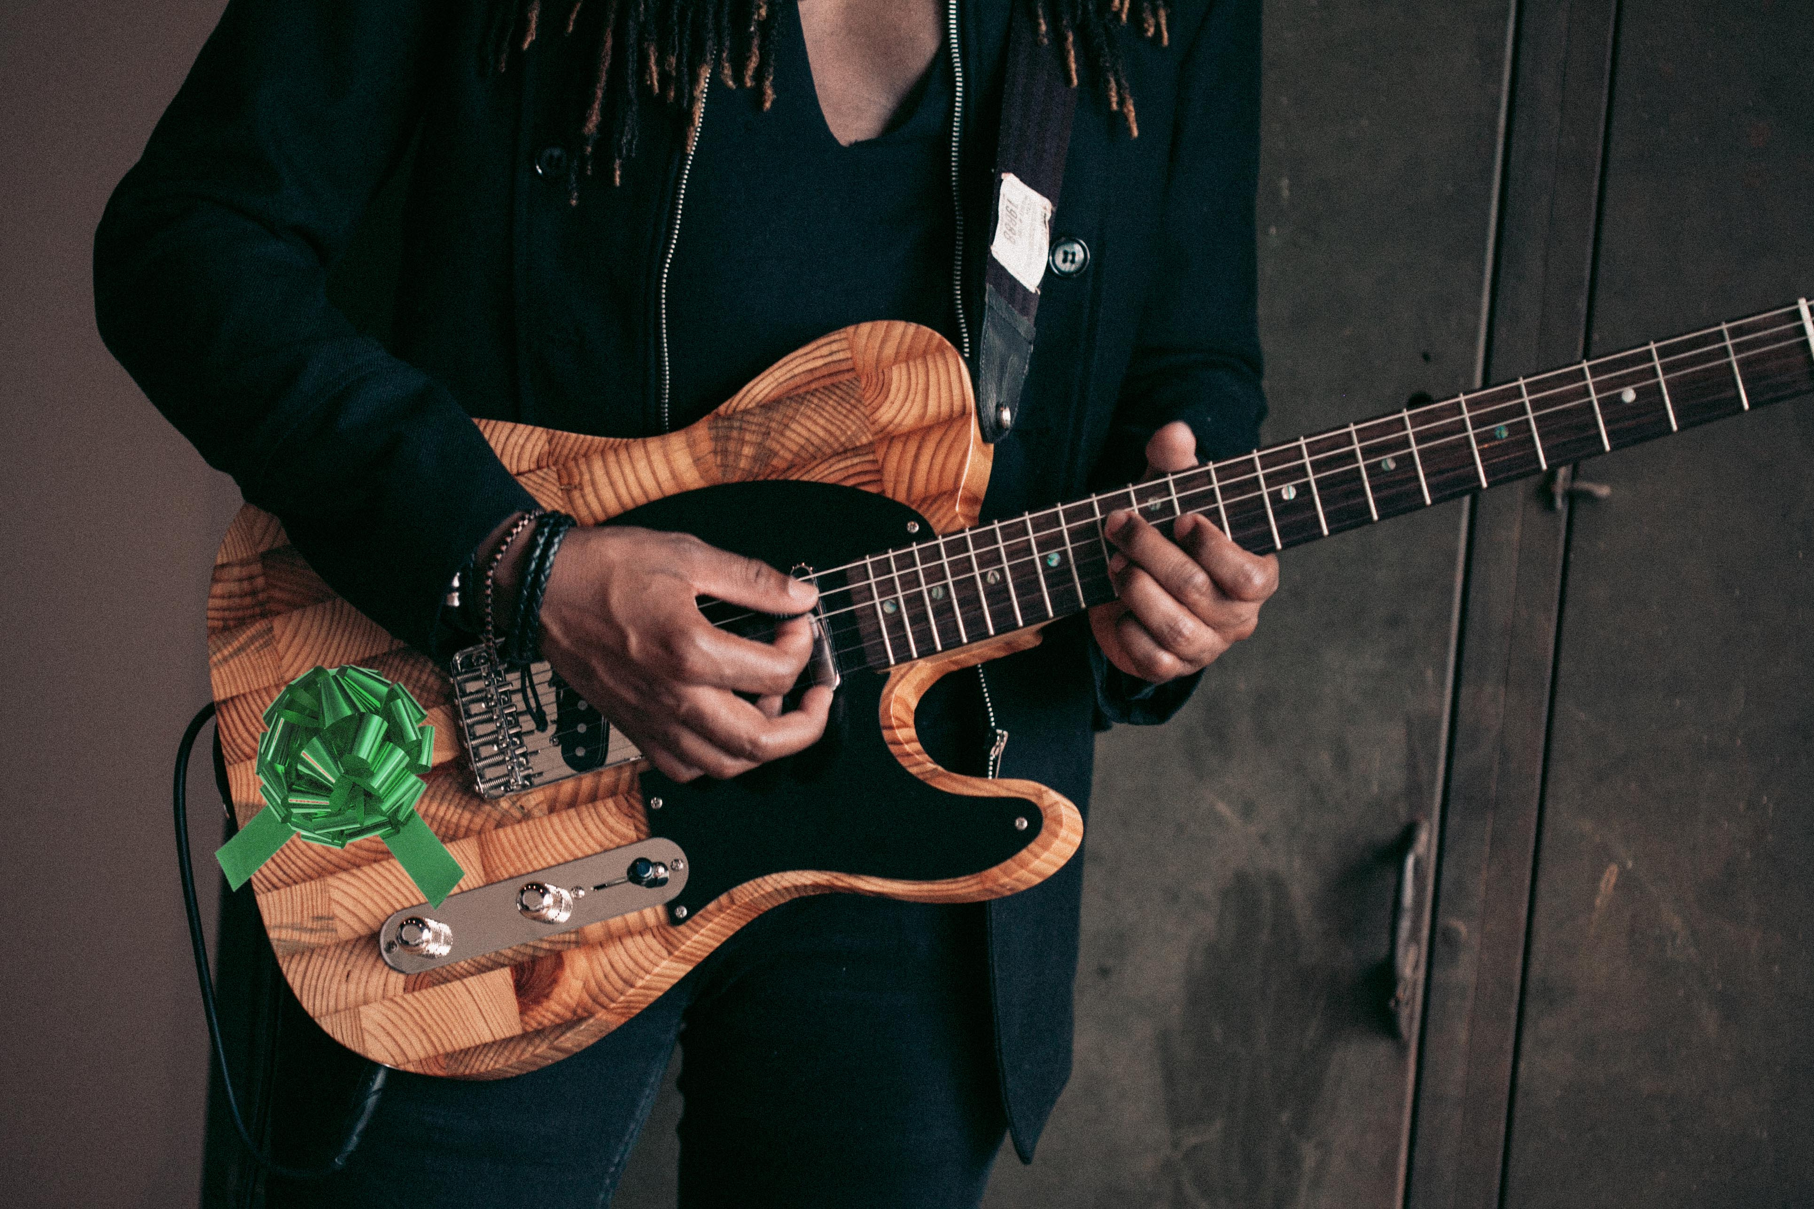
Detroit, October 16, 2017— This holiday season, Wallace Detroit Guitars is bringing the meaning back to gift giving with its one-of-a-kind, handmade guitars. One part the ultimate 'players' instrument and the other part beautiful objet d'art, Wallace Detroit Guitars are timeless instruments that will provide years of inspiration for the musician in your life. Made of reclaimed wood from several Detroit historical landmarks, each guitar has its own unique story and is the only one like it in the world.

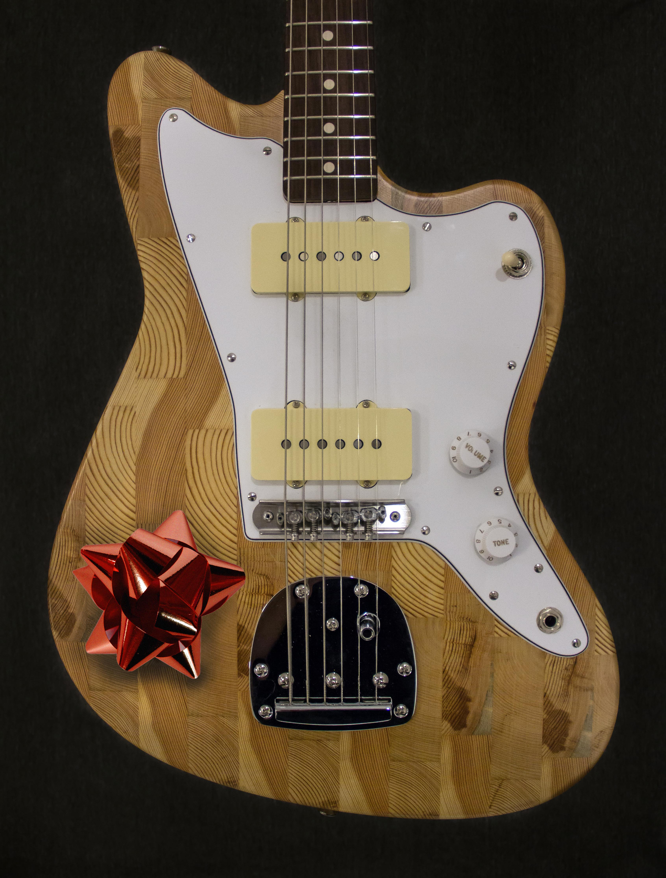
Each guitar is lovingly crafted from old growth Michigan wood sourced from the floorboards of the former Detroit Fire Department Headquarters, benches of The Brewster Wheeler Recreation Center and many other city landmarks. With several body styles, wood choices and hardware options to choose from, a Detroit Wallace Guitar is the perfect gift for any musician looking to chart his or her own musical path.

“Not only are our instruments timeless keepsakes, they are definitely 'players' guitars,” said Mark Wallace, founder of Wallace Detroit Guitars. “Our customers appreciate
how each instrument carries its own voice and aesthetic attributes, not to mention the effort and care that goes into building each and every one. These are a must-have for the guitar player in your life this holiday season.”

Recently, Wallace Detroit Guitars added its 'Build Your Own Guitar' configurator, a custom function on its website that allows users to create their own unique instrument by choosing their own wood selections from a range of original Detroit landmarks, body style, hardware and pickups. This is the ideal gift for any musician looking to construct his or her own 'signature guitar' for the holidays. To take advantage of the custom configurator service, orders must be placed no later than Friday, October 20th in order to receive before Christmas.

With this option, customers are able to choose from several body styles and unique custom finishes, including hand-rubbed oil, sunburst nitrocellulose lacquer or high gloss nitrocellulose lacquer. Pickguards come in any color, and standard, antique and Bigsby hardware options are also available. For fretboards, customers can select Rosewood, ebony or maple and choose among pickup options include P90’s and humbuckers.

Every Wallace Detroit Guitars instrument sold features a certificate of authenticity and ships with a one-of-a-kind handmade guitar strap fashioned out of reclaimed car upholstery and a hard-shell leather case.
For more information, visit wallacedetroitguitars.com.
To place your customer order, please visit: wallacedetroitguitars.com/build-your-own-guitar/configure/6748/

About Wallace Detroit Guitars
Founded by Mark Wallace in 2014, Wallace Detroit Guitars breathes new life into reclaimed wood from Detroit buildings by shaping it into some of finest American guitars on the market. Their instruments acknowledge not only Detroit’s architectural history, but also its proud tradition of both great craftsmanship and great music. With superior construction, premium components, and a great story, each guitar delivers a truly timeless playing experience.

Contact Information:
Jeff Touzeau
Public Relations
Hummingbird Media, Inc.
(914) 602-2913
jeff@hummingbirdmedia.com

