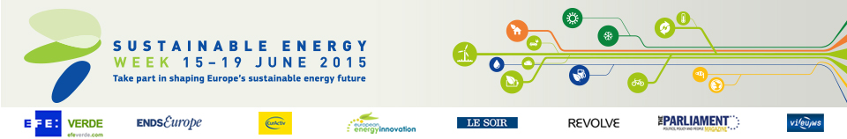

ecoGator – A smartphone app building on the EU label

Category

Energy efficiency

Location

Vienna, Austria

Energy efficiency in the palm of your hand

Looking for the most energy efficient fridge? Simple – just download the ecoGator app and point your smartphone at the EU energy label!

Developed through the myEcoNavigator project, the new smartphone app offers consumers a low-cost means of achieving energy efficiency with every purchase. The app scans the label using a smartphone’s built-in camera, provides a traffic light rating system and offers a simple comparison with other products on the market. In addition, ‘gamification’ elements – such as quizzes and tips – encourage more frequent use and help consumers lead a more sustainable lifestyle.

ecoGator was launched in October 2014, and by February 2015 some 12 000 users had already installed the app on their smartphone. The potential for expansion remains huge, and it is hoped that the project will produce accumulated energy savings of 1.95 TWh by 2020. By highlighting the best-performing appliances and better informing citizens, myEcoNavigator can play a key role in helping Europe meet its targets on energy efficiency and renewable energy.

Organisation

Austrian Energy Agency
Austria
www.energyagency.at
Project website: www.myeconavigator.eu/

