NAB 2019: RME Highlights High-Quality, Versatile Audio Solutions for Broadcasters, Podcasters
Leaders in audio networking, RME will showcase its AVB- and Dante-compatible gear, filling the needs of today’s broadcast professionals

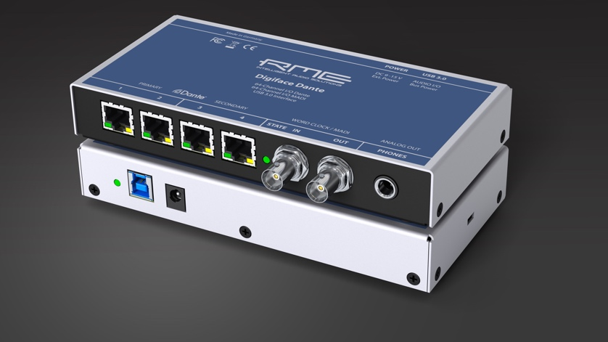
Las Vegas, Nevada, April 4, 2019 – RME [NAB 2019 booth C7506], premium German audio interface manufacturer, will highlight several products featuring Dante, MADI and AVB compatibility that take audio transmission to the next level for the live and sports broadcasting markets during NAB 2019 in Las Vegas.
“We are very excited to highlight several products at NAB 2019 that will elevate broadcasters’ audio setups,” said Derek Badala, Director of Sales, Americas for Synthax, RME’s US distributor. “These new Dante- and AVB-compatible products offer the most reliable and robust solution on the market for providing computer recording and playback of 128 channels of audio as well as 128x128 network matric mixer in these IP audio domains.”
The Future of Audio Transmission is Here
The Digiface Dante and Digiface AVB are the latest additions to RME’s popular Digiface line of audio interfaces. The Digiface Dante is a 256-channel, 192 kHz USB audio interface that combines a lightweight design with Dante network connectivity, while supporting AES67. The BNC connections provide Word Clock I/O and can be switched to work with MADI, allowing for MADI and Dante to be used simultaneously, and enabling the unit to work as a simple bidirectional format converter in standalone mode.
The Digiface AVB meets the growing need in the industry to distribute audio over a local area network. The Digiface AVB USB audio interface uses AVB to transfer up to 256 channels of audio between PC and audio networks. The integrated USB 3.0 connection allows up to 128 audio channels to be streamed back to the AVB network and another 128 channels to the computer — with sampling rates of up to 192 kHz. Users can adjust the channel sizes of streams between 2 and 32 channels as needed to ensure maximum compatibility with AVB audio devices available on the market.
Along with the latest Digiface models, RME will also highlight the M-32 AD Pro and M-32 DA Pro audio converters. Enabling transmission of 32 analog channels at a maximum 192 kHz sampling rate, these units boast redundant power supplies, more compact housing and network functionality — all features that broadcasters in today’s industry are looking for. An included AVB interface allows these converters to be blended into complex network structures.
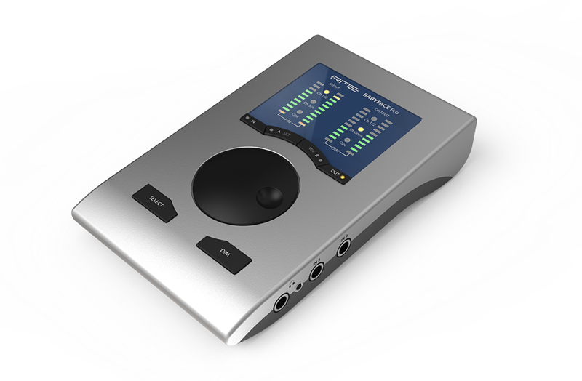
In addition to RME’s audio networking solutions, fellow Synthax-distributed brand Ferrofish will highlight its PULSE 16 DX — a Dante-compatible version of the popular line of PULSE audio converters.
Elevating Podcasters’ Setups
In addition to Dante- and AVB-compatible products, RME will also highlight its Babyface Pro — an intuitive audio interface that podcasters have been turning to for more digital expansion. The two-mic interface features 24 channels, delivers high-fidelity audio with minimal latency and comes complete with RME’s proprietary TotalMix mixing and routing software. TotalMix eliminates the struggle podcasters often face while inputting multiple sources of audio into their audio mixer, including while interviewing individuals via Skype. TotalMix makes it easy for podcasters to control their mix-minus setups intuitively through the software and eliminates the need for adapters or Y cables.
“As the podcasting community grows, more podcasters are looking to elevate their audio game and are turning to our Babyface Pro and TotalMix software,” Balada said. “From simultaneous multi-tracking to eliminating the mix-minus hurdle, the Babyface Pro and TotalMix software creates an intuitive audio configuration that easily improves any podcasters setup.”
Check out all of RME’s latest audio networking and podcasting solutions at booth C7506 during NAB 2019, April 8–11.
For more information on RME, visit http://www.rme-usa.com/
About Synthax, Incorporated
Synthax Inc. is the exclusive USA distributor for RME digital audio solutions, Ferrofish advanced audio applications, myMix audio products, and ALVA cableware. We supply a nationwide network of dealers with these products for professional audio, broadcast, music industry, commercial audio, theater, military and government applications. For additional information, visit the company online at http://www.synthax.com.

Media Contacts:
Katie Kailus
Public Relations
Hummingbird Media
+1 (630) 319-5226
katie@hummingbirdmedia.com

Jeff Touzeau
Public Relations
Hummingbird Media
+1 (914) 602 2913
jeff@hummingbirdmedia.com

