Gema Moreno
Antonio - Eloy Escuela Profesional

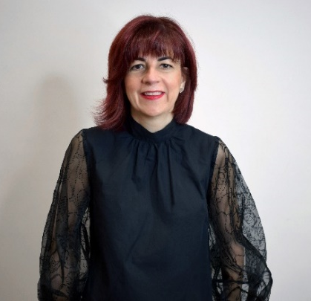
Gema Moreno carries hairdressing in her blood. Her grandfather, her mother, her uncle and their brothers have also been hairdressers, and from all of them she has learned the best example of tenacity, attitude and desire to improve and advance. She confesses that as a child she loved being at the salon and seeing how people came in and out very happy with the makeover. In addition, she enjoys dealing with the public and social relationships.
She started very young, at the age of fifteen, and took a one-year course at an academy, and then continued training for five years while studying the FP. From that moment on, she has taken numerous trainings, aesthetic and nail courses, courses and seminars with different commercial houses and educational companies: Wella, Salerm, Revlon, American Crew, Kapyderm, Rizos, Sassoon and with national and international references both in the field of male and female hairdressing. In the same way, she has taken courses related to Training, Didactic Methodology, etc. She is currently a trainer at Antonio - Eloy Professional School and teaching allows her to combine her great passions: the image sector and dealing with students and the public. Her main objective is to do her work better every day, give her best and improve in all areas to be able to transmit not only knowledge, but also values to her students.
Her works have received the recognition of the Picasso Awards – Andalusian Hairdressing Awards in several occasions, managing to be:
- Finalist Best Men's Collection (2021)
- Finalist Best Video (2021)
- Finalist Best Men's Collection (2020)
- Finalist Best Makeup (2020)
- Finalist Best Styling (2020)
- Press Award Finalist (2020)
- Best Photography Finalist (2020)
- Winner Best Men's Collection (2020)
- Winner Best Makeup (2020)
- Winner Best Photography (2020)
- Winner of the Press Award (2020)
She was also finalist at Best Men’s Collection of TCT Awards (2020). In addition, she has collaborated in several fashion events and catwalks held in the province of Málaga. She is also a member of CEPPE, the National Confederation of Private Education Centers and hairdressing and beauty professionals.

