Please note that this information is embargoed until 7 April 2021, 9:00 CEST

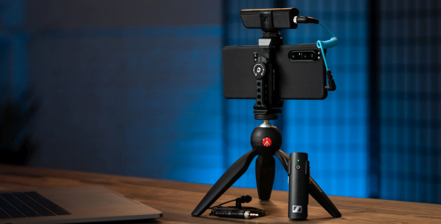

Nimble solutions for vloggers and creators
Sennheiser Mobile Kits cover all your audio recording needs – everything for getting creative in one package

Wedemark, 7 April 2021 – Rounding off the launch of its MKE 400 compact shotgun microphone for cameras and the XS Lav clip-on microphones for mobile phones and computers, audio specialist Sennheiser has also announced the launch of various Mobile Kits. These include a Manfrotto PIXI Mini Tripod and Sennheiser Smartphone Clamp, making them ideal for vloggers and content creators for whom the smartphone is the tool of choice during some or for all of their creation processes. To complement existing microphones, the Mobile Kit is also available on its own as an accessory.

The MKE 200 Mobile Kit with Manfrotto PIXI Mini Tripod and Sennheiser Smartphone Clamp makes this vlogging microphone even more versatile | 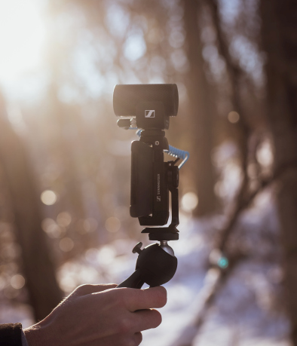

“The Mobile Kits are designed to satisfy all your audio needs in ready-to-go packages,” says Nicole Fresen, product manager at Sennheiser. “Whether you prefer an on-camera mic or a wireless lavalier, there is the right mic for every requirement, plus a few clever accessories to cater to your needs.”

MKE 200 Mobile Kit and MKE 400 Mobile Kit
As video recording often happens on various devices, both the MKE 200 and MKE 400 include 3.5 mm TRS and TRRS cables for use with DSLR/M cameras and mobile devices, respectively. With the Smartphone Clamp and Manfrotto PIXI, the Mobile Kit versions have vloggers and creators prepared for all recording situations.

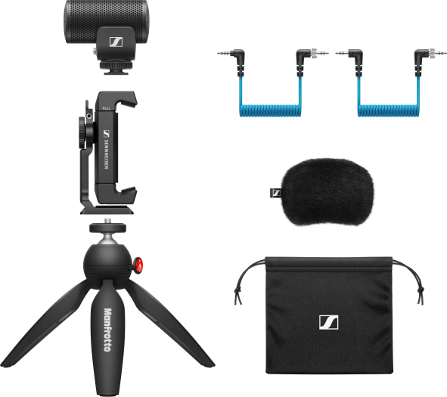  MKE 200 Mobile Kit | 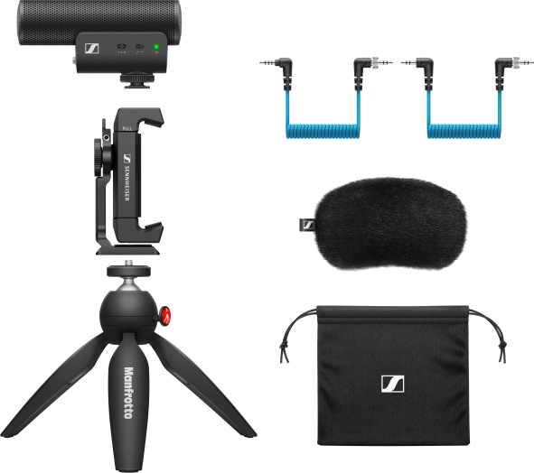  MKE 400 Mobile Kit

XS Lav USB-C Mobile Kit
This kit adds the Smartphone Clamp and PIXI to Sennheiser’s wired USB-C lavalier microphone to create an ideal vlogging and podcasting bundle.

XS Lav USB-C Mobile Kit | 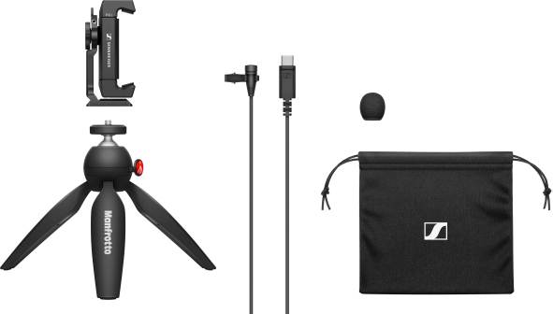

XSW-D Portable Lav Mobile Kit
Sennheiser’s wireless lavalier solution is not only supplied with the Smartphone Clamp and Mini Tripod but also includes an additional TRS-TRRS cable for connection to smart devices (also available separately as XSW-D Mobile cable). This special cable features an attenuator to ensure optimum levels for mobile devices.

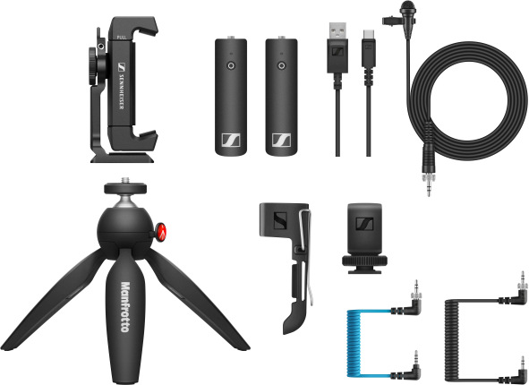 | The XSW-D Portable Lav Mobile Kit with the new XSW-D Mobile cable

CL 35 USB-C cable
Maybe you need to connect to a smart device with a USB-C socket? Then the CL 35-USB-C cable (TRS to USB-C) is for you. Available separately as an accessory, it’s ideal if you want to use the MKE 200 Mobile Kit, MKE 400 Mobile Kit and XSW-D Portable Lav Mobile Kit with a USB-C-device.

The CL 35 USB-C cable gets your MKE 200, MKE 400 and XSW-D Portable Lav Mobile Kit ready for recording with mobile devices with a USB-C connector | 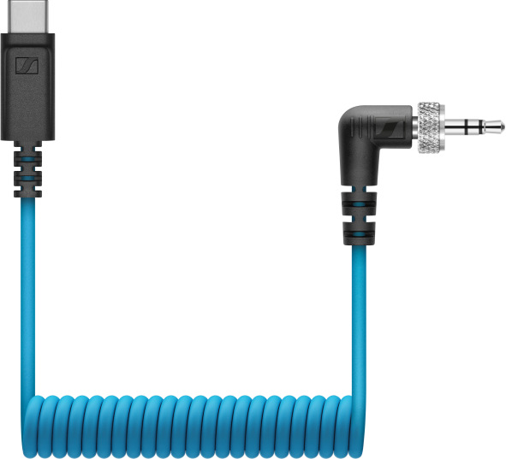

Pricing, content and availability
Camera microphones
MKE 200 Mobile Kit, available now: EUR 129 (MSRP), GBP 109 (MSRP), USD 129.95 (MAP)
MKE 400 Mobile Kit, available now: EUR 229 (MSRP), GBP 199 (MSRP), USD 229.95 (MAP)

Wired lavalier microphone
XS Lav USB-C Mobile Kit, available now: EUR 99 (MSRP), GBP 87 (MSRP), USD 99.95 (MAP)

Wireless lavalier microphone
XSW-D Portable Lav Mobile Kit, available from May 2021: EUR 329 (MSRP), GBP 289 (MSRP), USD 329.95 (MAP)

Accessories
CL 35 USB-C cable: EUR 29 (MSRP), GBP 26 (MSRP), USD 29.95 (MAP)
Mobile Kit: EUR 49 (MSRP), GBP 43 (MSRP), USD 49.95 (MAP)
XSW-D Mobile cable: EUR 19 (MSRP), GBP 17 (MSRP), USD 19.95 (MAP)

Useful links
Mobile Kits video
Download high-resolution product and accessory photos
Download high-resolution application photos

About Sennheiser
Shaping the future of audio and creating unique sound experiences for customers – this aim unites Sennheiser employees and partners worldwide. Founded in 1945, Sennheiser is one of the world’s leading manufacturers of headphones, loudspeakers, microphones and wireless transmission systems. Since 2013, Sennheiser has been managed by Daniel Sennheiser and Dr. Andreas Sennheiser, the third generation of the family to run the company. In 2019, the Sennheiser Group generated turnover totaling €756.7 million. www.sennheiser.com

Global Press Contact

Stephanie Schmidt
Stephanie.schmidt@sennheiser.com
+49 (5130) 600 – 1275

