Erica Synths Announces New Drum Series Modules
Erica Synths Drum Series consists of superior quality modules for feature-rich sound design and live performance

Riga, Latvia, July 5, 2018 — Erica Synths announces that its first drum modules are now available for ordering, including Bass Drum, Snare Drum, Toms, Clap, Mixer & Mixer Lite.
The company’s Techno System will be a set of 15 modules put together, as one of the most advanced techno/industrial music performance instruments ever created. The Techno System contains a set of new analogue drum modules, advanced drum/loop sampler, and a fat sounding fully analogue synth voice designed for screaming acid basslines.

Meantime, a dedicated Drum Sequencer provides complete control over the system, while Mixers glue the sound sources together with built in vactrol-based compressors. Additionally, Dual Drive and Dual FX modules take classic drum sounds to the next level, adding bite to the overall mix.

Every module has CV control over most important parameters for true modular functionality and dynamics of performance.

Release date: 20th of August 2018

Available on www.ericasynths.lv

Contact information
Eliza Aboltina
Marketing specialist
eliza@ericasynths.lv

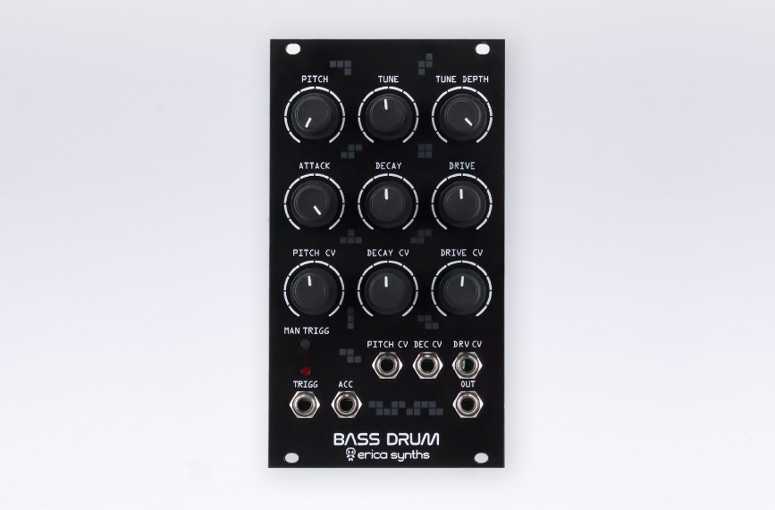

BASS DRUM features
- Pitch, Tune, Tune Depth controls
- CV control with attenuators over Pitch, Decay and Drive
- Manual trigger
- Accent for better expression
RRP: 225 EUR ex. VAT

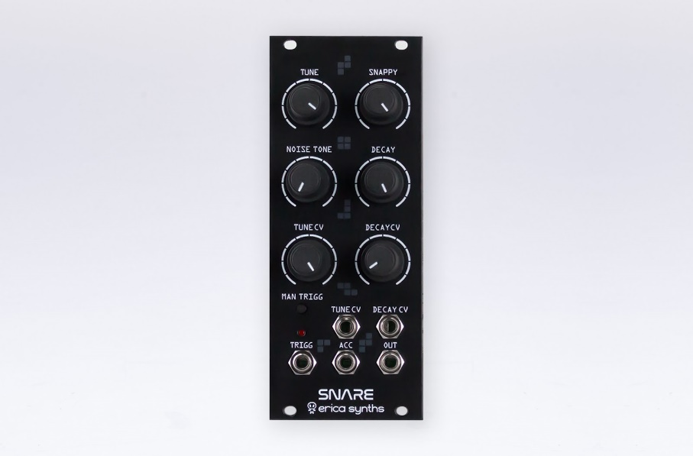

SNARE DRUM features
- Tune, Snappy, Noise tone and Decay controls
- CV control with attenuators over Tune and Decay
- Manual trigger
- Accent for better expression
RRP: 200 EUR ex. VAT

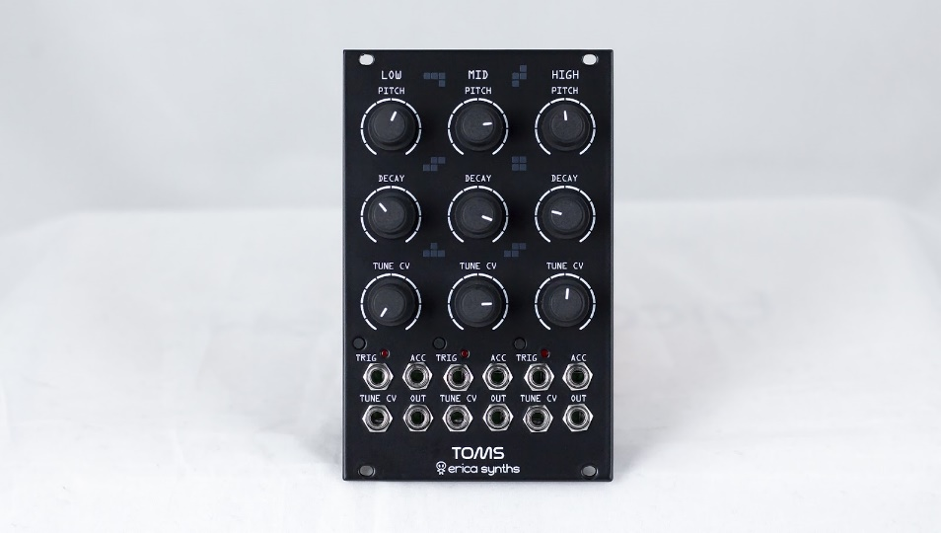

TOMS features
- Tune, Snappy, Noise tone and Decay controls
- CV control with attenuators over Tune and Decay
- Manual trigger
- Accent for better expression
RRP: 300 EUR ex. VAT

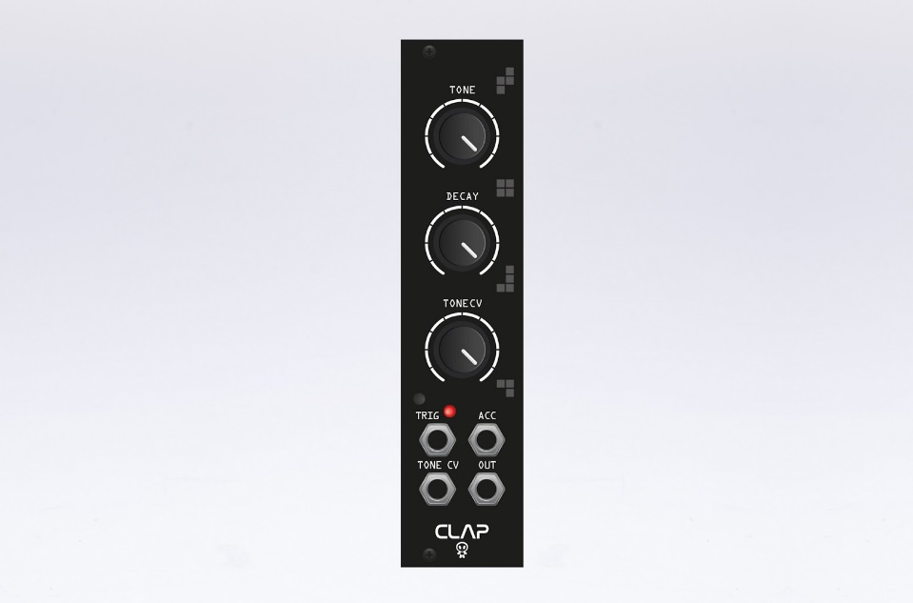

CLAP features
- Tone and Decay controls
- CV control with an attenuator over Tone
- Manual trigger
- Accent for better expression
RRP: 130 EUR ex. VAT
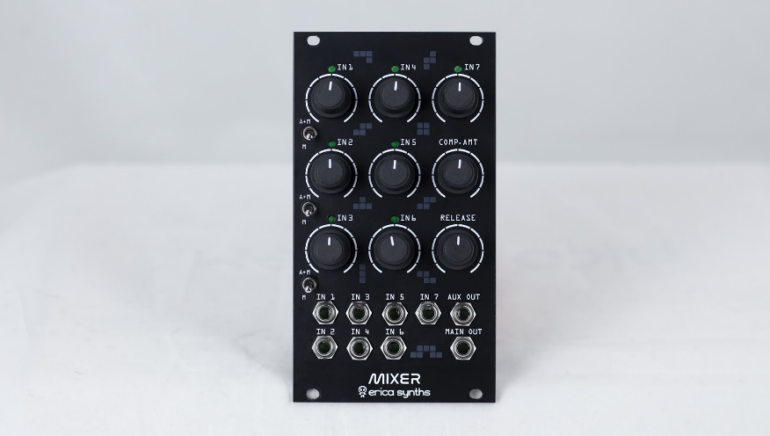

DRUM MIXER features
- 7 inputs
- Built in vactrol based drum compressor with Amount and Decay control
- +6dB signal boosting
- Three inputs assignable to main or aux send outputs
- Main and Aux Send outputs
- Signal level indicator LEDs
RRP: 180 EUR ex. VAT

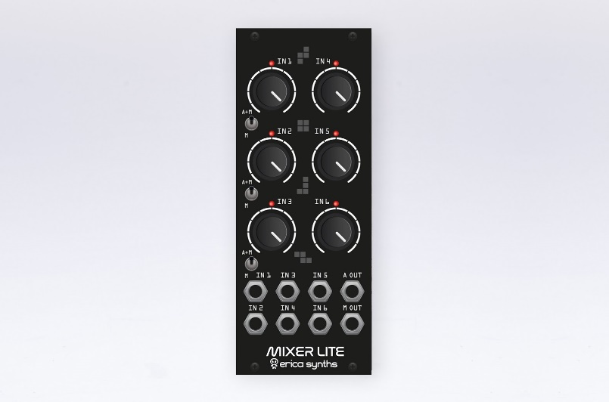

DRUM MIXER LITE features
- 6 inputs
- Built in vactrol based drum compressor with Amount and Decay control
- Three inputs assignable to main or aux send outputs
- Main and Aux Send outputs
- Signal level indicator LEDs
RRP: 150 EUR ex. VAT

