Nouvelle étude du Centre Cosmopolis d’études urbaines de la VUB sur la relation entre pollution de l’air, mobilité et densité de population.

La recherche cible le lien entre le niveau de pollution de l’air dans les quartiers de la région de Bruxelles capitale et la connectivité, mesurée en divisant le temps de trajet (voiture et transports en commun) par la densité de population.

L’analyse révèle des liens significatifs entre niveaux de pollution et connectivité. Un quartier bien connecté au reste de la région est également susceptible d’être une zone très polluée : c’est le cas de la zone autour de la petite ceinture, mais aussi des axes qui desservent la périphérie (avenue Louise, rue de la Loi, avenue de Tervueren, chaussée de Mons …) et une partie des boulevards Est (en noir sur la carte). La situation contraire se présente dans le sud boisé de la région où l’accessibilité est faible et où le taux de pollution est également faible (en gris sur la carte).

Un certain nombre de quartiers échappent cependant à cette tendance. De nombreux quartiers de la première couronne et une partie de la deuxième couronne (Saint Gilles le nord d’Ixelles, le sud d’Etterbeek, le nord de Molenbeek…) par exemple, bénéficient d’un taux d’accessibilité très haut et une pollution relativement faible (en vert sur la carte). D’autre part, les zones industrielles dans le nord de la région (Haren, une partie d’Evere…) ou dans le sud (le bas de Forest et Anderlecht) sont les zones les moins bien loties avec une accessibilité très faible et un taux de pollution élevé.

En s’intéressant à la relation entre la pollution de l’air, mobilité et densité de population, cette recherche démontre l’intérêt d’une approche globale des questions concernant l’environnement, les transports et l’urbanisme. En illustrant les différences régionales, l’étude pointe les limites du même approche pour toute la region. Pour finir, la carte offre un point de départ pour une recherche plus ciblée sur les situations spécifiques en termes de besoins et de vulnérabilité.

Informations pratique
La recherche a été mené par Nicola da Schio, Kobe Boussauw and Joren Sansen, du Centre pour la Recherche Urbaine de la VUB, Cosmopolis. L’article peut être téléchargé ici : https://authors.elsevier.com/a/1Y8ryy5jOZAJe or https://www.researchgate.net/publication/327201847_Accessibility_versus_air_pollution_A_geography_of_externalities_in_the_Brussels_agglomeration/download
ou demandé aux auteurs, et doit être référencé comme suit : da Schio, N., Boussauw, K., & Sansen, J. (2018). Accessibility versus air pollution: A geography of externalities in the Brussels agglomeration. Cities, 84, 178–189. https://doi.org/10.1016/j.cities.2018.08.006

Le Cosmopolis Centre for Urban Research est le Centre pour la Recherche Urbaine de la VUB. Le centre est spécialisé en recherche et recherche appliqué en géographie, aménagement du territoire, et gouvernance urbaine et métropolitaine. Fort d’une équipe multidisciplinaire, le groupe est expérimenté dans le travail avec la société civile, les organisations intermédiaires et les décideurs politiques dans plusieurs domaines concernant le développement territorial de la Région de Bruxelles Capitale. www.cosmopolis.be/about

Pour plus d'informations: Nicola da Schio ndaschio@vub.be

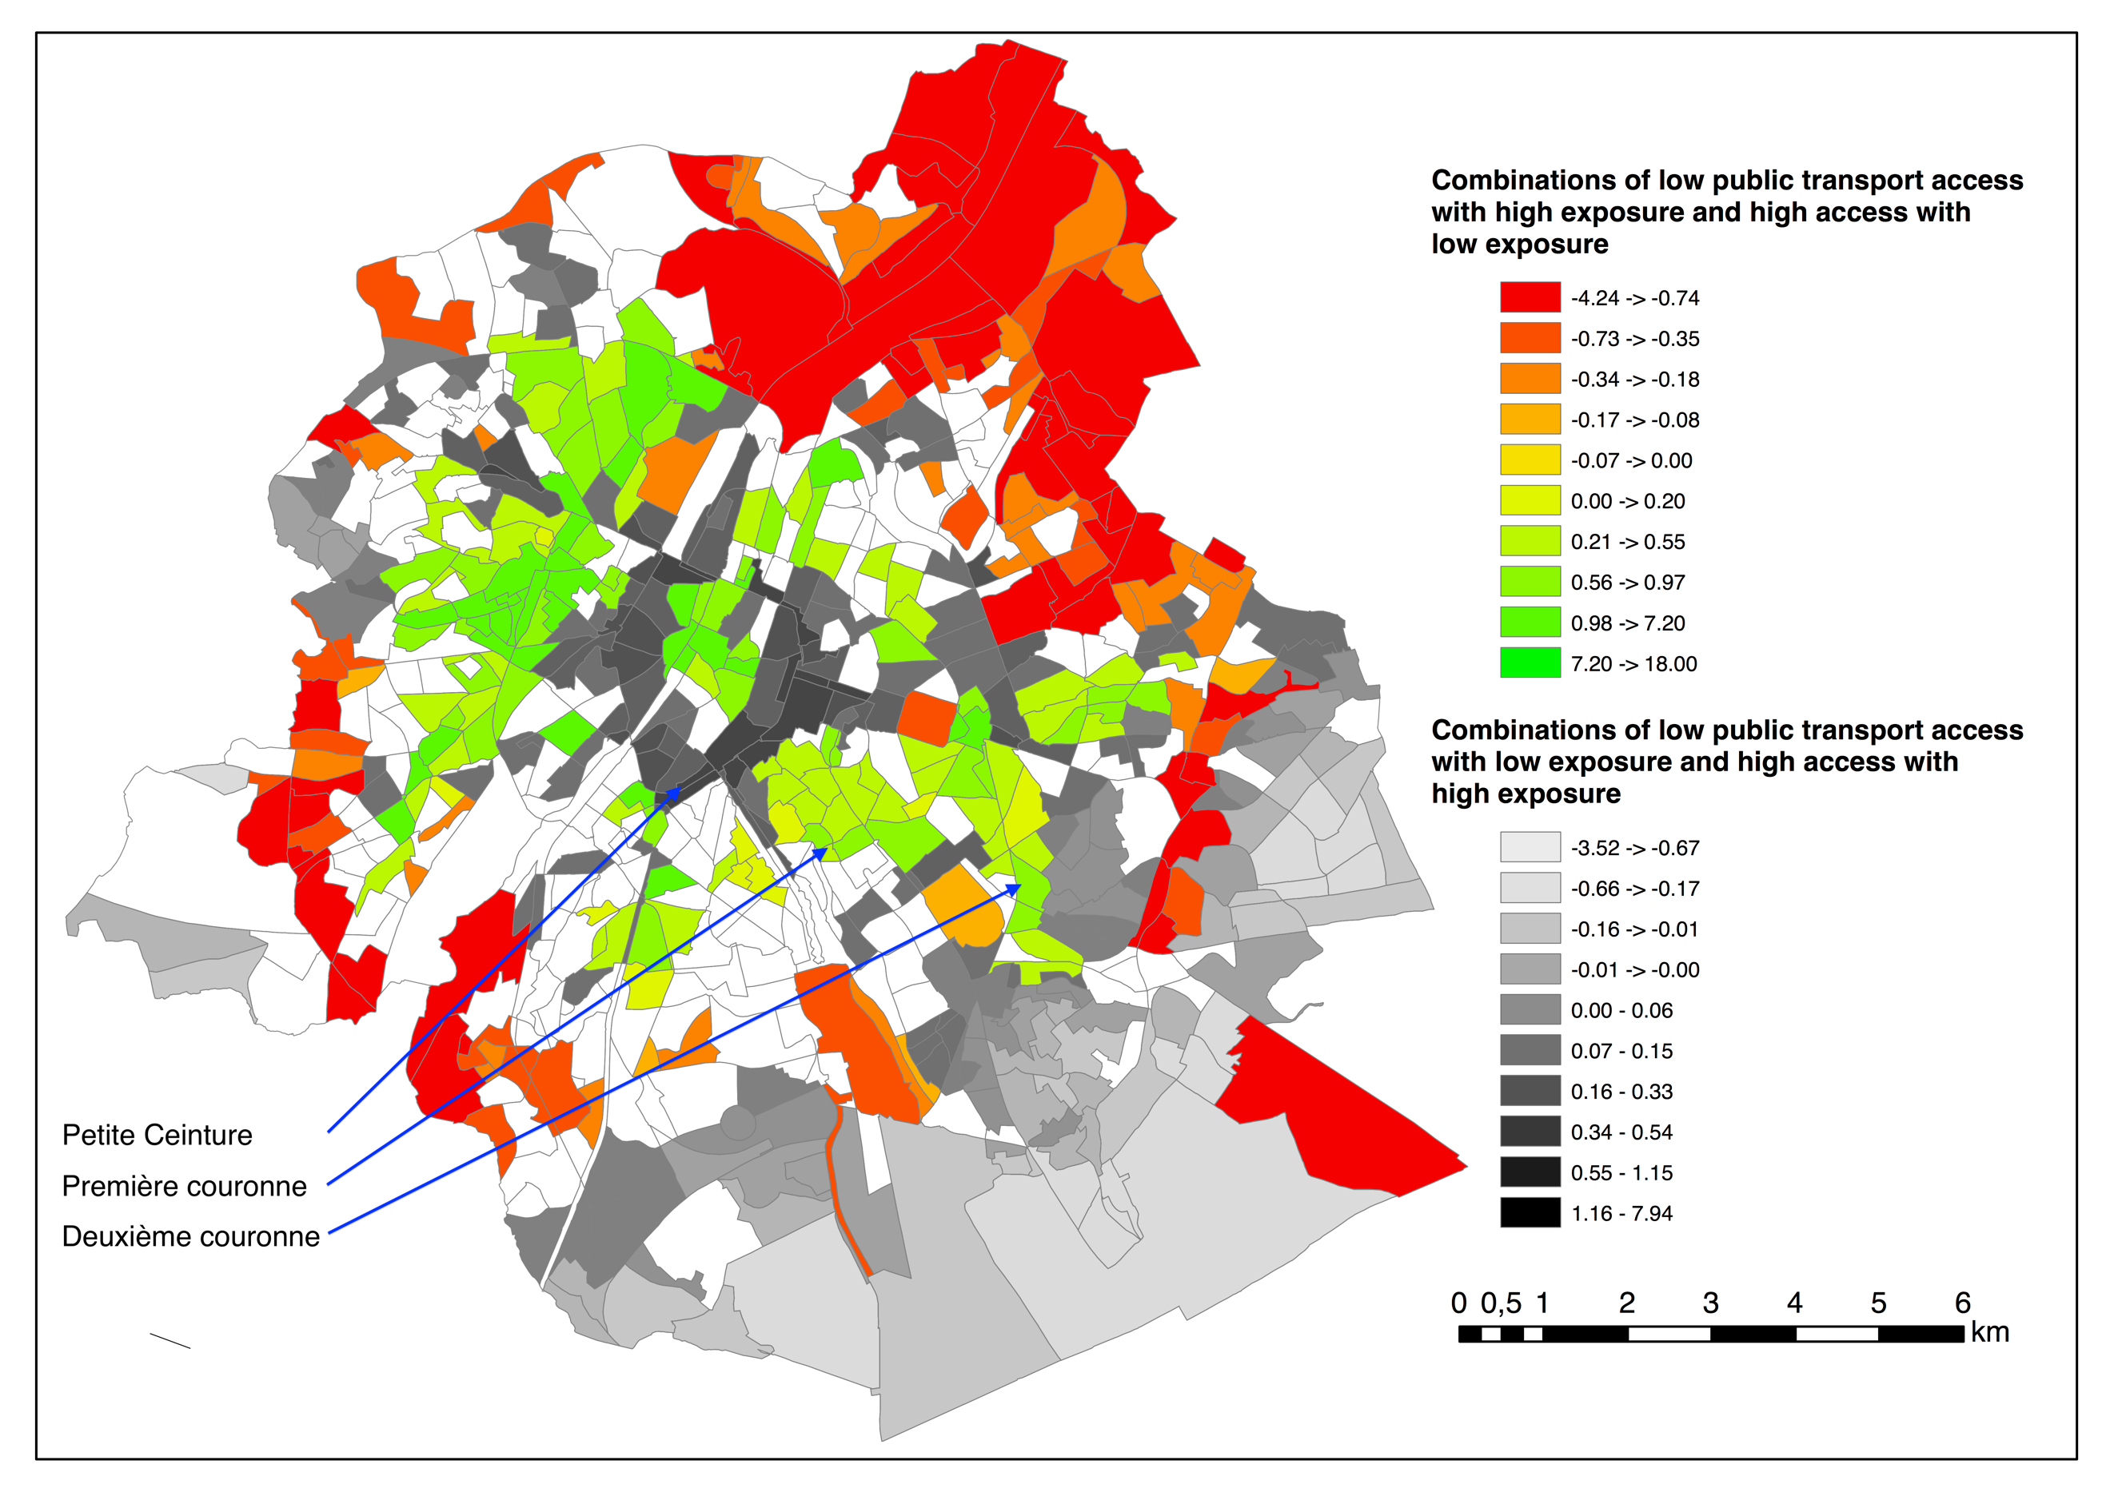
Fig. 1 - Agglomeration map (combination of NO₂ & public transport accessibility)
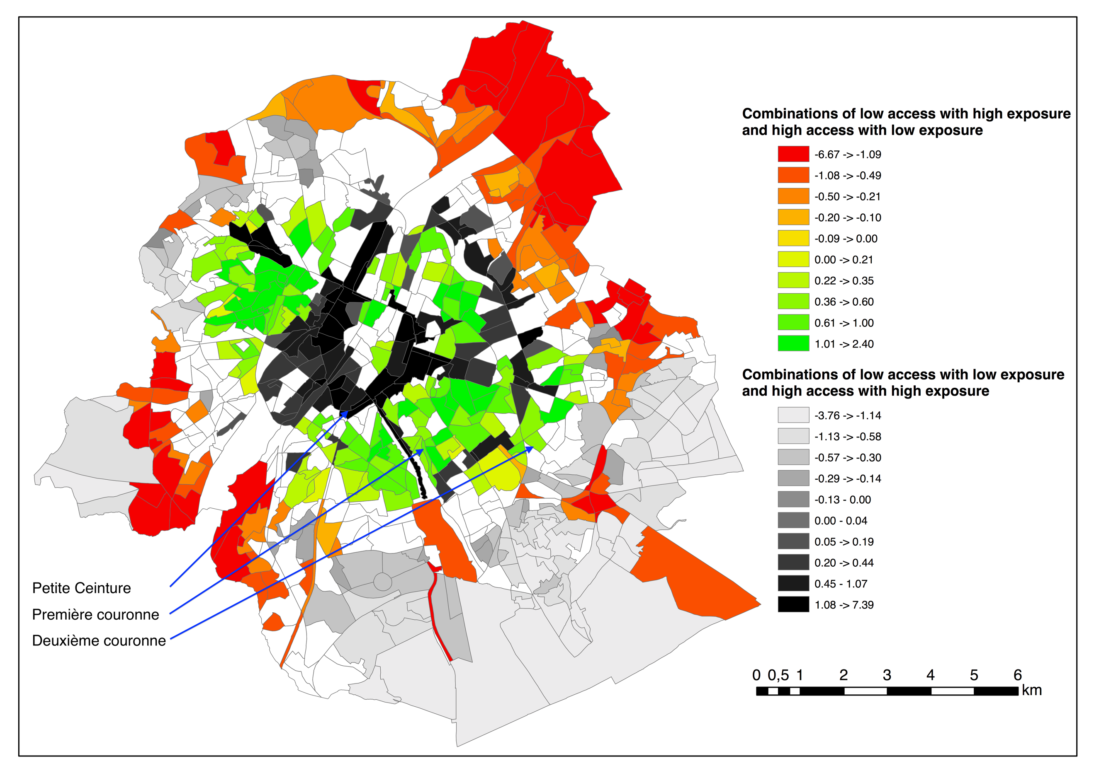
Figure 2 - Agglomeration map (combination of NO₂ & car accessibility)

Additional information
Costs and benefits of the urban form
The socio-ecological benefits and the burdens of urban living have long been recognised. By reducing all sorts of transaction costs, the concentration of people, businesses, and infrastructure provides opportunities for economies of scale, enhances information sharing, and facilitates the encounter of demand and supply of goods, of services, employment, or social activities. At the same time, it also contributes to a wide range of nuisances due to crowding, congestions and proximity of incompatible activities.

Understanding the relation between the benefits and the costs of urban living, where they are more present, when and why they run in parallel or they offset each other, is an essential endeavour both at the level of society and of individuals who need to arbitrate between different priorities, including liveability, health, quality of life, environmental concerns.

Geographic accessibility and air pollution in the Brussels Capital Region
The study has developed a novel approach to measure within the same index two emblematic benefits and costs of living in cities, namely geographic accessibility and air pollution, and has mapped their distribution in the Brussels Capital Region.

Geographic accessibility is calculated as the average time required for every resident in the Brussels region to reach every other resident by car or public transport. This measure takes into consideration transport time and the population density, and can be used to understand the potential for interaction: from the perspective of an individual residence, a high number of people within little travel time is likely to be associated with a high number of opportunities in terms of employment, consumption, services and leisure.

Air pollution, conversely, is recognised as one of the most important health and environmental issue of our times: this study focuses in particular on NO2, a pollutant largely originating from the transport sector and particularly problematic in the Brussels Capital Region.

Research findings: strong correlation between accessibility and pollution, albeit with exceptions.
Overall, demonstrating a strong correlation between geographic accessibility and air pollution, the study shows how they are indeed two sides of the urban agglomeration coin. This means that a neighbourhood which is relatively well connected and integrated with the rest of the region is also likely to suffer from relatively high level of pollution. In Brussels, this situation is observed in the neighbourhoods within the Pentagone, especially those close to the internal ring road, but also along some of the traffic arterials that irradiate toward the periphery (Av. Louise, axe Rue de Loi-Av. De Tervueren, Chaussée de Mons, …,) and part of the eastern boulevard (these neighbourhoods are in black in the map). The opposite situation can be found in the southern fringes, where large wooded areas are located and where the low-accessibility score is offset by the low pollution level (in grey in the map).

This general rule does not apply to the whole region, and a number of neighbourhoods escape the trade-off, both for the good and for the bad. Many neighbourhoods in the première couronne and part of deuxième couronne (Saint Gilles, nord d’Ixelles and Etterbeek in the south, Molenbeek in the north…) present highly desirable conditions, benefitting from relatively high level of accessibility, and low levels of pollution (in green in the map). In the model, finally, the industrial areas in the northern regional fringes (e.g. Haren, part of Evere…) or in the south (e.g.bas de Foret et de Anderlecht…) are the least desirable ones: while the decentralised position and the low population density result in low accessibility scores, the presence of high-density traffic routes contributes to high pollution levels.

Car & Public transport
Separate analyses were dedicated to accessibility by public transport and by car. The similarity between the PT and car accessibility map reveals that major and high accessible public transit lines correspond with major access roads. Due to this geographical correspondence, people reliant on public transport are not better off. If this was not the case, the areas with a high public transport accessibility, but low car accessibility, would probably light up bright green.

Wider implications
By looking at the relation between air pollution, mobility and population density, the research provides a useful approach to evaluate at the same time advantages and disadvantages of urban living and emphasises the need to tackle in an integrated manners questions of environment, transport, and urban planning.

By illustrating the different situations that characterised different areas of the region, the research also points at the limits of one-size-fits-all approaches for the whole region. More nuanced policy solutions should be adopted. In some areas, ambitious measures to drastically reduce pollution are required, even at the expenses of (car) accessibility and mobility. In other areas, the where pollution is less problematic, limiting traffic might result in unnecessary sacrifice for the residents.

In addition, the research provides the ground for more research focussing on specific situations in terms of need and vulnerability. There are specific groups of the population that benefit more than other from the geographic accessibility (and conversely suffers from the lack thereof), for instance for professional reasons. And at the same time, there are other groups who are particularly vulnerable to air pollution, and the places where they live and stay should be particularly protected from pollution (e.g. retirement homes, schools, hospitals).

