Sennheiser and Neumann Recognized at 38th Annual NAMM TEC Awards
Sennheiser XS Wireless IEM and Neumann NDH 30 Headphone capture Outstanding Technical Achievement Awards During Ceremony at 2023 NAMM Show

Anaheim, CA, April 2023 — Sennheiser and Neumann were both recognized for Outstanding Technical Achievement during the 38th Annual NAMM TEC Awards, held on April 13 at the Anaheim Convention Center in California. Sennheiser’s XS Wireless IEM monitoring system captured a TEC Award in the category of Wireless Technology, while Neumann’s NDH 30 headphone received top honors in the Headphone/Earpiece Technology category.

Sennheiser and Neumann were both recognized for Outstanding Technical Achievement during the 38th Annual NAMM TEC Awards (Photo credit: Jeff Touzeau)

“The Sennheiser Group is grateful to have been recognized once again by NAMM for Outstanding Technical Achievement,” commented Greg Beebe, Executive Vice-President, Professional Audio, at Sennheiser. Ralf Oehl, CEO of Neumann.Berlin, added: “The relentless innovation across each of our brands helps our customers around the world achieve their artistic goals, both in live performance and recording spheres.”

Now in its 38th year, the TEC Awards are widely regarded as the highest honor dedicated to the pro audio and sound recording industry, recognizing outstanding performance by the individuals, companies and technical innovations behind the sound of recordings, live performances, films, television, video games and multimedia.

Sennheiser’s XS Wireless IEM monitoring system, winner in the Wireless Technology category, was designed for the rigors of the small stage. The product features a reliable, comprehensive design, and operates in the professional-grade UHF range using pre-defined frequency banks. Advanced features such as integrated equalization, a limiter, and focus mode, along with a rack mount kit, deliver both value and performance in a high-quality, durable package.
The Sennheiser XSW IEM system | 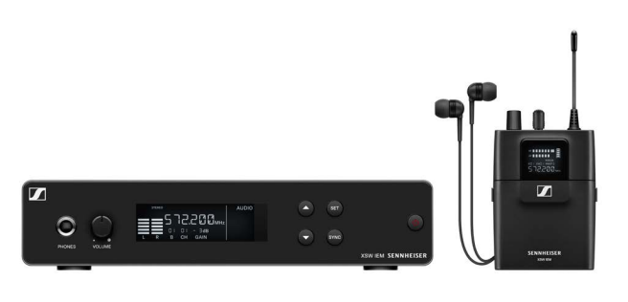
Meanwhile, the Neumann NDH 30, winner of the Headphone/Earpiece category, is a reference-class, open back studio headphone for the most demanding mixing and mastering applications in both stereo and immersive formats. The NDH 30 reproduces the linear sound image of a Neumann loudspeaker setup, perfectly calibrated via MA 1 Automatic Monitor Alignment, in a portable format. The NDH 30 features extremely low harmonic distortion and has a remarkably even response across the entire audio spectrum.

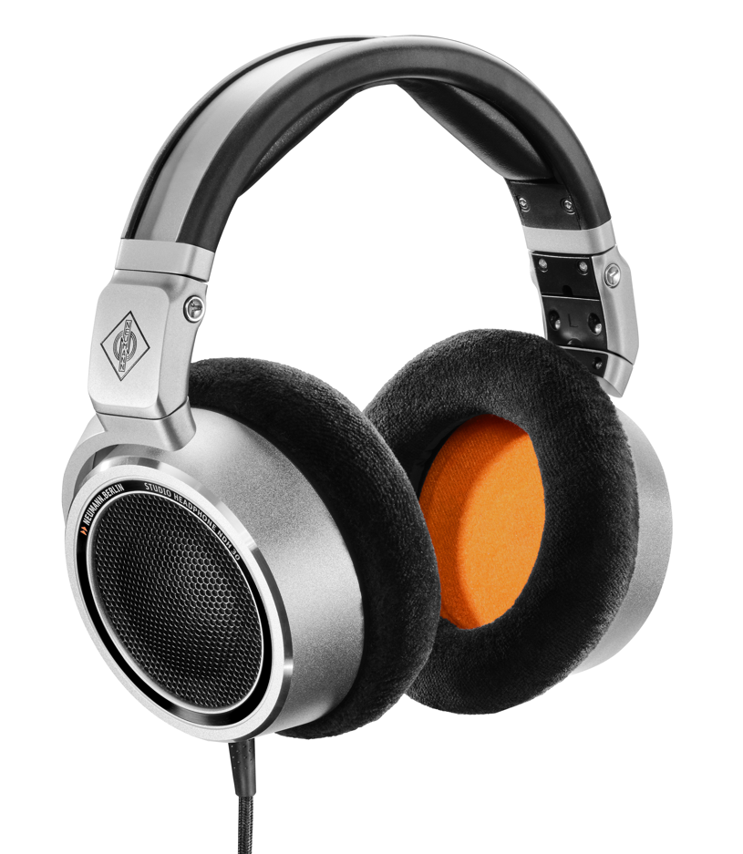 | The Neumann NDH 30 open-back studio headphone

(Ends)
The images accompanying this media release can be downloaded here.

About the Sennheiser Group

Building the future of audio and creating unique sound experiences for our customers - this is the aspiration that unites the employees of the Sennheiser Group worldwide. The independent family-owned company Sennheiser was founded in 1945. Today, it is managed in the third generation by Dr. Andreas Sennheiser and Daniel Sennheiser, and is one of the leading manufacturers in the field of professional audio technology. Within the Sennheiser Group are Georg Neumann GmbH (Berlin, Germany), manufacturer of studio-grade audio equipment; Dear Reality GmbH (Düsseldorf, Germany), known for its binaural, Ambisonics, and multichannel encoders with realistic room virtualization; and Merging Technologies SA (Puidoux, Switzerland), specialist in high-resolution digital audio recording systems.
sennheiser.com | neumann.com | dear-reality.com | merging.com

Local Press Contacts
Daniella Kohan Jeff Touzeau
daniella.kohan@sennheiser.com jeff@hummingbirdmedia.com
+1 (860) 227-2235 + 1 (914) 602-2913

