Jazz Drummer Karl Latham Employs Legacy RME Fireface UFX Interface on Pandemic-inspired Record ‘Together’

The UFX has been Latham’s main interface for nearly a decade due to its unrelenting stability and neutral sound characteristic
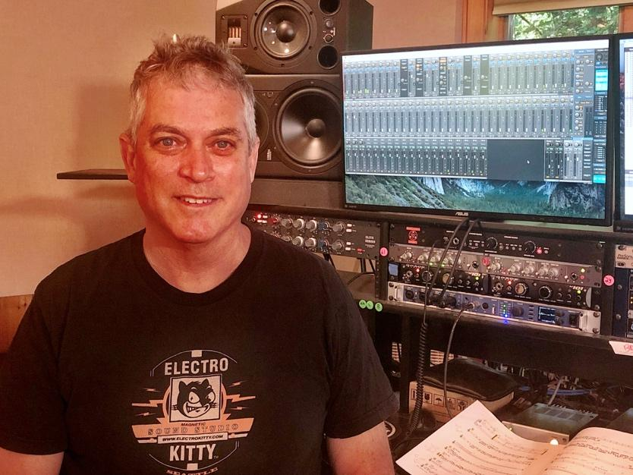
Fort Lauderdale, Florida, July 21, 2021 — Karl Latham is a one-man drumming machine. As a jazz drummer, educator and recording engineer, not a day goes by where Latham isn’t working or recording in his home studio with his RME Fireface UFX audio interface by his side. Latham first discovered RME’s interfaces in many studios when touring and recording in Northern Europe in 1993. While the original UFX model was replaced by RME in 2017 with the best-in-class Fireface UFX+, Latham still uses his original UFX on a daily basis, with the unit playing a central role in his home studio workflow for the last 8 years.
“I can’t express how much I love this piece of gear,” Latham said. “It literally beats every requirement I would ever have — from the stability to the sound quality to the ease of use. I’ve been using my UFX for just shy of a decade, and it’s still completely stable.”
Hitting Every Beat
From recording and self-producing his new album with NYC bassist Ryan Berg and pianist Alex Collins “Together” — released in June — to contributing drum tracks for numerous demos, artist releases and jingles, Latham’s RME UFX serves as his main interface, routinely running 24 tracks out of it.
“I run it as the front end to Pro Tools,” Latham explained. “I have a rather large home studio, designed by venerable studio designer John Stork. My entire house is wired to record in, so the UFX plays a very key role.”
Collins, Berg and Latham’s new album “Together” features such jazz standards as “Stella By Starlight,” “On Green Dolphin Street'' and “Polka Dots And Moonbeams.” The project was born out of Latham’s lockdown livestream concert series, “Concerts from the Cabin,” where Latham invited friends to play socially distanced at his home studio in New York.
“I created ‘Concerts from the Cabin’ just as a place for musician friends to come over and play socially distanced and provide an outlet for us to stay musically in contact with friends, family and fans,” Latham said. “Basically, it was for my friends who are primarily performers to simply try to stay sane. I learned how to operate [free streaming platform] OBS Studio and, while I knew nothing about video, I bought some lights and a pile of webcams, cables and hubs — it was all trial and error.”
Latham’s livestreaming series included jazz musicians John Lee (Dizzy Gillespie Alumni Director), Laurence Hobgood, Howard Paul, Freddie Hendrix, Tomoko Ohno, Martin Pizzarelli, Mitch Stein and Roger Squitero.
“We never rehearsed,” Latham said. “We just simply wrote a short list of each session of songs we collectively knew. We didn’t really discuss interpretations or forms, we just played.”
Initially, Latham envisioned a compilation ‘best of’ release of the streams, but after going over the streams with Ryan and Alex, he changed his mind. The album “Together” was the result of listening back to one the livestream events.
“The events with Ryan and Alex were so special that I thought it deserved all of my focus,” he said, adding that all of the streams also utilized the Fireface UFX interface. “I ran my entire studio flow capturing all the live instruments, MIDI for virtual instruments and sent that audio to OBS. Many fans said the livestreams sounded like a recording, not a live concert.”
While recording and producing “Together” at his home studio, Latham said the UFX’s sonic excellence and stability were key.
“The unit is ridiculously stable,” he said. “And the sound characteristic is exactly what I’m looking for. It’s completely neutral, letting the nuisances of the music speak for itself. It doesn’t color the audio at all which is important to me as both a musician and a producer.”
While Latham has been using his Fireface UFX for nearly a decade, he said the sound quality and stability are still bar-none.
“There’s just nothing like it on the market,” Latham explained. “RME products are unparalleled in their sonic clarity, ease of use and versatility. There is no better bang for your buck.”
For more on RME, visit: rme-usa.com

About Synthax, Incorporated
Synthax Inc. is the exclusive USA distributor for RME digital audio solutions, Digigram broadcast audio systems, Appsys digital audio tools, Ferrofish advanced audio applications, myMix personal monitoring systems and ALVA cableware. We supply a nationwide network of dealers with these products for professional audio, broadcast, music industry, commercial audio, theater, military and government applications. For additional information, visit the company online at http://www.synthax.com.

Media Contacts:
Katie Kailus
Public Relations
Hummingbird Media
+1 (630) 319-5226
katie@hummingbirdmedia.com

Jeff Touzeau
Public Relations
Hummingbird Media
+1 (914) 602 2913
jeff@hummingbirdmedia.com

