Sennheiser Evolution Wireless Digital: EW-DP
The 5th generation of Sennheiser’s popular wireless microphone systems for camera use is here

Wedemark, 14 April 2023 – At NAB, Sennheiser launches its 5th generation of Evolution Wireless systems for filmmaking and video applications. Purpose-built for content creators, filmmakers, and broadcasters, EW-DP is a fully digital UHF wireless microphone system with a new portable design and unmatched audio quality. At its heart is a compact, intelligent receiver that helps even novice users set up their audio with ease. The EW-DP EK receiver features an innovative magnetic stacking system, and can be conveniently controlled remotely via the Smart Assist app.

“On set time is the most valuable asset,” says Tobias von Allwörden, head of Sennheiser’s Audio for Video portfolio. “Therefore, we designed EW-DP such that it is intuitive and fast to set up and helps you to troubleshoot your system. EW-DP provides the reliability and consistency that you need in stressful filming situations and time-sensitive working scenarios.”

The EW-DP series

The EW-DP series
Besides the stackable EW-DP EK receiver, the series includes a bodypack transmitter for clip-on mics (EW-D SK), a handheld transmitter (EW-D SKM-S) and a plug-on transmitter (EW-DP SKP) that will launch in October. As part of the larger Evolution Wireless Digital family, EW-DP inherits the family features such as the exceptionally low latency of 1.9 ms and a wide 134 dB dynamic input range, which ensures that everything from a soft whisper to a loud scream can be reliably captured without distortion.

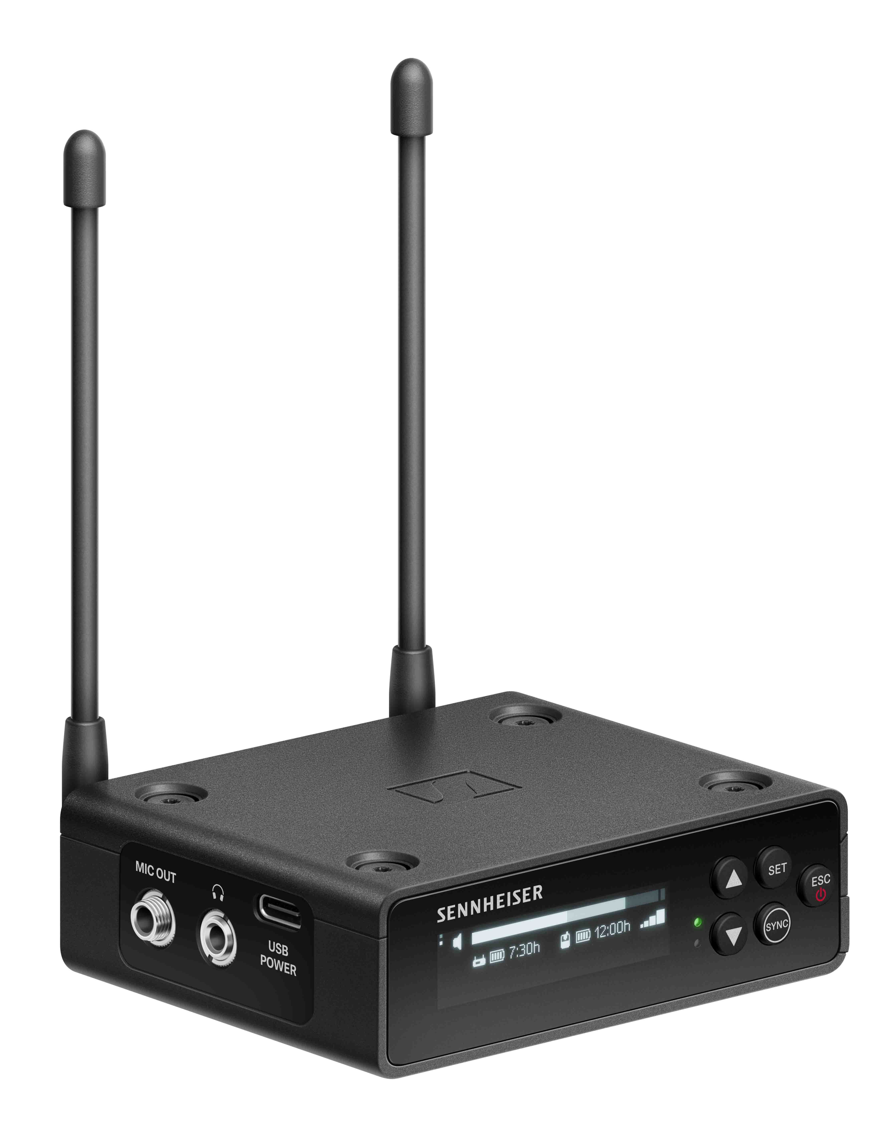 | The compact, stackable EW-DP EK receiver is at the heart of the system. Its OLED display ensures optimal visibility regardless of placement, angle, or light

Three sets are available now: The EW-DP ME 2 SET comes with a bodypack transmitter and the ME 2 omni-directional clip-on (lavalier) microphone, while the EW-DP ME 4 SET includes a cardioid clip-on microphone for noisier environments. The EW-DP 835 SET contains a handheld transmitter with cardioid MMD 835 dynamic microphone head.

All sets come with a magnetic mounting plate kit, a BA 70 rechargeable battery, two standard AA batteries, a locking 3.5 mm TRS to 3.5 mm TRS cable, a locking 3.5 mm TRS to XLR cable, and a USB-C charging cable for the receiver.

Peace of mind on location
“Though sound is decisive for the overall quality of a production, it is usually not the first priority on set. More often than not, freelancers will work without a dedicated audio person. There are enough challenges on set, so we embarked on developing a UHF audio system that would require minimal attention and give the videographer peace of mind,” explains von Allwörden. “For this, we collaborated closely with a peer group of filmmakers, camera operators and content creators. The outcome is EW-DP, which I like to call a UHF system with 2.4 GHz simplicity.”

Notably, EW-DP is the first portable wireless system that has magnetically stackable receivers with a user-facing OLED display and ergonomically designed controls. Thanks to EW-DP’s automated frequency coordination, videographers can get up and running quickly: The receiver finds a free frequency (which can also be initiated via the Smart Assist app), then the transmitter is simply synced via Bluetooth.

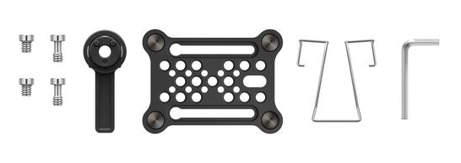

EW-DP’s magnetic plate allows filmmakers to simply (and securely) stack multiple receivers. Alternatively, the plate can be used with the provided clip to wear the receiver on the belt or attach it to the sound bag

Never caught off guard with Smart Notifications
EW-DP requires little RF or audio knowledge – if any issues should occur, the system will guide users with Smart Notifications that give tips for troubleshooting and show them where to fix a problem. The system sends alerts for audio clipping, low battery, occupied frequencies, muted transmitters, and unlinked devices – and all come with a suggestion of how to quickly solve the issue. “This guidance makes all the difference when audio isn’t your only responsibility on set,” comments von Allwörden.

Various powering options for long location shoots
The EW-DP receiver can be powered by a BA 70 lithium-ion rechargeable battery, two standard AA batteries, or via USB by a power bank, for example. Added to the variety of powering options is an exact read-out of battery runtime in hours and minutes to avoid surprises. Battery life is up to 12 hrs on the transmitters, and up to 7 hours on the receiver with the included BA 70 rechargeable battery.

Control via receiver or Smart Assist app
Automated set-up, operation and monitoring can also happen at a distance from the camera receiver – conveniently via Bluetooth using the Smart Assist app on nearly any iOS or Android device. In the app, auto frequency coordination creates reliable wireless connections for up to 16 systems on set, no wireless expertise required. Videographers can quickly and discreetly alter system settings across the room, and remotely override an accidentally activated mute button on the transmitter. The app also includes a support hub with video tutorials and detailed manuals.

The Smart Assist app is a convenient tool for setting up, operating and monitoring
EW-DP

Upcoming: A very special plug-on transmitter
There’s more to come: In October, a plug-on transmitter will be added to the series. With +48V phantom power on board, the EW-DP SKP will be able to turn any wired XLR microphone into wireless, such as an MKH 416 on a boom pole. In addition, the plug-on transmitter features a locking 3.5 mm mic input for lavaliers – making it a versatile tool that can act as a real problem solver.

A versatile tool: The SKP can be connected to dynamic and condenser microphones as well as lavalier mics with a 3.5 mm connector. Thanks to on-board recording, videographers have the option of having a safety copy of their audio on a micro SD card. Available from October 2023 | 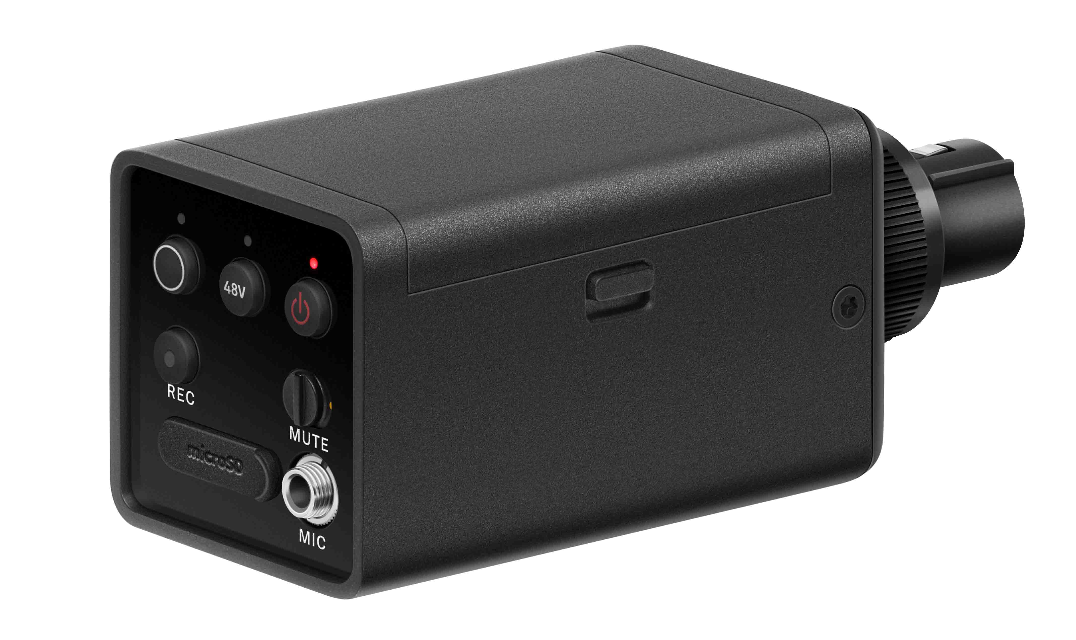

“In our conversations with the peer group, many expressed the wish to have some sort of safety net for their audio,” shares von Allwörden. “So we fitted the plug-on with a micro SD card slot for 24-bit, 48 kHz on-board recording.”

The plug-on transmitter will be part of the EW-DP ENG SET, which will include the receiver, a bodypack transmitter, the ME 2 lavalier mic and the SKP plug-on transmitter.

(Ends)

High-resolution product and system images can be downloaded here.
A selection of application and mood shots can be downloaded here.

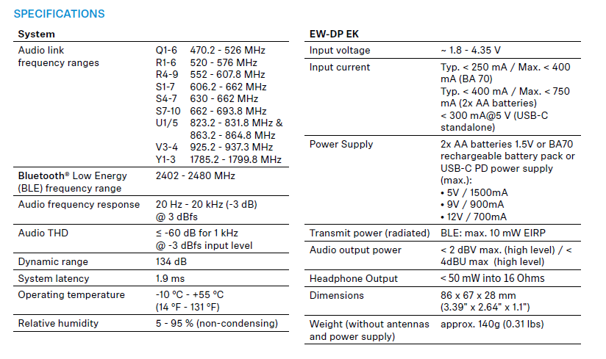

About the Sennheiser brand
We live and breathe audio. We are driven by the passion to create audio solutions that make a difference. Building the future of audio and bringing remarkable sound experiences to our customers – this is what the Sennheiser brand has represented for more than 75 years. While professional audio solutions such as microphones, meeting solutions, streaming technologies and monitoring systems are part of the business of Sennheiser electronic GmbH & Co. KG, the business with consumer devices such as headphones, soundbars and speech-enhanced hearables is operated by Sonova Holding AG under the license of Sennheiser.

www.sennheiser.com
www.sennheiser-hearing.com

Global Pro Audio Press Contact
Stephanie Schmidt
stephanie.schmidt@sennheiser.com
+49 (5130) 600 – 1275

