For immediate distribution

BAE Audio to Showcase Wide Range of Compressors at Sweetwater Sound’s 18th Annual GearFest

Fort Wayne, Indiana, June 17, 2019 – BAE Audio will highlight its expansive line of compressors, including the UK Sound 176 and 276 single- and dual-channel mono compressors, as well as BAE’s 500C FET compressor and 10DCF compressor/limiters — all of which deliver BAE quality workmanship for various applications at multiple price-points — at Sweetwater Sound’s 18th annual GearFest, to be held June 21-22 at Sweetwater’s headquarters in Fort Wayne, Indiana. BAE’s Colin Leibich will conduct live demonstrations of the at the GearFest 2019 BAE Audio booth on Friday, June 21 and Saturday, June 22 between 9 a.m. and 6 p.m.
GearFest 2019 will mark Sweetwater’s 18th annual free music gear festival attended by thousands of music gear fanatics from all over the country. The two-day festival features the newest musical instruments, music technology and audio equipment from top manufacturers like BAE Audio and will feature workshops, gear demos, product launches and performances by guest artists including drummer Dennis Chambers (Santana, John McClaughlin), guitarist Eric Johnson, producer/engineer Sylvia Massy (Tool, System of a Down), bassist Billy Sheehan and Mesa Boogie’s Randall Smith — and will, of course, include plenty of opportunities to test out new musical equipment firsthand.
Prosumer-Friendly: UK Sound 176 & 276
The UK Sound 176 and 276 single- and dual-channel mono compressors deliver the unique flavor of a vintage FET compressor in a single 1U rack space and at a friendly price-point, making a high-quality version of this studio staple more cost-effective than ever. Featuring the classic operation and sound characteristics of some of the hit-making compressors from the ‘60s and ‘70s, the UK Sound 176 and 276 make it easier to dial in great sound on any source. Input and output gains and selectable ratios of 4:1, 8:1, 12:1 and 20:1 allow users to tame peaks and fit each audio signal exactly where they want it in the mix, with a face-mounted gain reduction meter to let users know how hard the unit is working. Both models also feature the beloved "all buttons in" mode, which unlocks a hidden compressor function accessed by depressing multiple ratio buttons simultaneously.
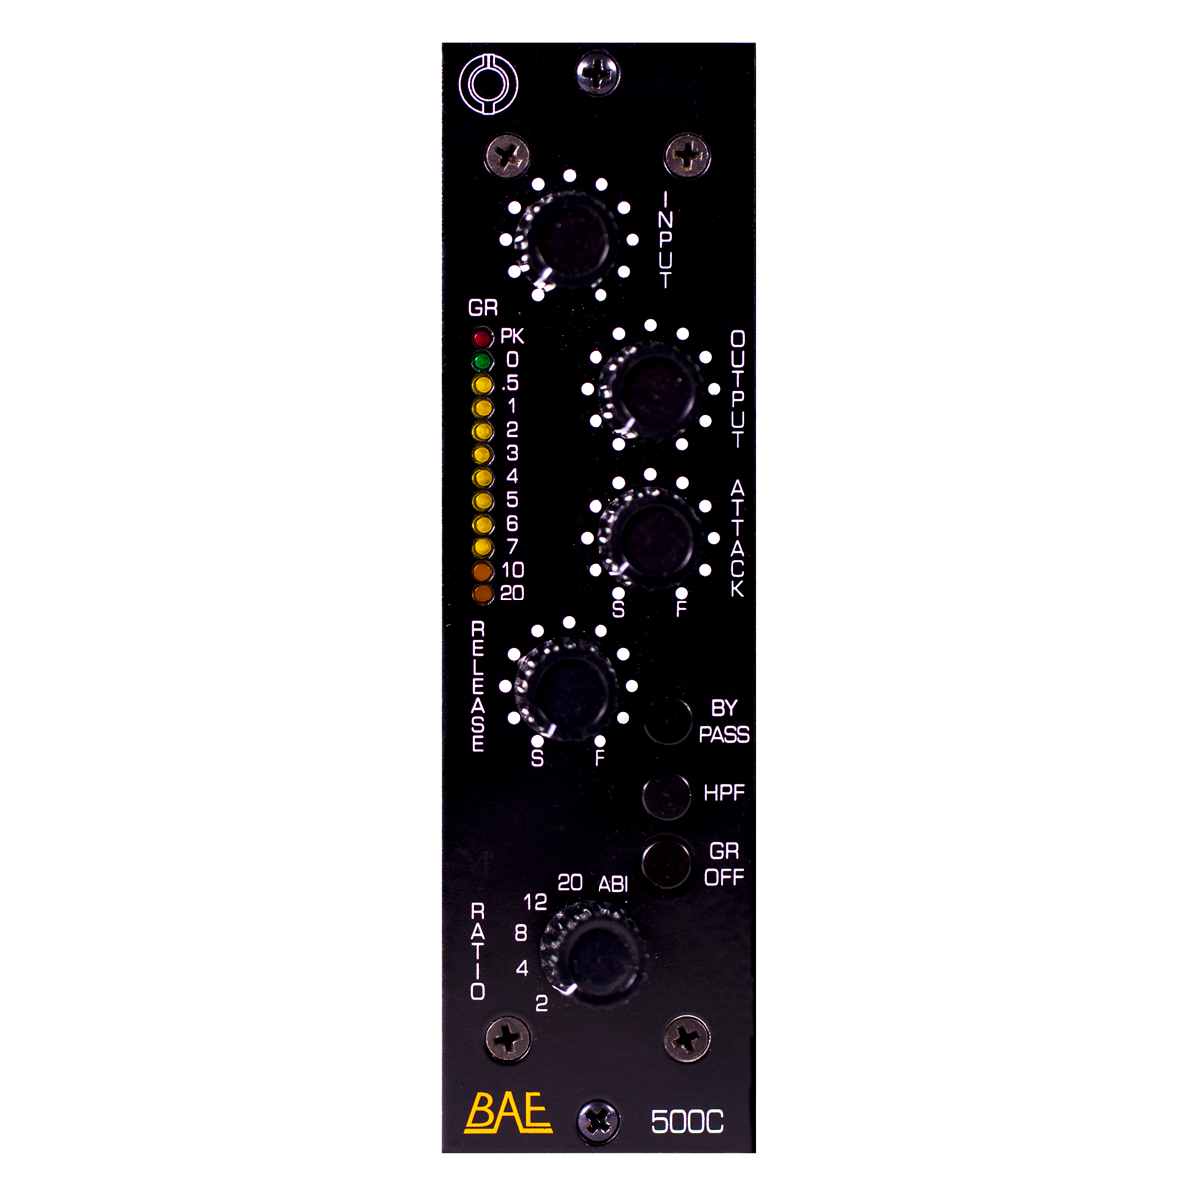
Lunchbox FET: BAE 500C compressor
BAE will also showcase its 500C, which gives users more portability without sacrificing BAE-quality craftsmanship. Based on the design of the most widely-used FET compressors of the ‘60s and ‘70s heard on countless hit records, the 500C features controls for input and output gain, plus the four selectable, time-honored compression ratios of 4:1, 8:1, 12:1 and 20:1. In addition to taming peaks, the 500C’s premium components and classic circuit design add desirable analog warmth to the user’s signal, making it ideal for everything from drums to bass and vocals. And, as with all BAE Audio gear, the 500C is hand-wired in California to ensure the highest possible quality control.
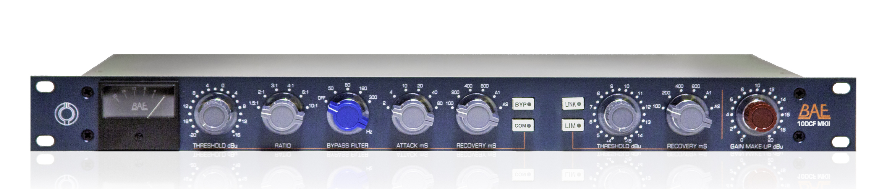
BAE 10DCF compressor/limiter leaves the low end alone
During Sweetwater GearFest 2019, BAE will also highlight the 10DCF compressor/limiter and 10DCF pair (stereo bus), which can be applied to the master output section — or even a mastering scenario — to add a complementary analog flavor to the user’s mix. Building on the capabilities of BAE’s 10DC compressor/limiter, the 10DCF features Carnhill and Jensen transformers with the addition of an inductor-based bypass filter, which delivers increased flexibility for users recording low-range frequency instruments, engaging at 50, 80, 160 and 300 Hz — perfect for users who want to compress a broad frequency range while leaving lower frequencies uncompressed. BAE’s 10DCF units are also stereo linkable, making them an ideal complement for the output stage of a mixer.
For more information on BAE Audio, please visit baeaudio.com.
About BAE Audio
BAE Audio is a U.S.-based manufacturer of high-end microphone preamp and equalizers, all of which are faithful to vintage designs of the seventies and before. The company is committed to the vintage philosophy of hand wiring and hand soldering all of its components to achieve a high quality and authentically vintage sound. For more information on BAE Audio, please visit our website at www.baeaudio.com.

Media Contact
Jeff Touzeau
Public Relations
Hummingbird Media
+1 (914) 602 2913
jeff@hummingbirdmedia.com

