Sennheiser brings the speed of sound to Mercedes-AMG ONE hypercar
The future of audio and the future of driving performance are set to intersect in the Mercedes-AMG ONE

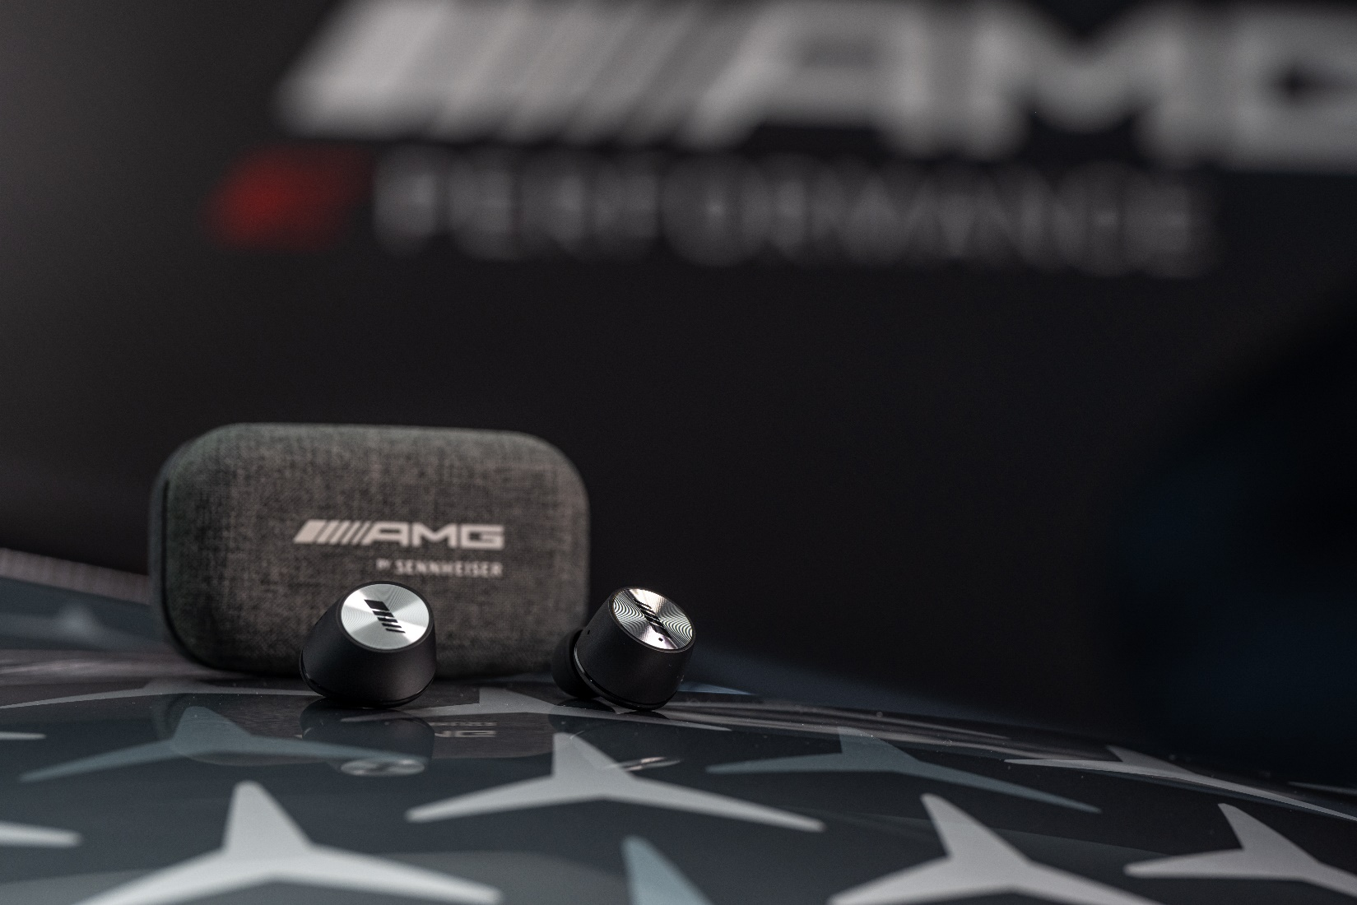

Marlow, UK, 9th June 2022 – Sennheiser and AMG, the high-performance subsidiary of Mercedes-Benz AG, have entered into a new collaboration that sees the future of driving performance and the future of audio intersect in the new Mercedes-AMG ONE hypercar. The AMG ONE will give drivers an authentic Formula 1 racing experience, with stunning MOMENTUM audio quality on the road by legendary audio expert Sennheiser.

The two-seat Mercedes-AMG ONE will bring the most modern and efficient Formula 1 hybrid technology almost one-to-one from the racetrack to the road. Combining overwhelming racetrack performance with exemplary efficiency, the AMG ONE will produce more than 1,000 hp, at a breath-taking maximum speed of over 350 km/h.

To augment the driving experience by enabling a joyful listening experience on the road and attenuate engine sound, the Sennheiser AMBEO Mobility division will provide owners of AMG ONE with optimised, smart-controlled MOMENTUM True Wireless earbuds.

“MOMENTUM True Wireless is the perfect match for a car as powerful as the Mercedes-AMG ONE, as they enable users to enjoy incredible high-fidelity sound even in noisy environments thanks to their advanced Active Noise Cancellation feature. And when greater situational awareness is needed, the Transparent Hearing feature lets the wearer blend in outside ambient sound at a touch” explained Frank Foppe, Sennheiser True Wireless Product Manager.

Ergonomically designed for the best possible fit and to reduce fatigue, as well as offering up to 28-hours battery life by charging on the go from the supplied case, the earbuds are co-branded with the AMG-Mercedes and Sennheiser names.

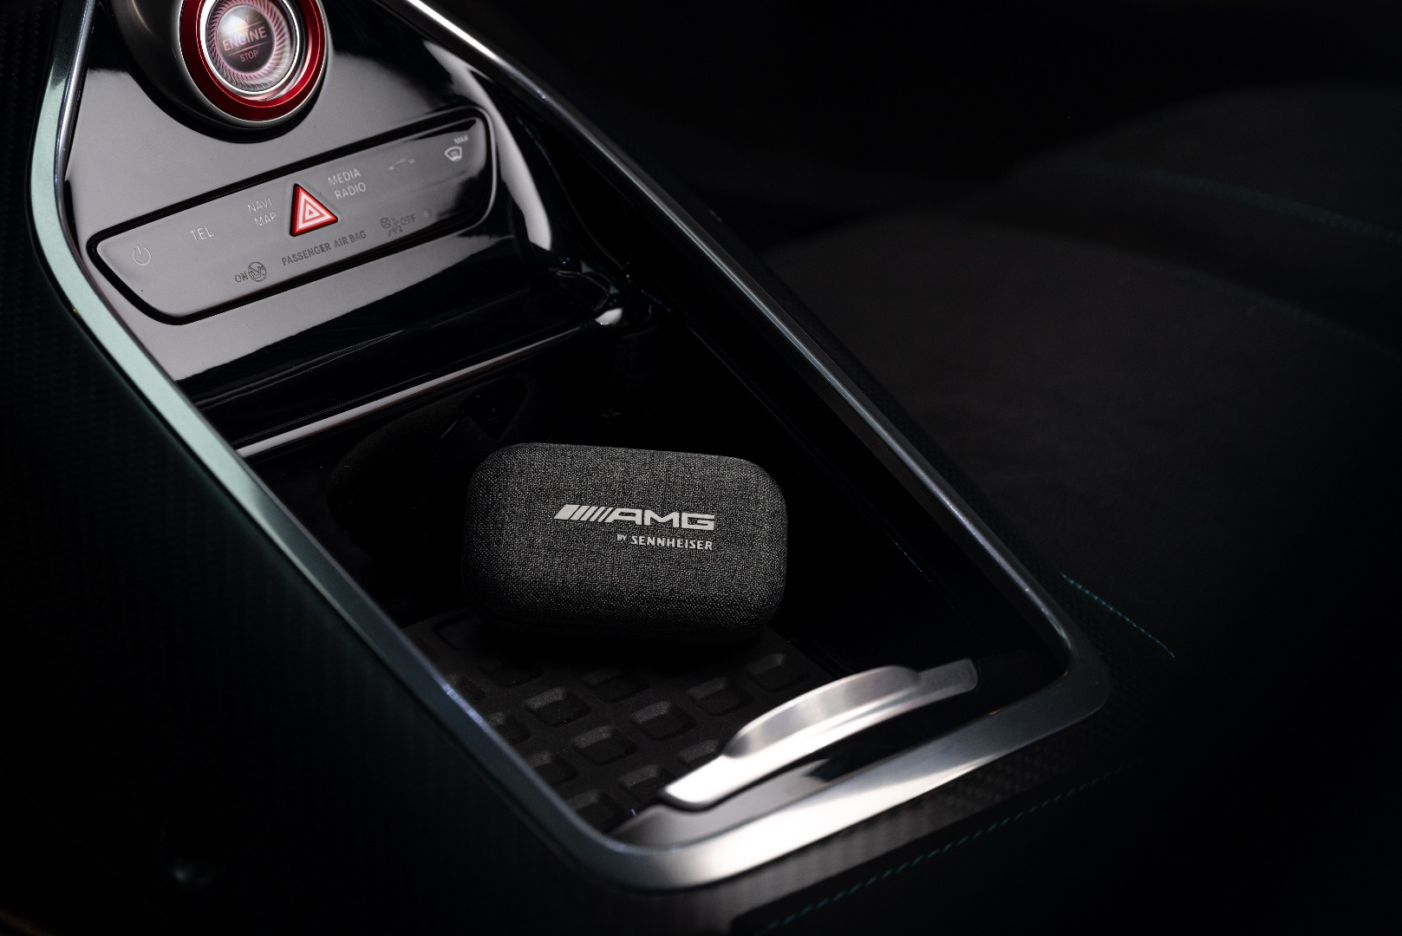

“At Sennheiser, we love pushing boundaries and setting new standards for the listening experience. And emotion is driven by sound, in both the audio and the automotive worlds. Driving a F1 engine while enjoying premium music quality is the kind of unthinkable user experience that our AMBEO Mobility team is built to address”, added Veronique Larcher, Head of Sennheiser AMBEO Mobility. As sound is one of the most thrilling elements of any high-performance car, the collaboration between Mercedes-AMG and Sennheiser for the AMG ONE came naturally: Both parties are assuring an outstanding experience to fully meet customer’s expectations for premium quality.

Please find more information about this project here.

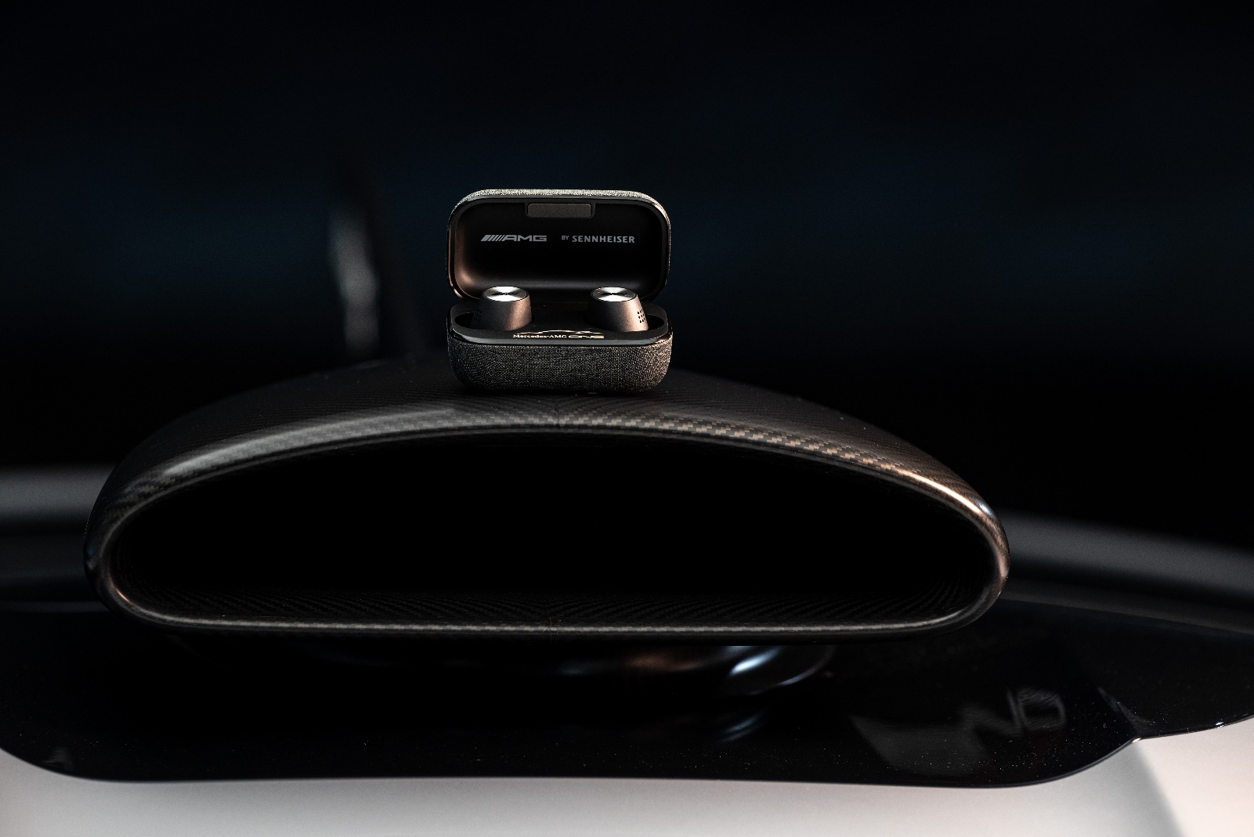

About the Sennheiser brand
We live and breathe audio. We are driven by the passion to create audio solutions that make a difference. Building the future of audio and bringing remarkable sound experiences to our customers – this is what the Sennheiser brand has represented for more than 75 years. While professional audio solutions such as microphones, meeting solutions, streaming technologies and monitoring systems are part of the business of Sennheiser electronic GmbH & Co. KG, the business with consumer devices such as headphones, soundbars and speech-enhanced hearables is operated by Sonova Holding AG under the license of Sennheiser.

www.sennheiser.com
www.sennheiser-hearing.com

Press contact
Sonova Consumer Hearing GmbH

Milan Schlegel
PR and Influencer Manager EMEA, Sennheiser Consumer
Milan.Schlegel@sennheiser-ce.com

Harvard PR
Sennheiser UK&I PR agency
sennheiser@harvard.co.uk

