Photo: Christian POGO Zach, courtesy of the Gärtnerplatztheater

Gärtnerplatztheater relies on Sennheiser Digital 6000
40 digital wireless channels supplied for Munich musical theatre

Wedemark, 2 November 2022 – The State Theatre on Gärtnerplatz, commonly known as the Gärtnerplatztheater, was opened in 1865 and its late-classical façade still characterises the ambience of the square in the centre of Munich that gives it its name. Last year, the theatre was converted to digital microphone technology from Sennheiser.

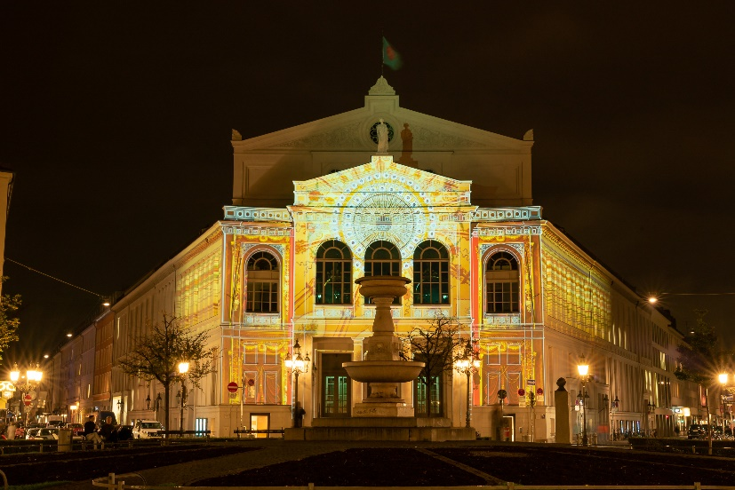 | The Gärtnerplatztheater has adopted digital wireless microphones from Sennheiser  Photo: Sara Kurig, courtesy of the Gärtnerplatztheater

The repertoire of the Gärtnerplatztheater includes performances from all areas of musical theatre, from musicals and modern operettas to revues. The main performance venue is the grand auditorium, which is designed as a classical tiered theatre (balcony with a central box and three galleries) and can accommodate an audience of just under 900 people. There is also a foyer, which is occasionally used to stage musical events, and an orchestra rehearsal room, which also serves as a location for chamber music performances and recitals. In addition, the rehearsal stage is sometimes used for performances such as chamber operas and can accommodate up to 100 people. The youth theatre is also a regular guest on the rehearsal stage of the Gärtnerplatztheater.

The grand auditorium of the Gärtnerplatztheater  Photo: Christian POGO Zach, courtesy of the Gärtnerplatztheater | 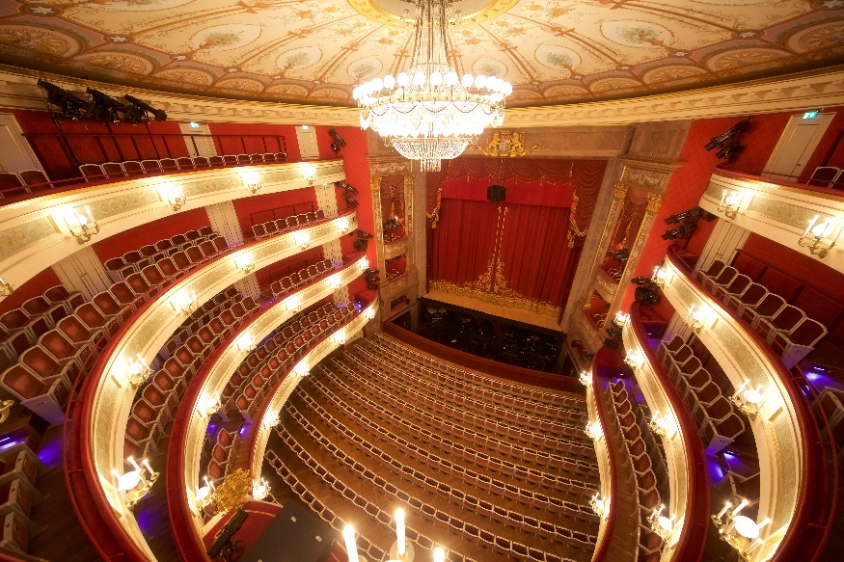

From VHF via analogue UHF to digital UHF
Dirk Buttgereit has been head of the sound department at the Gärtnerplatztheater since 2003. In conversation, the experienced audio professional frequently uses the term “Mikroport”, a sign that the theatre can look back on a long history of using Sennheiser wireless systems.

“We’ve been using Sennheiser wireless solutions since the beginning of the Mikroport era,” Buttgereit reports. “Even back in the 1980s, the theatre was already equipped with wireless systems from Sennheiser. These included a system working in the VHF range, which we operated with an impressive 12 channels. As part of a refurbishment in 2007, we acquired 24 Sennheiser wireless channels from the 3000 series. In 2014, we added 12 channels from the 2000 series, making a total of 36 channels available overall. Unfortunately, the digital dividend and the ensuing restriction in frequencies did not leave us unscathed, but we were able to have our equipment converted to suitable frequency ranges by the Sennheiser service team. We have always had only the very best of experience with the service team in Barleben.”

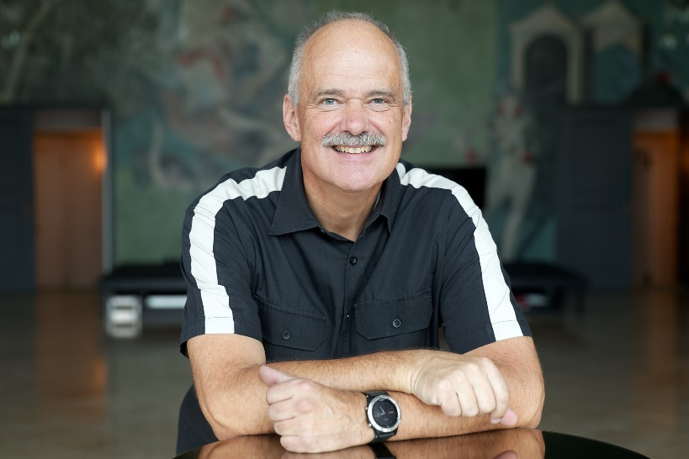 | Dirk Buttgereit, head of the sound department at the Gärtnerplatztheater

Buttgereit adds: “In summer 2021, the acquisition of a new digital mixing console gave us the ideal opportunity to convert the entire Gärtnerplatztheater to state-of-the-art digital wireless systems. Nowadays, there are so many wireless signals in the air even inside a theatre that the Sennheiser digital microphone system, which does not generate any intermodulation products, is a big help in efficiently using the spectrum.”

40 Sennheiser digital wireless channels
Forty channels from the Sennheiser Digital 6000 series were acquired. At the Gärtnerplatztheater, 20 EM 6000 two-channel receivers are neatly installed in a 19” rack in a temperature-controlled equipment room. The audio link to the mixing console is digital via a Dante network. The Gärtnerplatztheater does not currently make use of a redundant link via a primary and secondary port. Receiver clocking also takes place over the Dante network. The signal flow to the power amplifiers is predominantly digital – according to Buttgereit, latency within the digital chain is “not an issue, because it remains below the threshold of perception.”

Forty ultra-compact Sennheiser SK 6212 bodypack transmitters and four SKM 6000 handheld transmitters fitted with Neumann KK 205 capsules (super-cardioid) transmit their signals to the 20 two-channel receivers. The theatre’s extensive microphone equipment includes Sennheiser MKE 1 clip-on microphones (omnidirectional), and more of these microphones will subsequently be added: “The MKE 1 are amazingly resistant to sweat, and if we consider just how much some performers tend to sweat during a show, this is an extremely important factor for us,” Buttgereit points out. “All in all, we currently have 60 MKE 1 in use at the Gärtnerplatztheater.” The compact SK 6212 bodypack transmitters have proven to be robust and reliable in everyday use. According to Buttgereit, their mechanical quality is on a par with that of the proven Sennheiser SK 5212 bodypack transmitters.

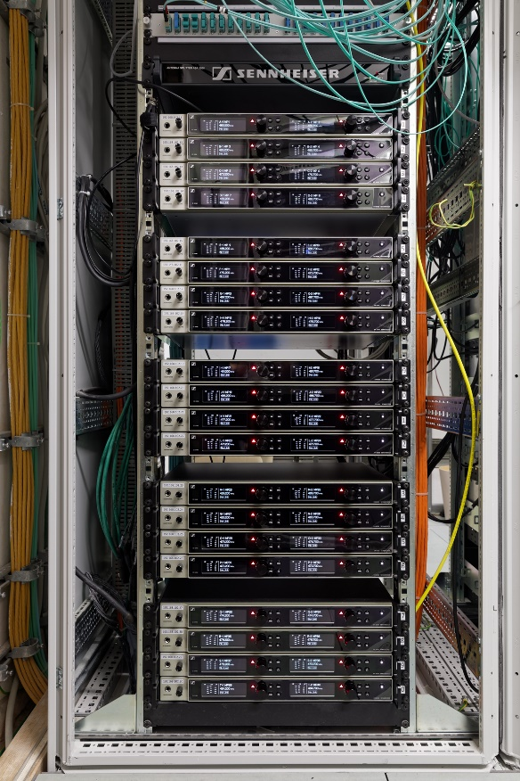 | The Gärtnerplatztheater has 20 EM 6000 two-channel receivers from the Sennheiser 6000 series in use

Frequency management with WSM software
At the Gärtnerplatztheater, the Sennheiser Digital 6000 systems are operated in the A1 - A4 frequency segment (470 - 558 MHz). AD 3700 are used as active broadband directional antennas and are placed in the same positions as their predecessors, using the wiring already available in the theatre.

The antennas are connected to a Sennheiser ASA 3000 antenna splitter that supplies signals to three cascaded groups, each with eight EM 6000. If the number of receivers rises in the future, more outputs are available on the splitter. Buttgereit says that the range of the wireless connections during performances is “completely unproblematic, as we only work in an enclosed space that is a manageable size”.

The frequencies that are used in the individual performance venues at the Gärtnerplatztheater were calculated using the Sennheiser WSM (Wireless Systems Manager) software when the systems were set up in summer 2021 and, according to Buttgereit, they have not been changed since then. “This is a fixed installation in which normally nothing fundamentally changes. We have been using the new Sennheiser Digital 6000 systems for more than a year now. So far, we haven’t noticed any interference or other artefacts that might make it necessary to change individual frequencies.”

The Gärtnerplatztheater has combined the EM 6000 microphone receivers with ultra-compact SK 6212 bodypack transmitters | 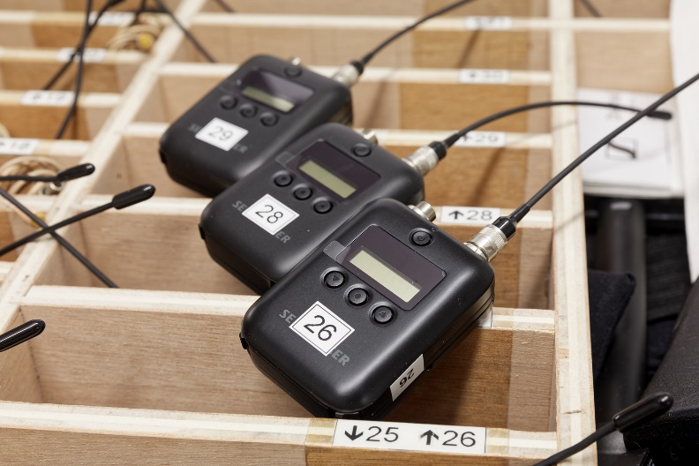

Before the performances begin, the Sennheiser bodypack transmitters and their microphones are handed out to the performers from a mobile workplace. This so-called “service station” is located in a corridor near the access area to the stage and, in addition to bodypack transmitters, headsets, and microphones, it also provides all the necessary accessories, including various adhesive plasters that are needed to attach the tiny microphones to the performers’ skin. The sound engineers can keep an eye on all the relevant parameters of the wireless connections with the aid of the WSM software installed on a laptop.

Impressive battery technology
The handheld and bodypack transmitters used at the Gärtnerplatztheater are powered by Sennheiser BA 60 and BA 62 rechargeable lithium-ion battery packs. The corresponding charging infrastructure is grouped around six L 6000 charging stations with 22 LM 6062 charging modules for the bodypack transmitter batteries and four LM 6060 charging modules for the handheld transmitter batteries. Buttgereit is impressed: “The charging stations are integrated into the network, which enables us to remotely monitor the capacities of the battery packs being used. The battery life of up to 13 hours is outstanding and more than sufficient for a normal day in our theatre. There is a display that shows the remaining battery life in hours and minutes, and you can absolutely rely on it to be accurate.”

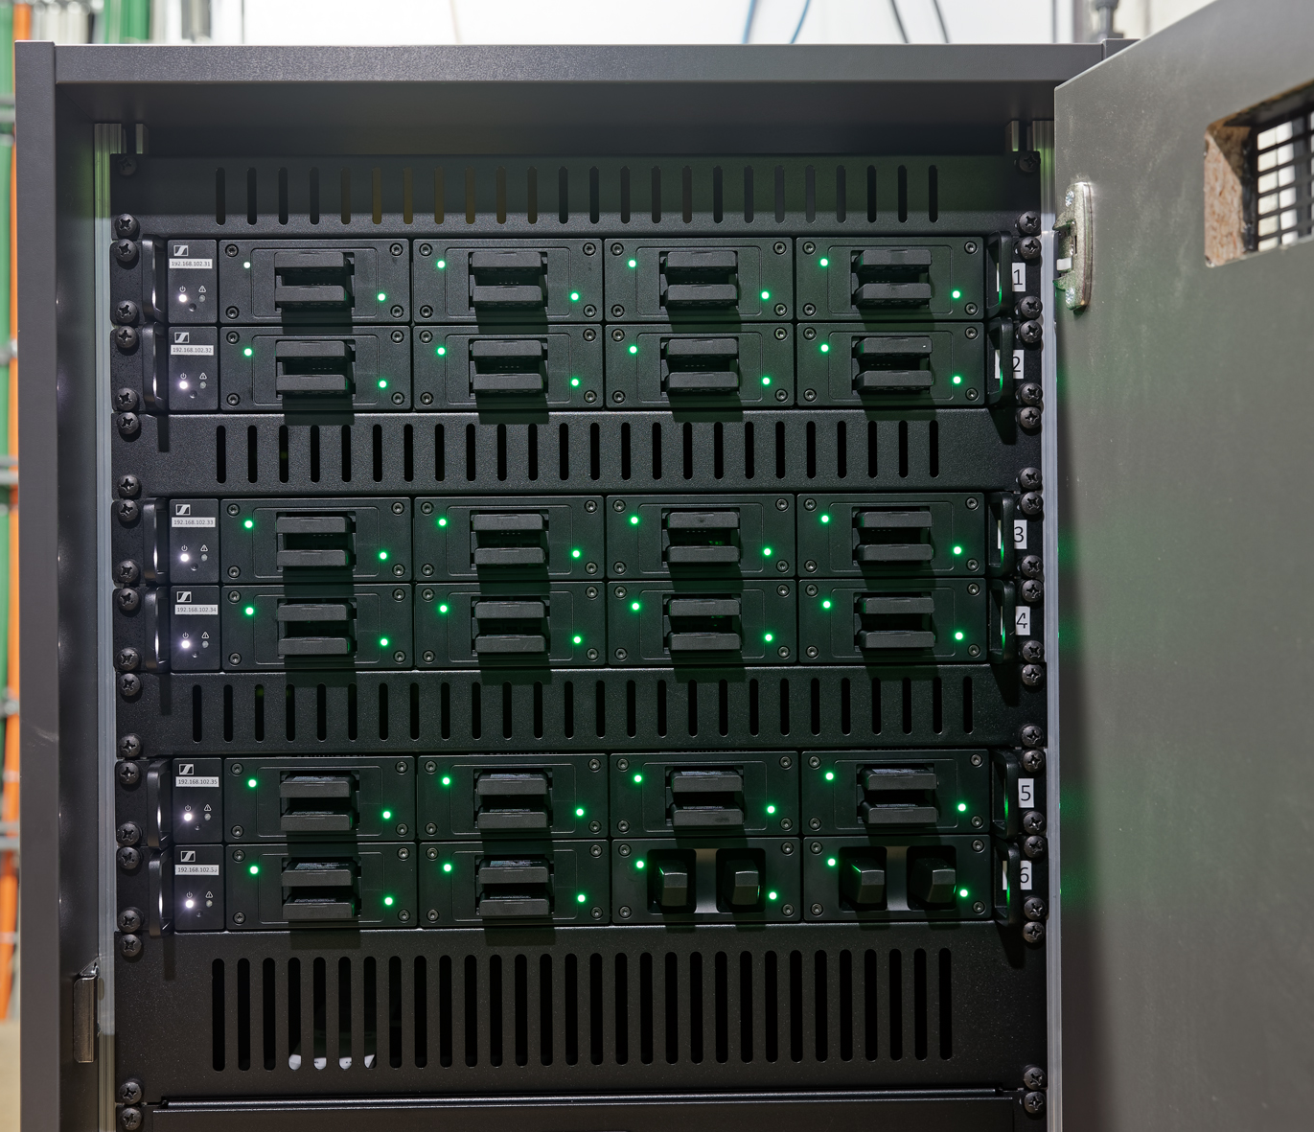 | Six L 6000 charging stations provide power for the batteries

Future-proof systems
The Sennheiser Digital 6000 wireless systems were supplied by SALZBRENNER media GmbH. The contact partner on behalf of Sennheiser was Roland Bachmann (Account Manager Pro | AV). “We are really pleased and proud that the Gärtnerplatztheater has been placing its trust in Sennheiser wireless systems for decades,” says Bachmann. “By installing the ground-breaking Digital 6000 systems, the Gärtnerplatztheater is excellently equipped for the most demanding sound requirements and has systems that are future-proof.”

Roland Bachmann from Sennheiser | 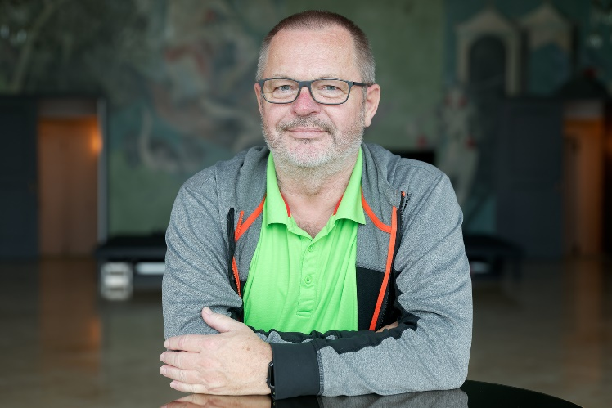

Reliable with excellent sound
Buttgereit is more than satisfied with the Digital 6000 systems: “The systems are absolutely reliable. Noise is not an issue at all with digital transmission, and because the channels have no intermodulation, there’s no problem in equipping the main actors with two bodypack transmitters and two headsets during performances. This regularly occurs at our theatre to ensure secure transmission, and our costume department has even made special straps with pockets to hold the SK 6212. The Sennheiser Digital 6000 systems provide excellent sound, and after our decades of positive experience with wireless systems from Sennheiser, we wouldn’t have expected anything else!”

The high-resolution images accompanying this media release can be downloaded here.

About the Sennheiser brand
We live and breathe audio. We are driven by the passion to create audio solutions that make a difference. Building the future of audio and bringing remarkable sound experiences to our customers – this is what the Sennheiser brand has represented for more than 75 years. While professional audio solutions such as microphones, meeting solutions, streaming technologies and monitoring systems are part of the business of Sennheiser electronic GmbH & Co. KG, the business with consumer devices such as headphones, soundbars and speech-enhanced hearables is operated by Sonova Holding AG under the license of Sennheiser.

www.sennheiser.com
www.sennheiser-hearing.com

Global Pro Audio Press Contact

Stephanie Schmidt
Stephanie.schmidt@sennheiser.com
+49 (5130) 600 – 1275

