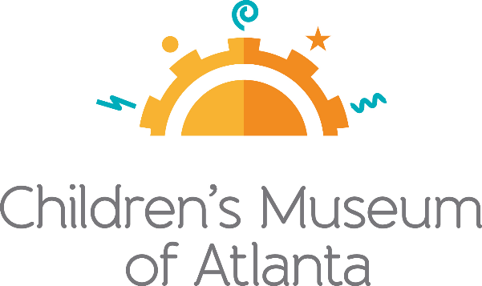

CONTACT
Julia Murphy
BRAVE Public Relations
404.233.3993
jmurphy@emailbrave.com

*MEDIA ADVISORY*
Children’s Museum of Atlanta to debut virtual town square series
Program provides an age-appropriate resource to help parents educate children on important issues in their community

ATLANTA (July 16, 2020) – Children’s Museum of Atlanta has long served as a gathering place where families, educators and others come together to learn about and discuss issues important to the community. Beginning today, July 16, the Museum is launching CMA Town Square: Let’s Talk About . . . a virtual interview series that aims to help families and educators learn about and discuss issues important to our community, as well as provide resources that can help those families have deeper conversations. Weekly guest speakers will discuss topics such as systematic racism, equity in education, mental health and more. During this important time in history, Children’s Museum of Atlanta is proud to offer a program that helps families to dig deeper on how to raise children who want to work to create a more diverse, inclusive and equitable society for all.

Each session will be 30 minutes long, allowing 20 minutes of interview time with the guest speaker and up to 10 minutes of audience Q&A. The sessions will take place on Facebook live stream and will be posted on Children’s Museum of Atlanta YouTube channel with a list of resources.

WHAT: CMA Town Square: Let’s Talk About…
Children’s Museum of Atlanta is proud to offer the Atlanta community a resource that can help families have the hard conversation about systematic racism

WHEN: Thursdays at 10 a.m.
Guest speakers will have a 30-minute conversation with time for Q&A

July 16 – Racism in the Classroom: Cori Cain – Director of Strategic
Partnerships, The Rollins Center for Language & Literacy at the Atlanta Speech School

July 23 – Children’s Intersecting Identities: Stacey French-Lee, Ph. D. – clinical Assistant Professor in the Department of Early Childhood and Elementary Education at Georgia State University, Executive Director of campus Child Development Program

July 30 – Social Justice Resources for Parents: Brian Williams, Ph. D. – Director of the Alonzo A. Crim Center for Urban Educational Excellence, clinical Associate Professor in the Department of Early Childhood and Elementary Education in the College of Education at Georgia State University, known as “Dr. Science” at the Children’s Museum of Atlanta

WHERE: Children’s Museum of Atlanta Facebook
Families are invited to join guest speakers live on Children’s Museum of Atlanta’s Facebook or watch later on Children’s Museum of Atlanta’s YouTube

HOW: This digital series is free and open to the community; for more information
visit: childrensmuseumatlanta.org/cma-town-square

For more information or to support Children's Museum of Atlanta, visit childrensmuseumatlanta.org
or call 404.659.KIDS [5437]

