sennheiser store san francisco to host fashion icon COLLEEN QUEN for immersive sound, ART & FASHION EXPERIENCE on january 17

San Francisco, December 20, 2018 – Audio specialist Sennheiser will host the extraordinary couturier Colleen Quen for an immersive sound, art and fashion experience at its San Francisco store on the evening of January 17th, 2019. The invitation only event will feature an immersive art performance by Ms. Quen, whose designs have been showcased on celebrities including Paris Hilton, Tyra Banks, Vivica A. Fox and Geena Davis and others.

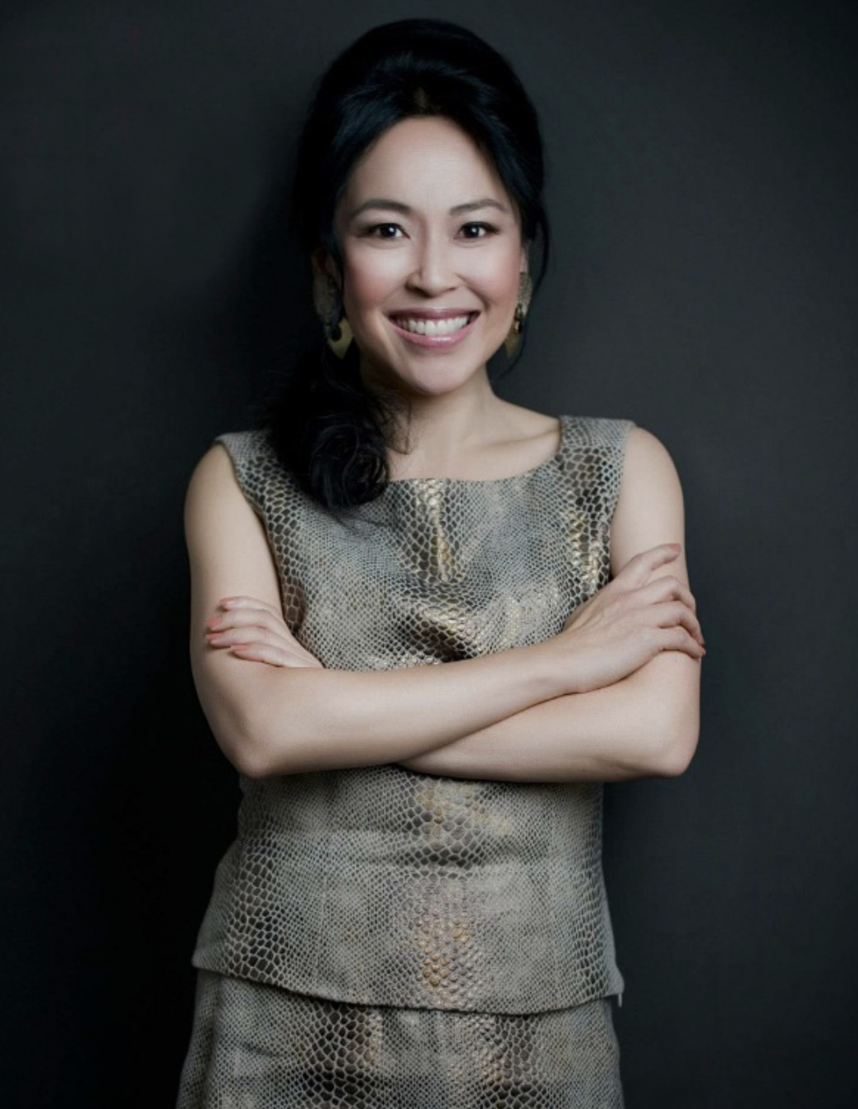
During the event, Ms. Quen — a fourth generation Chinese American and native San Franciscan — will describe her three decades-long journey as a couture designer, fusing the worlds of art, music and fashion. Ms. Quen will then paint a live model, Rachel Earl, who will be wearing a custom-made Sennheiser couture piece.

In addition to enjoying Ms. Quen’s immersive performance, guests will have a rare opportunity to experience Sennheiser’s HE 1 headphone, a masterpiece of audio technology featuring the ultimate sonic purity and timeless beauty.
- Who: Couturier Designer Colleen Quen
- What: Immersive Sound, Art and Fashion Experience
- Where: Sennheiser Store, 278 Post Street, San Francisco
- When: January 17, 2019 between 6:00 p.m. and 10:00 p.m.

- Champagne, wine and desserts will be served and RSVPs will be confirmed on a first-come, first-served basis. To learn more, about Colleen Quen, please visit www.quenlife.com. To learn more about the event or to register, please visit the eventbrite site.

- About Sennheiser
- Shaping the future of audio and creating unique sound experiences for customers – this aim unites Sennheiser employees and partners worldwide. Founded in 1945, Sennheiser is one of the world’s leading manufacturers of headphones, microphones and wireless transmission systems. With 21 sales subsidiaries and long-established trading partners, the company is active in more than 50 countries and operates its own production facilities in Germany, Ireland, Romania and the USA. Since 2013, Sennheiser has been managed by Daniel Sennheiser and Dr. Andreas Sennheiser, the third generation of the family to run the company. In 2017, the Sennheiser Group generated turnover totaling €667.7 million. www.sennheiser.com

- Press Contact

- Jeff Touzeau
- jeff@hummingbirdmedia.com
- +1 (914) 602-2913 +

