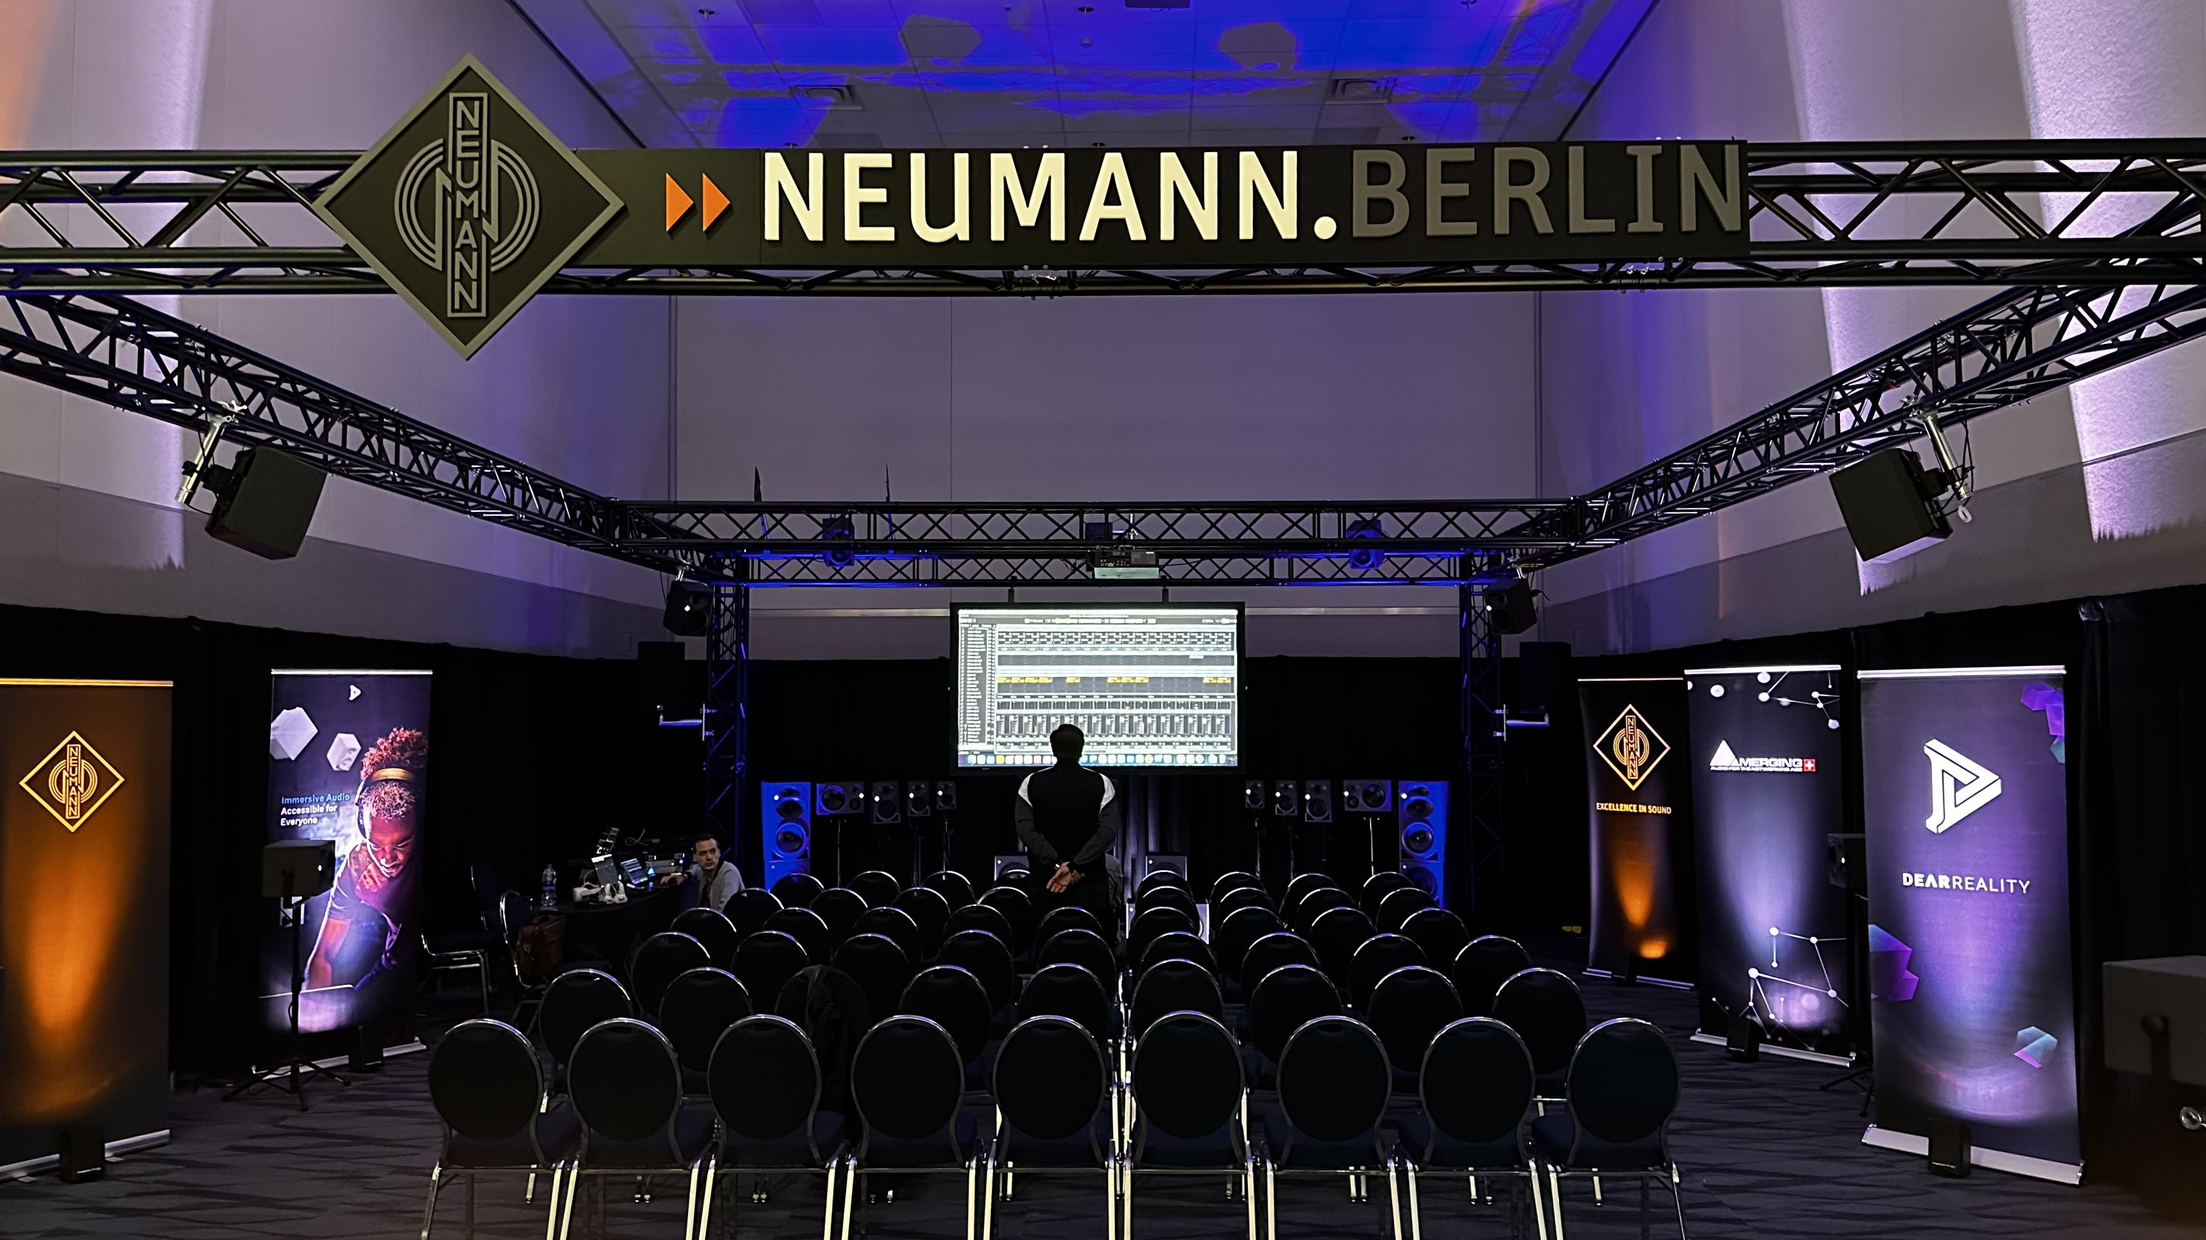

Sennheiser Group brings innovative immersive audio solutions and expert insights to AES NY 2023
Neumann hosts immersive audio panels and presentations featuring Grammy Award-winning engineers throughout the show at Demo Room 3D03

New York, October 11, 2023 – Sennheiser Group (Demo Room 3D03) will be hosting an exclusive series of immersive presentations from Grammy-award winning audio engineers and producers during the 155th AES NY Convention, taking place from October 25th-27th at the Javits Center in New York City. The demo room will also feature a comprehensive lineup of end-to-end immersive recording and mixing solutions, with hands-on microphone testing available to visitors. Highlights on display from Neumann.Berlin will include the KH line of monitors, including the recently released KH 120 II, the NDH 30 open-back headphones, and the company’s groundbreaking MT 48 Interface. With this, Merging Technologies will exhibit the Hapi and Anubis interfaces and Dear Reality its suite of spatial audio production plugins including dearVR PRO, dearVR MONITOR and dearVR SPATIAL CONNECT to enable monitoring, mixing and automating spatial audio in various environments.

The Neumann demo room will be outfitted with a full 9.1.6 immersive system, including two pairs of stereo monitors that will showcase AMBEO 2-Channel Spatial Audio functionality. Here, Neumann will host 11 different presentations featuring Grammy award-winning engineers and producers discussing and demonstrating their most recent immersive mixes on the Neumann immersive system. Additionally, the demo room will celebrate Neumann’s nearly 95-year history with a timeline displaying decades of the brand’s legendary products. The timeline will include beloved modern and classic mics, monitors and more, including but not limited to the U 87, M 149 and KU 80.

Presentation Series: Hear from industry-leading audio experts
Attendees will be treated to exclusive immersive demos and intimate question-and-answer sessions with decorated audio engineers and producers. The lineup of Grammy-winning presenters includes Justin Gray, Andrew Scheps, Ulrike Schwarz and Jim Anderson, George Massenburg, Chuck Ainlay, Jimmy Douglass, Michael Romanowski, Jeff Balding, Fab Dupont, and Morten Linberg. This stacked lineup has collectively worked with music icons ranging from Adele, Alicia Keys, George Strait, The Rolling Stones, Snoop Dogg and more. The complete demonstration schedule below.

TIME | Wednesday  October 25 | Thursday  October 26 | Friday  October 27
11:00am-12:00pm | Justin Gray | George Massenburg | Jeff Balding
1:00pm-2:00pm | Andrew Scheps | Chuck Ainlay | Fab Dupont
3:00pm-4:00pm | Jim & Ulrike Anderson | Jimmy Douglass | Morten Linberg
4:30pm-5:30pm | Audio Educators | Michael Romanowski

Presentations are open to all AES attendees on a first-come, first-served basis. Session dates and times are subject to change.
Up close and personal with Neumann’s microphone locker
The demo room will feature an isolation booth to allow visitors to test out a selection of classic and modern Neumann microphones. Microphones available to try include, but are not limited to the TLM family, U 87, U 67, M 49 V, KMS series stage mics, and the new Miniature Clip Microphone (MCM) system for close-miking instruments. An acoustic guitar will be provided.

With this, Neumann will be showcasing a variety of new products including the KH 120 II monitors, the NDH 30 open-back headphones, and the brand’s first-ever audio interface, the MT 48, developed in close cooperation with Merging Technologies. Boasting an expansive dynamic range, top-tier converters, preamps, and headphone amplifiers, the recently released MT 48 establishes cutting-edge benchmarks in sound fidelity. Its integrated DSP power enables the creation of monitor mixes enriched with advanced EQ and dynamic processing, all effortlessly managed through an intuitive touchscreen interface.
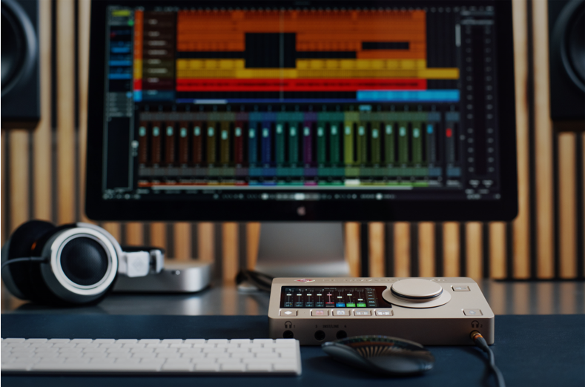
The Neumann MT 48 audio interface and NDH series headphones will be featured at AES NY 2023

WMAS: Experience the future of wireless transmission today
In a separate, closed-to-the-public experience space next door (Demo Room 3D04), VIP customers will have the opportunity to participate in educational sessions about WMAS, the game-changing broadband wireless technology currently in development by Sennheiser. For more information or to request information or VIP access to the WMAS sessions, reach out here.

[ends]

About the Sennheiser Group
Building the future of audio and creating unique sound experiences for our customers - this is the aspiration that unites the employees of the Sennheiser Group worldwide. The independent family-owned company Sennheiser was founded in 1945. Today, it is managed in the third generation by Dr. Andreas Sennheiser and Daniel Sennheiser, and is one of the leading manufacturers in the field of professional audio technology.
sennheiser.com | neumann.com | dear-reality.com | merging.com

Local Press Contacts
Daniella Kohan
daniella.kohan@sennheiser.com
+1 (860) 227-2235

Jeff Touzeau
jeff@hummingbirdmedia.com
+1 (914) 602-2913

Ashley Kinchen
ashley@hummingbirdmedia.com
+1 (504) 616-1683

