Moog’s Model 15 Modular Synthesizer App Is Now Available for macOS Big Sur
Free to all current Model 15 iOS App owners, this update to the award-winning app makes it the first official desktop soft synth from Moog.

See Hi-Res Photos Here

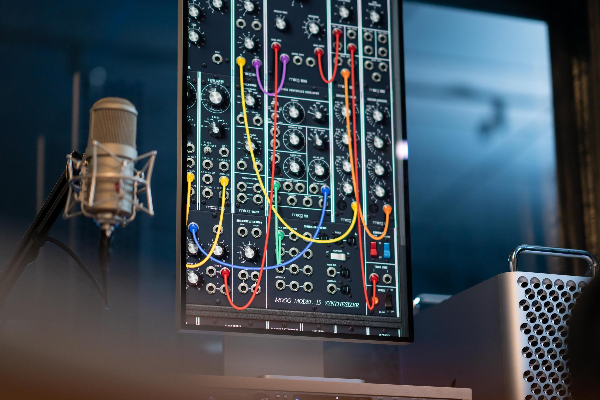

The first Moog modular synthesizer and synthesis educational tool created exclusively for iOS is now also available on macOS Big Sur.

This free update to the Moog Model 15 Modular Synthesizer App, available for Mac users running Big Sur, makes it possible to recreate the sounds and workflow of the classic hardware Model 15 modular synthesizer using a macOS device through Audio Unit v3, or as a standalone sound design tool.

Each facet of the Moog Model 15 modular synthesizer has been meticulously recreated in this application to ensure the power and transcendent sound quality of each module remains intact. The character, harmonic complexity, and mystique of the instrument’s modules—from the legendary Moog 921 series oscillators and 904A Low Pass Filter to the coveted 907 Fixed Filter Bank—have been painstakingly preserved as the app continues to add more value for users.

What’s New
- This update allows for seamless integration with Logic, GarageBand, and MainStage for use in studio and live performance environments. The Model 15 App can be used standalone, as an Audio Unit v3 plugin, or as an effect in your existing audio chain.
- A new expansion pack, free to download for app owners, features 80 modular patches with a range of styles that will inspire both budding synthesists and advanced sound designers alike. From sub-rattling basses to mix-cutting leads, punchy percussion to dynamic pads, the Synthesist’s Toolkit has something for everyone, no matter where you are on your modular journey.
- Seven new built-in tutorials encourage the exploration of modularity, introducing synthesis concepts and unique scenarios an artist would not encounter with hardwired synthesizers. Focusing on the nuances of modular patching, these tutorials are designed to inspire users to discover new levels of depth and movement in their sound.

This added universal compatibility is now included in all future downloads of the Model 15 App (at the same price). If you already own the Model 15 App on your iOS device, no additional purchase or upgrade is required to use the app on your Apple Silicon or Intel based Mac laptop or desktop, and it can be downloaded from your previously purchased items.

Download the Model 15 App Here

More about the Moog Model 15 App
The Moog Model 15 App is an iOS and macOS version of the iconic, ultra-powerful 1970s modular synthesizer. Designed to evoke the joyous experimentation and sonic bliss of its predecessor’s vintage hardware, the Moog Model 15 App meticulously recreates the look, feel, and sound of its highly expressive analog namesake.

The Model 15 Modular Synthesizer App features both monophonic and four-voice polyphonic operation, easily commanded via four seamlessly integrated controllers. Simple controls provide instant access to a traditional Moog keyboard, 1150 ribbon controller, eight-step sequencing arpeggiator, and the award-winning Animoog keyboard with 22 built-in scales and polyphonic modulation capabilities. Also included are extended features which expand the capabilities of the app beyond the traditional offerings of the hardware Moog Model 15, including total MIDI integration. Learn more here.

More about Moog Music
Moog Music is the world’s leading producer of theremins and analog synthesizers. The employee-owned company and its customers carry on the legacy of its founder, electronic musical instrument pioneer Dr. Bob Moog. All of Moog’s instruments are built with love inside its factory in downtown Asheville, North Carolina. Learn more here.

