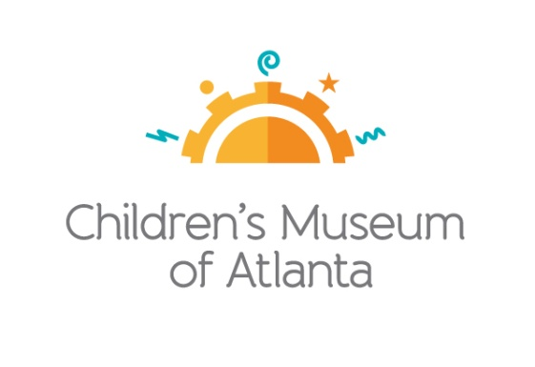

CONTACT
Becca Meyer / Jennifer Walker
BRAVE Public Relations, 404.233.3993
bmeyer@bravepublicrelations.com/
jwalker@bravepublicrelations.com

*MEDIA ADVISORY*
Save on admission to Children’s Museum of Atlanta with Target Free Second Tuesday
Monthly free admission is made possible through generous support of Target

ATLANTA (July 12, 2017) – Children’s Museum of Atlanta invites local families to visit the Museum free of charge on the second Tuesday of each month with Target Free Second Tuesdays! Through the aid of Target, visitors can explore the Museum’s six permanent, interactive exhibits as well the ever-changing traveling exhibit.

Registration for Target Free Second Tuesdays will be available exclusively online through the Museum’s website (childrensmuseumatlanta.org) the day prior to each event to create a seamless process for guests. Reservations for the August 8 Target Free Second Tuesday will open on August 7. Families will be limited to six tickets per registration. Patrons will be able to choose from two sessions listed below:

- Session 1: 1 p.m. – 3:15 p.m.
- Session 2: 3:45 p.m. – 6 p.m.

Guests who do not register in advance will be admitted on a first come, first serve basis pending availability.

WHAT: Target Free Second Tuesdays
Families can receive free admission during select hours on the second Tuesday of every month

WHEN: Second Tuesday of every month
Upcoming 2017 dates: Registration Opens:
August 8 August 7
September 12 September 11
October 10 October 9
November 14 November 13
December 12 December 11

WHERE: Children’s Museum of Atlanta
275 Centennial Olympic Park Drive, NW
Atlanta, GA 30313

HOW: Beginning August 8, families can guarantee entrance to Target Free Second Tuesday by visiting childrensmuseumatlanta.org.

For more information or to support Children's Museum of Atlanta, visit childrensmuseumatlanta.org
or call 404.659.KIDS [5437]

###

