

Girl Named Tom Takes to The Road with Sennheiser EW-DX System
Following a three-month U.S. tour, band depends on strength of signal, ease of set up and consistency - night after night

Old Lyme, August 21, 2023 – When pop music siblings Girl Named Tom — Bekah, Josh and Caleb Liechty — first set out in 2019 they would travel from city to city and gig to gig in an old minivan. Then, in 2021, Girl Named Tom made history as the first trio to ever win NBC’s The Voice, placing four songs concurrently on the iTunes Top 10 charts, with two of them reaching #1, during the show’s twenty-first season. Now playing to larger audiences in bigger venues across the United States, Girl Named Tom recently wrapped a several-month tour on which they used the new Sennheiser EW-DX digital wireless system for vocals as well as electric and acoustic guitars and the EW G4 wireless in-ear monitoring system for all five musicians in the band.

“We were honored to be the first American touring act performing with this specific set up, and we are thrilled to report that these microphones are the best we’ve ever used, by far,” the siblings commented. “At our first soundcheck, our sound man, Felix, was raving about the system, the strength of signal, the ease of set up and the consistency from night to night, city to city. The sound quality is smooth and consistent, giving us the ability to improve our music immensely — which means when we have an off night, we can’t blame it on technical difficulties!”
And then there were three
The three singers are all using Sennheiser’s MM 435 cardioid dynamic vocal microphone capsule. “I was excited to try out the 435 and it definitely delivered,” says Felix Hunt, who mixes front-of-house, monitors and is also the band’s tour manager. “It has a lot of nice detail, especially for a dynamic mic, but it is still predictable in the way that a dynamic mic should be. I really love the microphones. I like the 435 pretty much better than any other vocal mic I’ve ever used. I’m anxious to try it out on other artists as well.”
The trio’s singing abilities and the choice of microphone all help Hunt create a great mix at every performance. “They have really great mic technique, so we don’t have to use hyper cardioid mics, plus it is a relatively quiet stage. One of our vocalists is right in front of the drum kit, so on a smaller stage I might duck his vocals a little bit when he is not singing.” Otherwise, he says, “I just let the mics stay wide open.”

The EW-DX EM 2 two-channel receiver is available with a range of hardware options, from handheld transmitters, bodypack transmitters, lavalier mics, and more. | 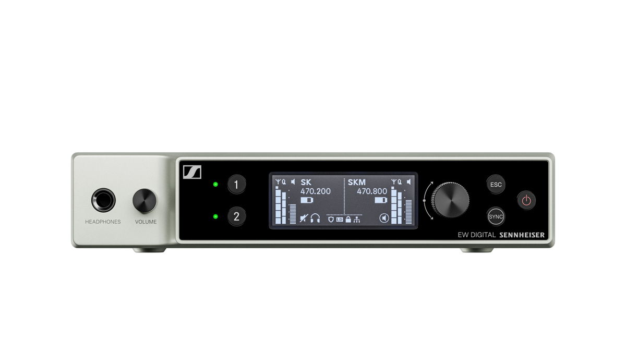

Unparalleled ease of set up: scan and sync
Hunt has been especially impressed by how easy it is to set up the EW-DX system at each show. “It has been a new thing for me with how quickly these mics scan and how easily they sync. Every day I fire them up, I scan and sync them, I hand the band the mics and they are good to go. I’ve never even had to mess with networking, they scan so fast, and I don’t think I’ve ever had to resync, so it is super simple,” he says.

But ultimately, for all the technical capabilities of the system, it’s the sound that matters. The siblings are quick to praise the EW-DX mics for helping them take their vocals to the next level. “When Bekah first sang into the 435 capsule she was amazed at the natural sound of her voice," says band member Joshua Liechty. “And Caleb has reflected multiple times throughout this first tour on how these mics have improved his confidence as a singer. Thanks to the richness of the mic and the clarity of the IEM system, Caleb has been transformed from a confident harmonizer into a confident lead singer when so called.”

They continue, “Our first real experience performing with Sennheiser was onstage with NBC's The Voice. So, we were already familiar with the clarity, the body and the exquisitely textured quality of our voices through Sennheiser capsules. The EW-DX system immediately improved our ability to maintain those qualities while moving around the stage, switching instruments as we often do. With Sennheiser, we’ve found the best technology possible to project our live vocals over a room, theater or arena full of people.”

Girl Named Tom is sibling trio Caleb, Bekah and Josh Liechty (left to right).
EW-DX on acoustic and electric guitars
The band’s touring EW-DX system was also fit for a wireless electric guitar and three wireless acoustic guitars: “We did the first couple of weeks wired, then we went wireless, and everything went really well,” Hunt reports. “Once we get the gain structure settled in, we plug it in every day and it’s the same as wired. For me, the true test of how the wireless works on a show like this is on the artists’ in-ears. If this works well, it will probably sound really good out in front.”

The three singers and the bass player use G4 wireless IEM set ups, with the drummer on a wired body pack. “It is super easy to tune them, and it doesn’t take much time at all,” Hunt says. “I scan the packs every day and then attach the relevant frequencies to the network boxes. There is almost no processing on the in-ears, which is a testament to the mics, for sure. I haven’t had to fuss with sculpting and EQ and they are always really, really happy with their vocal sound.”

Despite playing in some challenging RF environments, Hunt says, the EW-DX system has stood up to the task. “There have been no problems with the reach,” he also comments. “We use one of the mics in the talk back which is carried all around the stage and there are no troubles. We did a dinner-type of show in Alexandria, Virginia, and the band went out into the crowd, singing in the middle of the room, and we had no problems at all with the signal. Also, they were right in front of the P.A. and there were no problems; those mics are really easy to work with in front of the P.A.”

While the trio’s familiarity with Sennheiser began on The Voice, it was the long-standing relationship between Sennheiser Relations Manager Tim Moore and GNT’s manager Jenni Tackett that solidified the partnership. Tim and Jenni have worked together for the better part of a decade across several artists. When Moore reached out about working together it was an enthusiastic yes. “Tim has always taken great care of my artists, not only with the quality of products and sound on stage, but with care and understanding of the artists entire organization,” said Tackett.

Impressive reach and reliability
For the Liechty siblings, it’s all about the live show right now. “We don’t have much original music recorded, so if fans want to hear original music from Girl Named Tom, it’s at a live show. It really matters how these songs spin through the air to our fans and with Sennheiser, they sound clear as a bell. And someday, when we win a Grammy for our live recording, there will be no better way to capture it than with the mics from Sennheiser.” Girl Named Tom will be releasing new original music through Republic records on August 25th. The single “What A View” is available for Pre-Save here: https://presave.umusic.com/girl-named-tom

[ends]

About the Sennheiser brand
Building the future of audio and creating unique sound experiences for our customers - this is the aspiration that unites the employees of the Sennheiser Group worldwide. The independent family-owned company Sennheiser was founded in 1945. Today, it is managed in the third generation by Dr. Andreas Sennheiser and Daniel Sennheiser, and is one of the leading manufacturers in the field of professional audio technology.

sennheiser.com | neumann.com | dear-reality.com | merging.com

Local Press Contacts
Daniella Kohan
daniella.kohan@sennheiser.com
+1 (860) 227-2235

Jeff Touzeau
jeff@hummingbirdmedia.com
+1 (914) 602-2913

