25th Jul,2016

Toyota Motor Corporation, Motorsport Marketing Division

**TOYOTA GAZOO Racing WRC**

**makes a promising start**

Under the mind of making ever-better cars through motorsport, TOYOTA GAZOO Racing WRC team has been working for the development of the Toyota Yaris WRC for nine months. After a great deal of teamwork was put in, the Toyota Yaris WRC enjoyed its first outing this spring on the fast gravel roads of Finland, before heading for southern Europe. This intensive test program has confirmed that the Yaris WRC, which will be competing in the World Rally Championship next season, is a well-designed car.

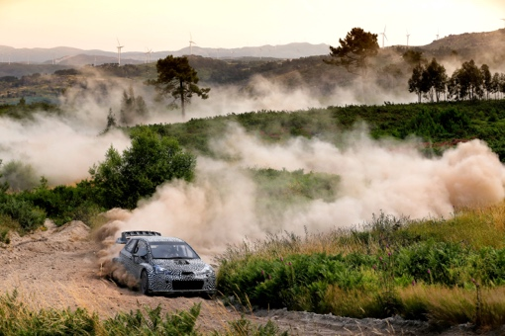

**■Ten test sessions covering some 5,000 kilometers**

Bound by the utmost secrecy but filled with great excitement, the

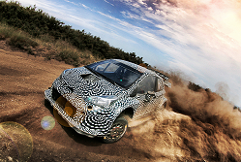TOYOTA GAZOO Racing WRC team undertook the very first shakedown of the Yaris WRC in May of this year, not far from the team's workshops in Puuppola, Finland. This first, highly promising session was followed by many others. Although the Toyota Yaris has now completed over 5,000 kilometres of road testing, it is still in the early stages of its development.

"We have worked hard to be on time" admitted Tommi Mäkinen, Team Principal, TOYOTA GAZOO Racing WRC. "We have completed a lot of test sessions since May and we have stuck to our schedule. The addition of a second car helped us to up the pace and diversify the development testing. We want to test in all conditions and on all surfaces so that we are ready for 2017."

**■Two Toyota Yaris WRCs for greater efficiency**

With a view to fully optimising the development programme, a second Toyota Yaris WRC was quickly added to the test schedule.

"The reason we are working with two cars is that we wanted to split development into two parts. The first team works only in Finland, on the reliability and endurance of the car, with a test programme focused on the engine and gearbox. The second test team is focused on the suspension and is working at the other European bases, such as Spain and Portugal," explained Tom Fowler, WRC Chief Engineer. "We haven't started testing on tarmac as yet, but we can already tell that the performance levels of the car are really high. We have been able to work without any major issues so far and that's very encouraging."

**■A strong test driver line-up**

Tommi Mäkinen, Juho Hanninen and then Jarkko Nikara all had a turn behind the wheel of Toyota Yaris WRC before sharing the development programme on the various roads selected.

"I just couldn't resist, so I was the first to size up the car!" admitted Tommi Mäkinen. "The feeling was great and it was fun to drive as well. We are also lucky to be able to call upon the experience of Juho Haninnen, who is our main test driver, and Jarkko Nikara. Other drivers are expected to join the development team very shortly," he concluded.

"The first time I drove the Yaris WRC, I was very impressed!" explained Juho Hanninen, test driver for the TOYOTA GAZOO Racing WRC team. "The handling and balance of the car were perfect; the work done on the design is exceptional. We have wasted no time in racking up the miles because the car has been very reliable from the word go and we've not been held up by any major technical issues. In the initial tests outside of Finland, we have tackled a wide variety of conditions but the performance of the Toyota Yaris WRC has been very consistent."

**■A passionate team!**

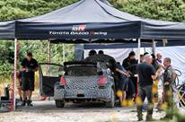Each week, new members join the TOYOTA GAZOO Racing WRC team based in Puuppola, Finland. It's a genuine melting pot of car lovers featuring no fewer than seven different nationalities, all focused on achieving the same goal.

"I’m very fond of the family atmosphere that we have always had in our Puuppola workshops. I have been pleasantly surprised to see that, even though our facilities have grown and we are now employing more and more people, this working atmosphere remains largely unchanged. There are no language barriers here. The team is very united and everyone does their best without compromise. I think that is one of the essential ingredients in a successful team and I'm pleased to see everybody has adopted the same approach and is pulling in the same direction," commented a delighted Tommi Mäkinen, Team Principal, TOYOTA GAZOO Racing WRC.

**Follow us!**

Follow TOYOTA GAZOO Racing WRC via:

Facebook: www.facebook.com/TOYOTAGAZOORacingWRC

Twitter: www.twitter.com/TGR_WRC (@TGR_WRC)

Instagram: TOYOTA GAZOO Racing WRC - @TGR_WRC

YouTube: www.youtube.com/channel/UCCtALHup92q5xIFb7n9UXVg

**Check them out!**

Fancy seeing some action with the Toyota Yaris WRC? Just go here:

<YouTube link to be update on 22nd Jul >

**Picture Data**

You can download the related pictures via the below URL

<http://www.toyota.co.jp/ms/press/>

→ WRC → 2016 Season

Contact for this article

TOYOTA GAZOO Racing PR Office (JAPAN)

Email: tgr_pr@rights-apartment.com

TELL: +81-52-552-0576