Deep Bass with Highest Precision: Neumann Unveils the DSP-Powered Studio Monitor KH 150

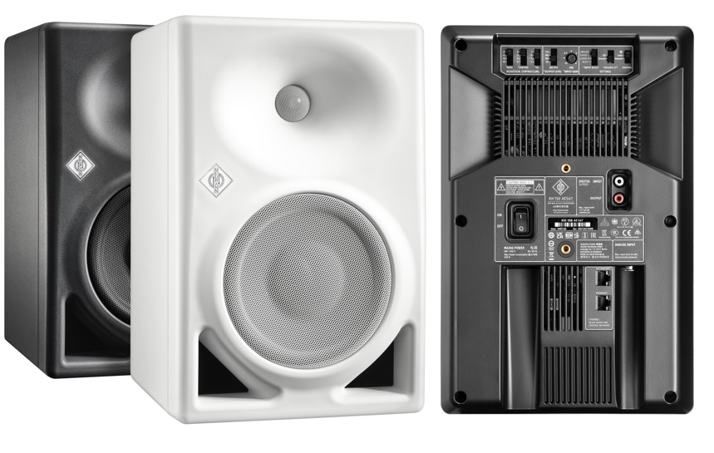

Berlin, Germany, August 22, 2022 – German studio specialist Neumann.Berlin expands its line of reference-class studio monitors with the KH 150. The bi-amplified, DSP-controlled loudspeaker features the same high-resolution tweeter as all Neumann studio monitors and a newly developed 6.5” woofer with ultra-low distortion and high SPL capability. Despite its rather compact format, the KH 150 surprises with outstanding clarity, even at high volume, and extended low-end. The KH 150 has an exceptionally flat frequency response from 39 Hz to 21 kHz (±3 dB) and is recommended for all applications from broadcast to music production. Including styles that require a powerful, deep low-end and/or elevated listening levels such as urban music, EDM, and film scoring.
“The KH 150 closes the gap between the KH 120 and the KH 310, but it does far more than that”, explains Portfolio Manager Stephan Mauer. “Its internal DSP engine offers many benefits such as a phase linearized crossover and a new level in tonal consistency. The KH 150 is made to extremely low tolerances of no more than ± 0.8 dB! And you can hear it, too: Stereo imaging is razor-sharp.”

Digital electronics also allows the KH 150 to be calibrated via Neumann’s MA 1 Automatic Monitor Alignment (sold separately). “The KH 150 follows the same philosophy as all Neumann studio monitors: highest linearity, lowest distortion, no coloration, and perfect adaptability to any acoustic environment”, states Neumann’s CEO Ralf Oehl. “In our pursuit of sonic perfection, we not only optimize every parameter of the loudspeaker itself, we also include the greatest variable: the listening environment. The KH 150’s DSP engine perfectly integrates with Neumann’s game-changing MA 1 Automatic Monitor Alignment for best possible sound in any room.”

In addition, the KH 150 is extremely energy efficient. Neumann engineers took great care to develop a patent pending amplifier technology which combines superior audio performance with the energy efficiency of Class D. Although the KH 150’s amplifiers deliver up to 145 W to the 6.5” woofer and 100 W to the 1” tweeter, they only consume 17 W at idle. Auto-standby reduces power consumption to 0.3 W when the KH 150 has not been used for a while, but can be deactivated.

The KH 150 offers analog and digital inputs (S/PDIF). It will also be available in an AES67 variant with redundant AES67 audio network ports that are fully compliant with broadcast standards such as ST 2110, ST 2022-7 redundancy, and RAVENNA. At the same time, the KH 150 AES67 is compatible with DANTE®-generated AES67 network streams.

The KH 150 and KH 150 AES67 will be available in September 2022. List prices: KH 150 € 1,650 / $ 1,750 ; KH 150 AES67 € 1,895 / $ 1,999. More information at https://en-de.neumann.com/kh-150

- Linear frequency and phase response
- DSP engine for outstanding performance and automatic room alignment via MA 1
- Deep low end down to 39 Hz and high SPL capability
- Analog and S/PDIF connectivity, optionally with AES67

About Neumann
Georg Neumann GmbH, known as “Neumann.Berlin”, is one of the world’s leading manufacturers of studio-grade audio equipment and the creator of recording microphone legends such as the U 47, M 49, U 67 and U 87. Founded in 1928, the company has been recognized with numerous international awards for its technological innovations. Since 2010, Neumann.Berlin has expanded its expertise in electro-acoustic transducer design to also include the studio monitor market, mainly targeting TV and radio broadcasting, recording, and audio production. The first Neumann studio headphones were introduced in 2019, and since 2022, the company has put an increased focus on reference solutions for live audio. Georg Neumann GmbH has been part of the Sennheiser Group since 1991, and is represented worldwide by the Sennheiser network of subsidiaries and long-standing trading partners.

Press Contact Neumann:
Andreas Sablotny
andreas.sablotny@neumann.com
T +49 (030) 417724-19

