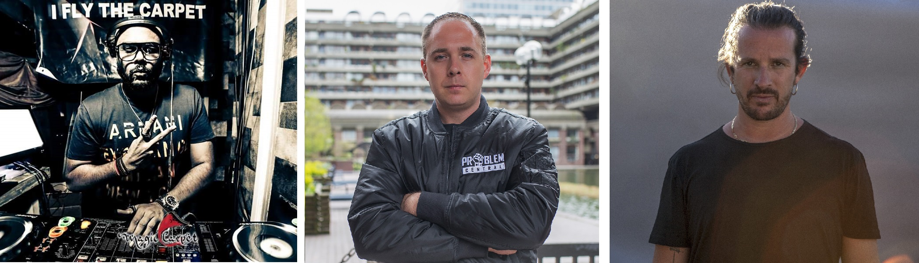

#DontStopTheMusic

Live concerts waiting for you to enjoy!

Wedemark/Germany, April 30, 2020 – Sennheiser’s #DontStopTheMusic series continues bringing great performances to enjoy from the comfort of your home: Luciano is back and DJ Milan, Logan D and ReneShades will also be performing!

Live concert streams from Friday, May 1 to Friday, May 8
Please follow @sennheiser on Instagram and switch on notifications in IGTV to receive alerts, as dates and artists may be subject to change at short notice. Some concerts will be streamed via Sennheiser’s Facebook channels.

- DJ Milan (@djmilansg):
Friday, May 1 at 14:00 UTC (10:00 New York time, 16:00 Berlin time)
- Logan D (@logand1983) – live on Facebook:
Friday, May 1 at 17:00 UTC (13:00 New York time, 19:00 Berlin time)
- ReneShades (@reneshades):
Tuesday, May 5 at 17:00 UTC (13:00 New York time, 19:00 Berlin time)
- Luciano (@magikluciano) – live on Facebook:
Wednesday, May 6 at 15:00 UTC (11:00 New York time, 17:00 Berlin time)
- DJ Mendy (Mendy Indigo) (@mendy_indigo):
Friday, May 8 at 14:00 UTC (10:00 New York time, 16:00 Berlin time)
- Evil B vs B Live (@badjames247):
Friday, May 8 at 16:00 UTC (12:00 New York time, 18:00 Berlin time)

* A note on the time zones
The concert times are given in Coordinated Universal Time (UTC), with EDT and CEST added for convenience. EDT is short for Eastern Daylight Time, which is four hours behind Coordinated Universal Time. EDT is the time in New York, for example. CEST is Central European Summer Time, which is two hours ahead of UTC – Berlin or Wedemark time, for example.

More music
Please also check out http://www.sennheiser.com/anniversary for the next livestream dates and a great selection of music videos to watch and listen to. Just put on your headphones (or turn up the speakers) and immerse yourself in immersive jazz club recordings, electro sets, or live takes from recording studios.

It’s free but why not donate to fight the coronavirus?
At Sennheiser, we’re delighted to be working with these fantastic artists to help spread positivity by putting on exclusive concerts. They’re totally free, but if you do want to say thank you, do consider supporting the WHO in its fight against the coronavirus:
https://www.who.int/emergencies/diseases/novel-coronavirus-2019/donate

For your social media channels:
Enjoy your favorite artists at home and check out the exclusive concerts in Sennheiser’s (@sennheiser) streaming concert series – live on Instagram and Facebook!

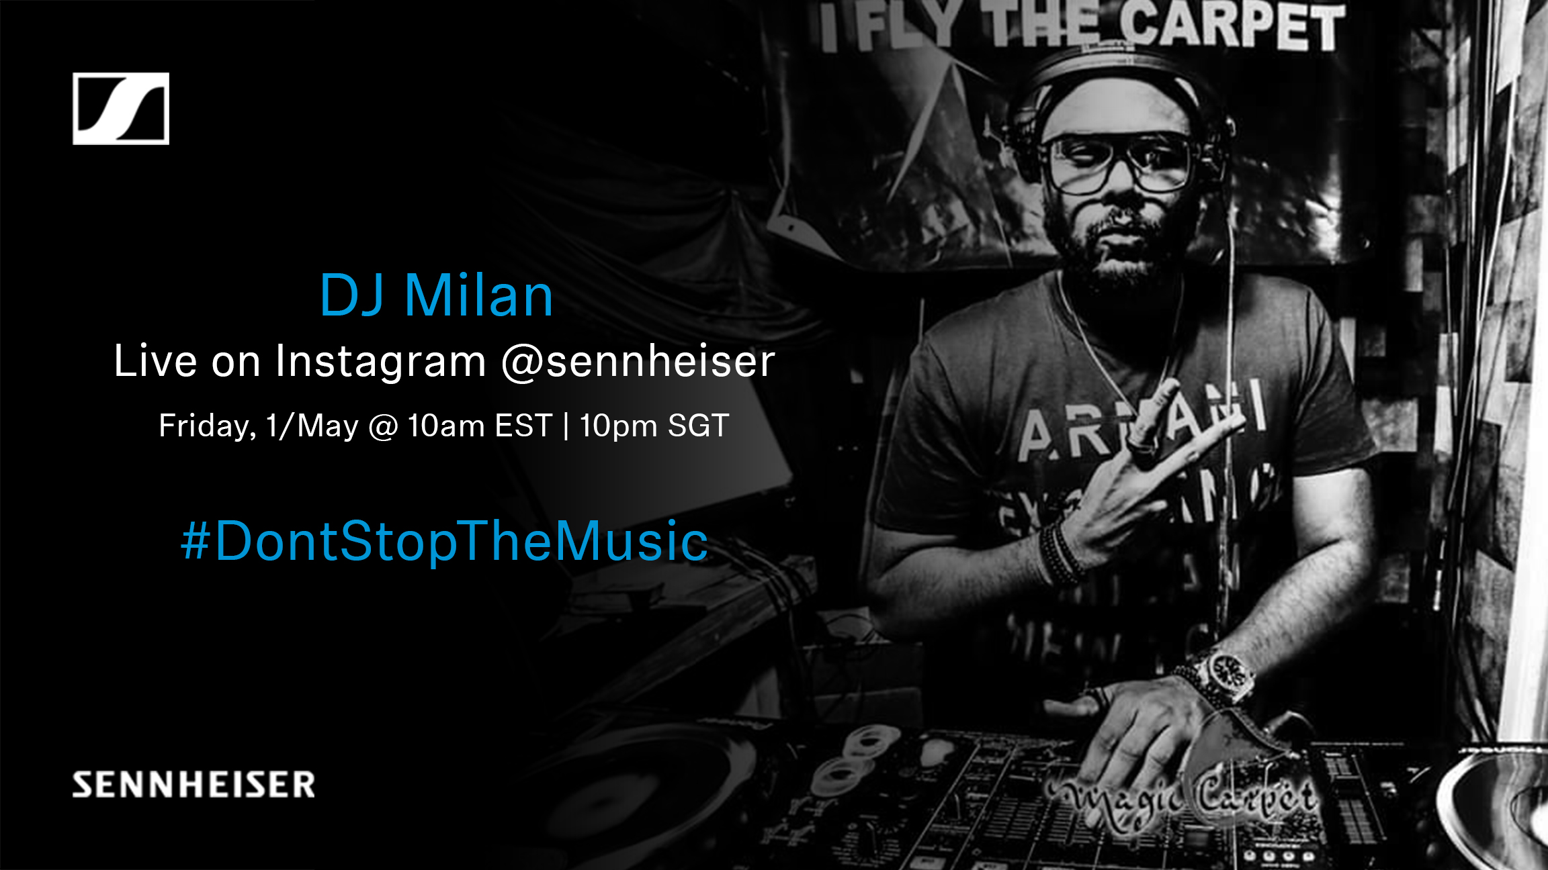 | 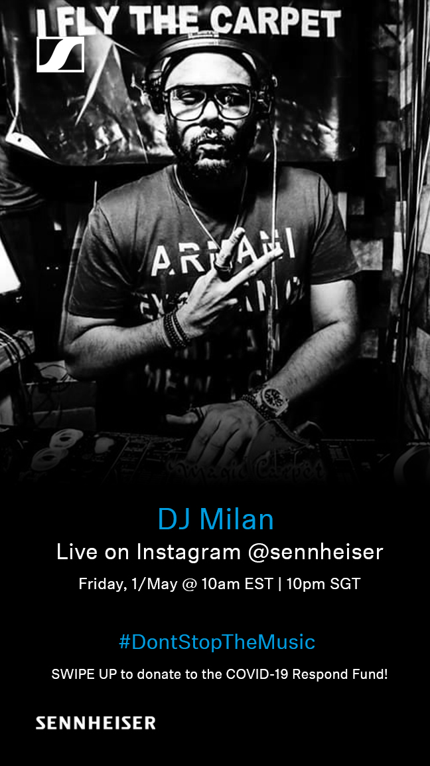
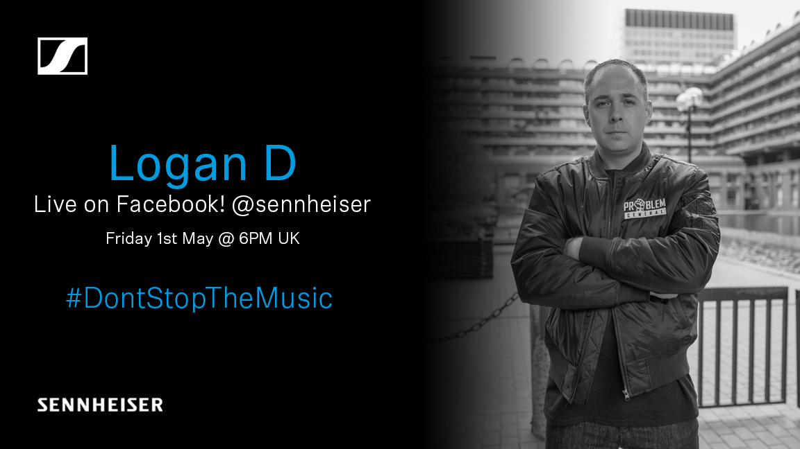 | 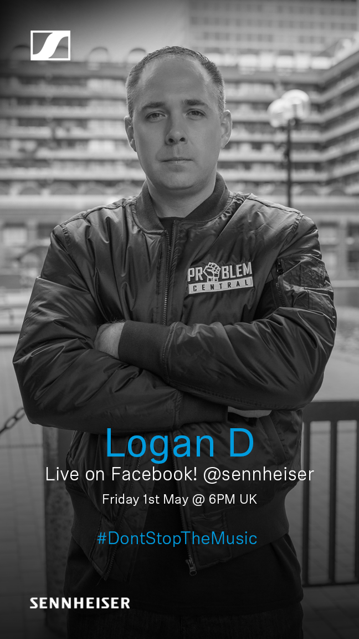
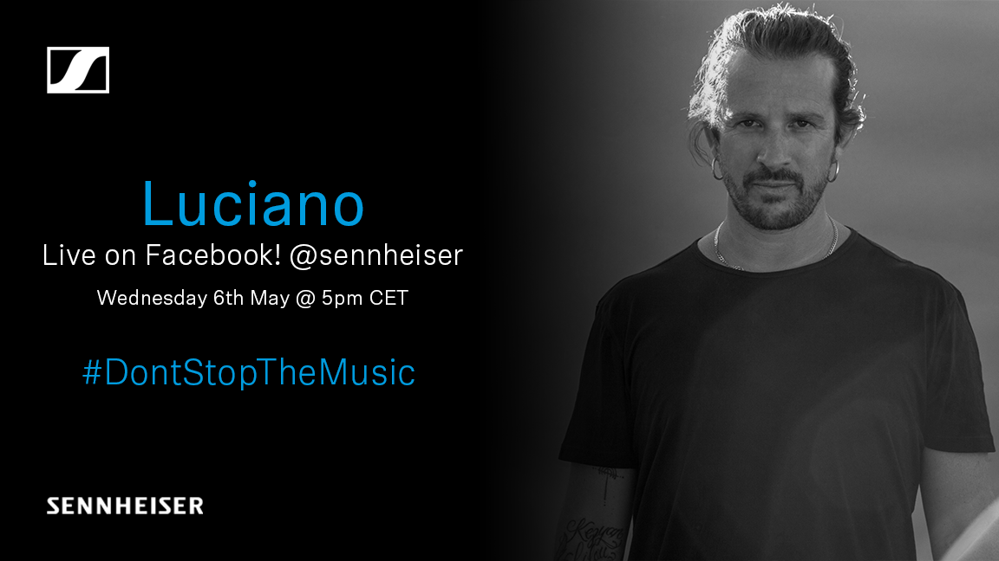 | 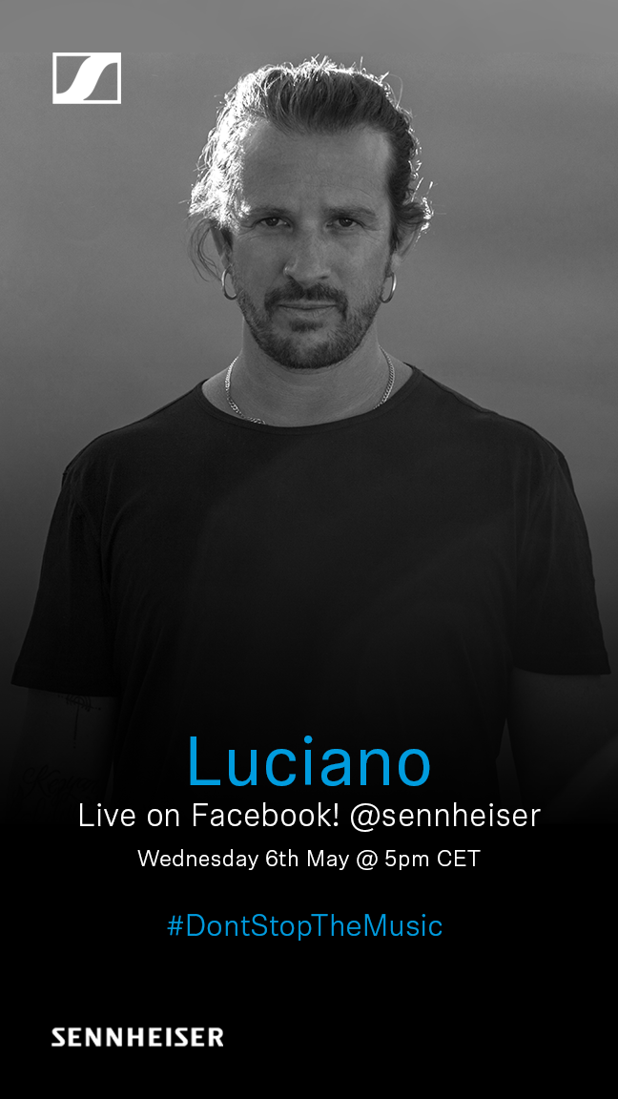

About Sennheiser
Founded in 1945, Sennheiser is celebrating its 75th anniversary this year. Shaping the future of audio and creating unique sound experiences for customers – this aim unites Sennheiser employees and partners worldwide. The independent family company, which is managed in the third generation by Dr. Andreas Sennheiser and Daniel Sennheiser, is today one of the world’s leading manufacturers of headphones, loudspeakers, microphones and wireless transmission systems. In 2018, the Sennheiser Group generated turnover totaling €710.7 million. www.sennheiser.com

Press Contacts

Mareike Oer Stephanie Schmidt
mareike.oer@sennheiser.com stephanie.schmidt@sennheiser.com
T +49 0(5130) 600 – 1719 T +49 0(5130) 600 – 1275

