Neumann’s MCM: The Preferred Microphone for South Korean Musicians

Berlin, Germany, October 2023 – Neumann.Berlin, the legendary studio specialist, is the preferred audio brand for musicians in South Korea. The Miniature Clip Microphone System (MCM) has been making waves since its release, and musicians around the world have experienced how the MCM is raising the bar of electret capsules with its superior audio quality and its reliability. With acclaimed artists like Jang Ha-eun (classical guitarist), Mellow Kitchen (saxophonist), and KoN (violinist) joining the ranks of MCM users, it is evident that Neumann's MCM is setting new standards in the world of microphones.

Jang Ha-eun – A Rising Star in the Music Scene

Jang Ha-eun is a popular South Korean singer and classical guitarist who has made a name for herself on the international stage. Most notably, she was one of the finalists at the popular South Korean talent show “Superband 2” and performed at Carnegie Hall in New York with the Union City Orchestra. Her collaboration with prestigious orchestras such as the Seoul Grand Philharmonic Orchestra and the Bolshoi Theatre National Opera Orchestra have further showcased her exceptional guitar skills and musical talent.

As a musician, sound quality is of utmost important to Jang Ha-eun, and the MCM has solved some of the greatest challenges that she often faced on stage.

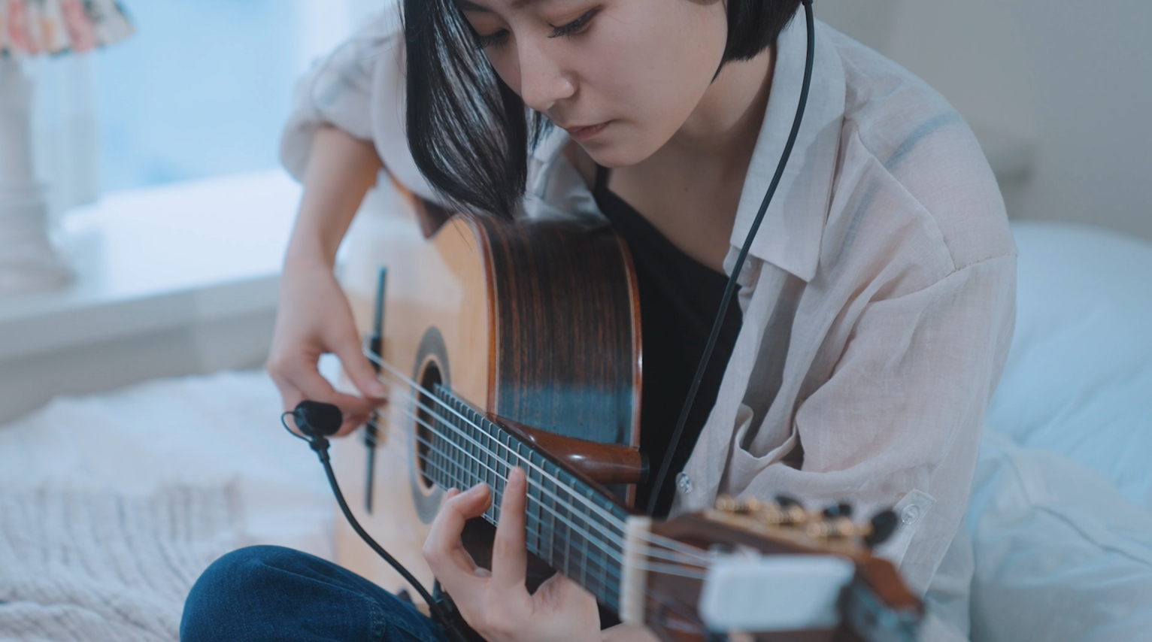
The Neumann MCM was a game changer for guitarist Jang Ha-eun

“I always aim to achieve the best sound quality for all my performances. However, dealing with challenges like feedback issues and the hassle of setting up complicated equipment makes it hard to deliver a seamless performance. This is why my experience with the Neumann MCM microphone was a real game-changer,” shared Jang Ha-eun.

“It delivers a well-balanced audio output that captures both the sharp highs and delicate lows with incredible precision. What's really special about it is how it can add a sense of depth to the sound, creating an immersive experience for the audience. Plus, it is easy to carry around, and you don't need extra stands or holders to set it up.”

Mellow Kitchen – a multifaceted artist

Mellow Kitchen is a South Korean composer and saxophonist who has gained popularity in the mainstream media through his performances in album recordings and at live sessions for famous artists such as Shin Seung-hun, Shinhwa, Epik High, Sistar, Brown Eyed Soul, and Park Jae-jung. He also appeared in various music programmes across major broadcast networks. With a growing fanbase, Mellow Kitchen held his first solo and sold-out concert in 2019 and released his first full-length album “Beautiful Day” in 2021.

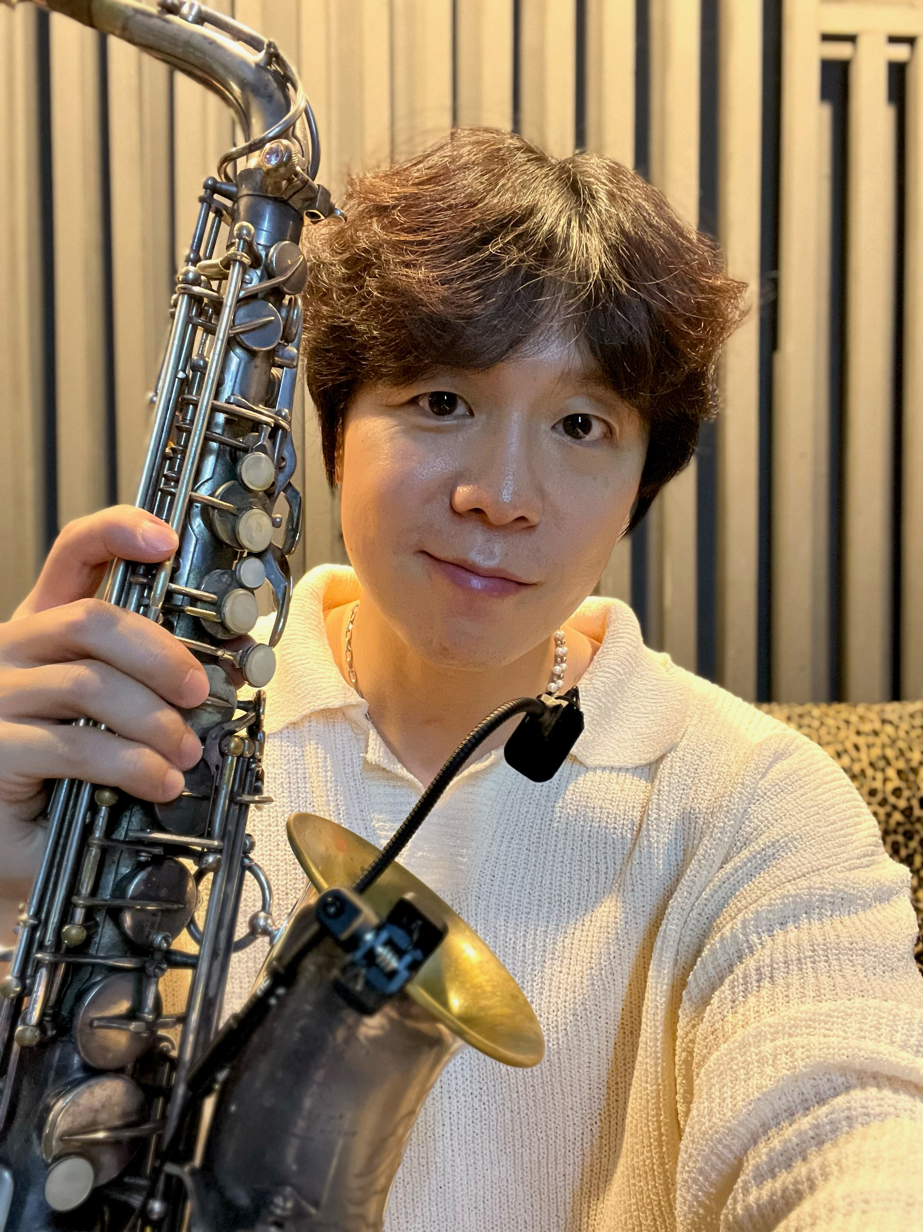
Mellow Kitchen shared that discovering the Neumann MCM is akin to finding the perfect musical partner

Mellow Kitchen shares his experience using the Neumann MCM: “When it comes to creating the perfect sound, microphones can sometimes fall short. But then, we were introduced to the Neumann MCM and it was truly like a breath of fresh air in the world of sound. If felt like we our usual input of 100% effort is giving us 120% in terms of sonic richness. It was like a lightbulb moment for sound quality, elevating every note we played,“ explained Mellow Kitchen.”

“But it wasn't just about volume. The MCM microphone brought out details that we didn't even know existed. It handled nuanced frequencies well and effortlessly balanced the highs and lows. It was like finding the perfect musical partner, and we haven't looked back since.”

KoN – South Korea’s first Gypsy Violinist

KoN is a renowned classical violinist with a global presence, having performed at various concerts and music festivals around the world. He specializes in a wide range of music genres such as classical, jazz, pop, tango, and pioneered the gypsy violin genre in South Korea.

One of KoN’s most notable performances took place during the 2022 South Korean presidential election coverage on KBS where he played the violin atop the Lotte World Tower, the tallest building in Korea (555 meters), setting a record for “highest violin performance” in Korea. With a demanding schedule of over 100 performances annually, it is no surprise that he is always searching for the perfect microphone that can help him achieve the most perfect sound.

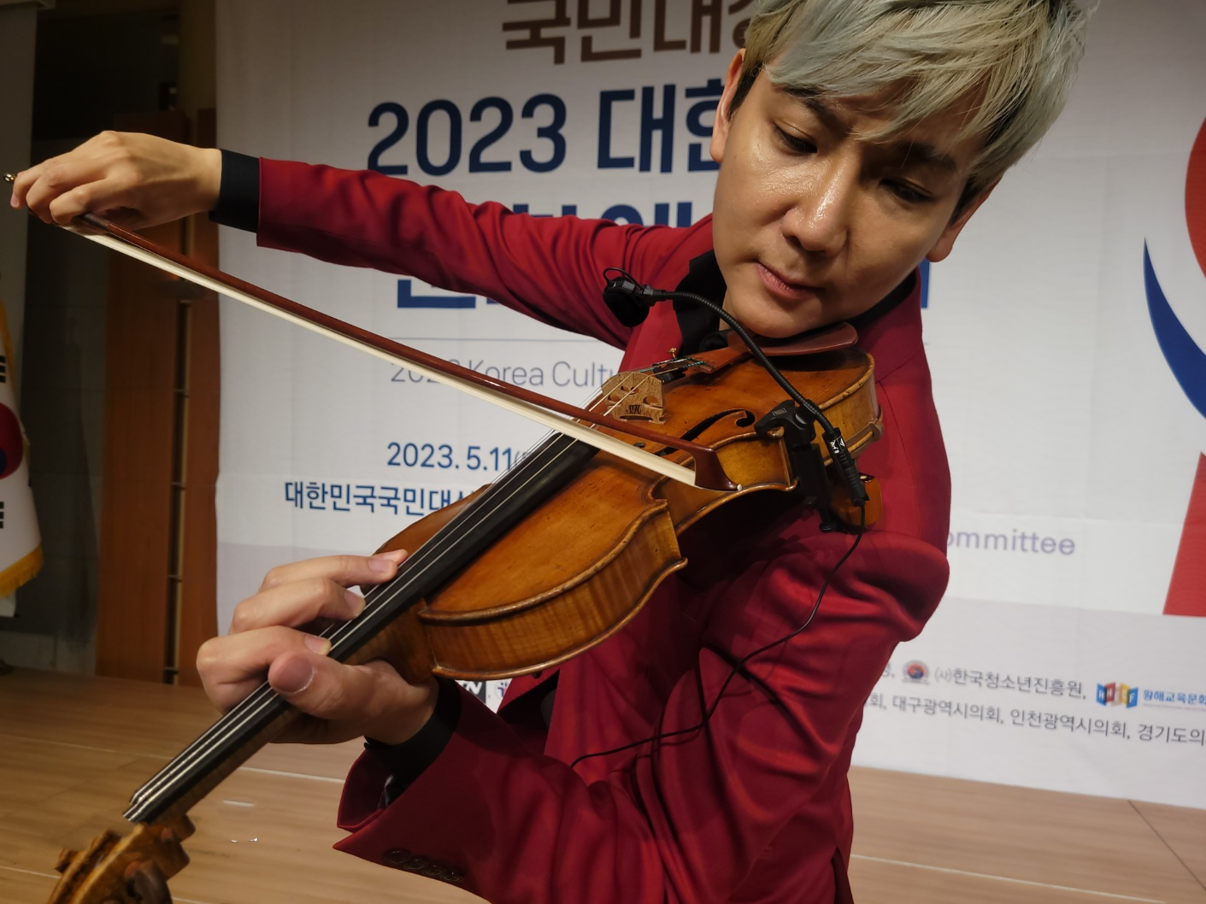
Classical violinist KoN performed with the Neumann MCM at an event in South Korea

“What matters most to me as a violinist is how well a microphone captures the instrument's true sound. The MCM stands out remarkably, closely resembling the original violin sound. It's my top choice when performing,” KoN explained.

“MCM's exceptional balance across high, mid, and low frequencies suits both the warm and enveloping tone of an old violin and the energetic and powerful tone of a modern one. It preserves the warm texture characteristic of Neumann microphones, akin to recording with a Neumann condenser microphone in a studio setting. Among the microphone options I've used for violin, MCM is undoubtedly the best.”

Links to short video documentary:
Korean with English subtitles: https://youtu.be/aDNd7XBJGXw
Korean without subtitles: https://youtu.be/1LvXyRT9V74

About Neumann
Georg Neumann GmbH, known as “Neumann.Berlin”, is one of the world’s leading manufacturers of studio-grade audio equipment and the creator of recording microphone legends such as the U 47, M 49, U 67, and U 87. Founded in 1928, the company has been recognized with numerous international awards for its technological innovations. Since 2010, Neumann.Berlin has expanded its expertise in electro-acoustic transducer design to also include the studio monitor market, mainly targeting TV and radio broadcasting, recording, and audio production. The first Neumann studio headphones were introduced in 2019, and since 2022, the company has increased its focus on reference solutions for live audio. With the introduction of the first audio interface MT 48, and its revolutionary converter technology, Neumann now offers all the necessary technologies needed to capture and deliver sound at the highest level. Georg Neumann GmbH has been part of the Sennheiser Group since 1991 and is represented worldwide by the Sennheiser network of subsidiaries and long-standing trading partners. www.neumann.com

Press Contact APAC:
Phang Su Hui
suhui.phang@sennheiser.com
T +65 91595024

Press Contacts Global:
Andreas Sablotny
Andreas.Sablotny@neumann.com
T +49 (030) 4177 24 – 19

Raphael Tschernuth
Raphael.Tschernuth@neumann.com
T +49 (030) 4177 24 – 67

