

Biuro prasowe better. gaming agency
bettergamingagency.prowly.com

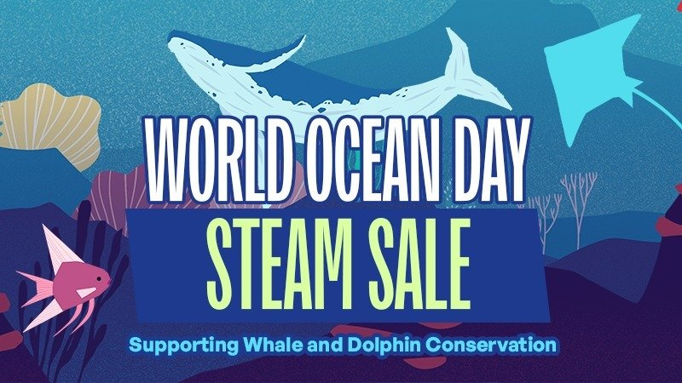

Dive into deals… and help the ocean – a special Steam sale for World Ocean Day launches today!

Starting today, until June 12, Steam users can once again support a good cause celebrating the upcoming World Ocean Day (June 8). As part of the special sale, selected titles will be available at discounted prices, with participating developers and publishers donating a portion of their profits (after Steam fees) to Whale and Dolphin Conservation (WDC) – a global charity dedicated to protecting whales, dolphins and the ocean.

As part of the festival, over 200 titles are discounted on Steam, with some offers going up to 90% off. Participating games include:

- This War Of Mine: Complete Edition
- Flooded
- House Flipper
- Spilled!
- Still Wakes The Deep
- The Walking Dead: The Telltale Definitive Series
- Phasmophobia
- Among Us

This marks another edition of a growing initiative that has been bringing together developers and players from all over the world to support the ocean and its inhabitants. However, this is just a part of the larger World Ocean Day Festival 2025, which also includes charity livestreams hosted by popular streamers. Donations raised during their special streams will go directly towards the protection of whales, dolphins, and other marine life.

Today we kick off yet another edition of an event that proves, year after year, that we can make a real impact on the world around us. Thanks to our collaboration with our game dev partners, since 2022, we've raised over $1 million, supporting initiatives like WDC’s Safe Seas programme, which tackles threats such as entanglement in fishing nets, climate change, and ocean pollution. The incredible support from developers, publishers, and players is deeply meaningful to us – we’re thrilled to once again be part of this effort with you!

– Sally Ward, WDC’s head of digital partnerships



Why is it important to join and help?

🐳 The ocean produces more oxygen and absorbs more carbon than all our forests combined! Thanks to phytoplankton – tiny organisms that produce oxygen and absorb carbon dioxide - and marine plants, the ocean is responsible for over half of the global oxygen production and absorbs a large portion of CO₂ emissions, playing a key role as a climate regulator.

🌱 Whales help keep the ocean healthy by cycling nutrients and fertilizing phytoplankton. We need a thriving and diverse marine ecosystem, which means more whales, not less.

🎣 Around 300,000 whales and dolphins accidentally die each year by getting entangled in active fishing gear, along with sharks, turtles, and seabirds. Abandoned fishing gear, known as ghost gear, also poses a deadly threat to many marine species with an estimated 11,000 tonnes of fishing gear being lost or discarded in European seas every year - that’s the same weight as the Eiffel Tower.

💙 WDC works with fishing communities around the globe to encourage less destructive fishing practises, collaborates with organisations to help remove deadly ghost gear from the sea, and influences governments and decision makers to create policy change.

If you’d like to learn more about the efforts of Whale and Dolphin Conservation and discover how you can contribute to a cause that affects us all, be sure to watch the video below.

https://www.youtube.com/watch?v=7TmAZSZtikA

I'm proud that our game is part of the initiative. Supporting the cause felt natural to us – after all, Flooded presents a vision of what could happen if we don’t invest in ‘restoring’ the planet on time. One of the game’s key mechanics – the progressive flooding of the map – is a direct metaphor for the consequences of environmental neglect. Partnering with Whale and Dolphin Conservation is a great way to highlight this real-world issue and take a step toward solving it.

– Tymoteusz Piasek, creator of Flooded

The World Ocean Day Steam Sale starts today and will last all week, until June 12. A portion of the revenue from selling the participating titles (after Steam fees) will support Whale and Dolphin Conservation. Alongside the Steam event, live charity streams will be hosted by top creators, raising additional funds for marine life protection.

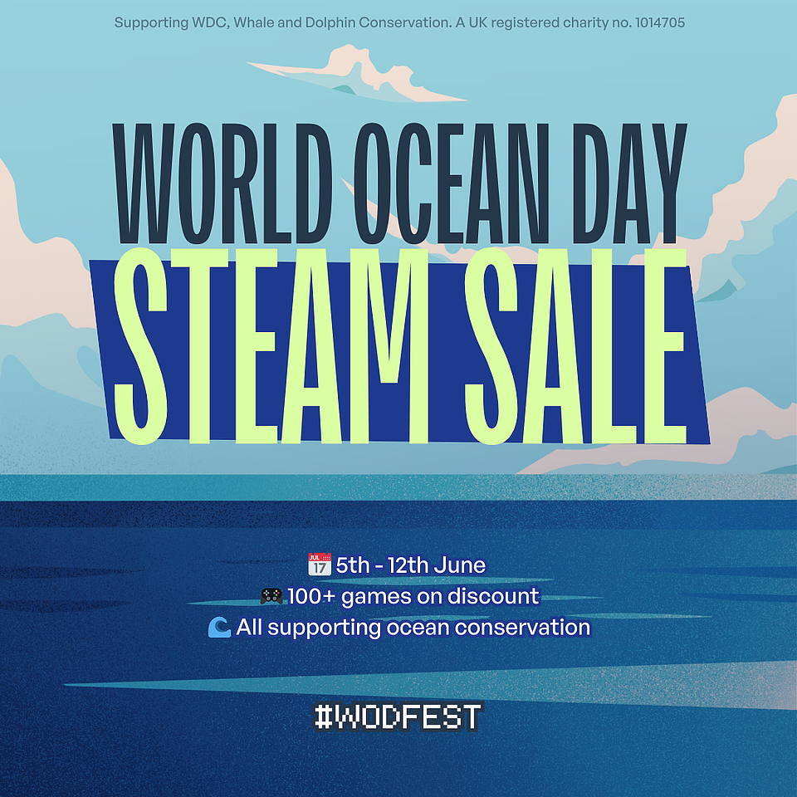

The full press kit is now available HERE.

Learn more:
About the World Ocean Day Festival – LINK
About World Ocean Day – LINK
About Whale and Dolphin Conservation – LINK
About Games for Waves – LINK

About Whale and Dolphin Conservation

Whale and Dolphin Conservation is the leading global charity dedicated to the protection of whales and dolphins.

They work to protect whales and dolphins from the many threats they face today, including marine pollution, hunting and whaling, vessel strikes, entanglement in fishing nets, and capture followed by a life in captivity. WDC advocates for the rights of whales and dolphins as intelligent, sentient creatures and promotes their vital importance in maintaining healthy ocean ecosystems, upon which all living beings rely. WDC works globally through campaigns, lobbying, advising governments, conservation projects, field research, rescue, education and much more. They bring together, and work hand-in-hand with, businesses, philanthropists, scientists, NGOs, governments and grassroots communities to find solutions to the problems faced by whales and dolphins. Their vision is a world where every whale and dolphin is safe and free.

UK Registered charity number: 1014705

