# **iFi GO Pod Air: Same Magic, Now Lighter**

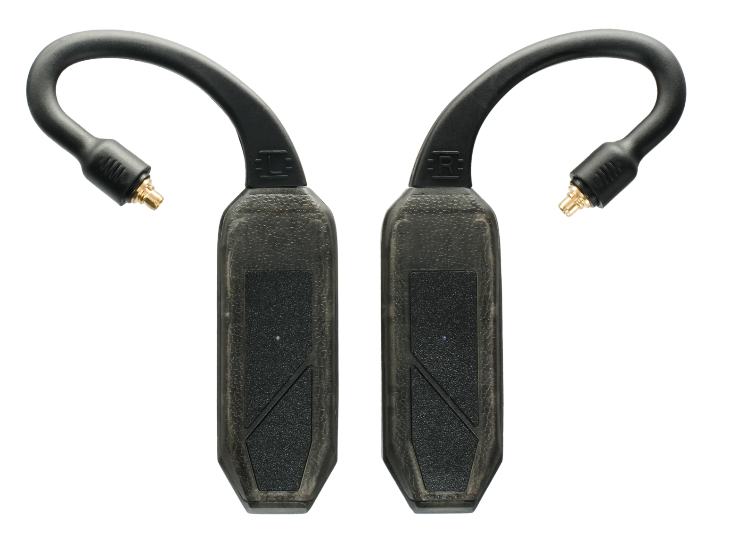 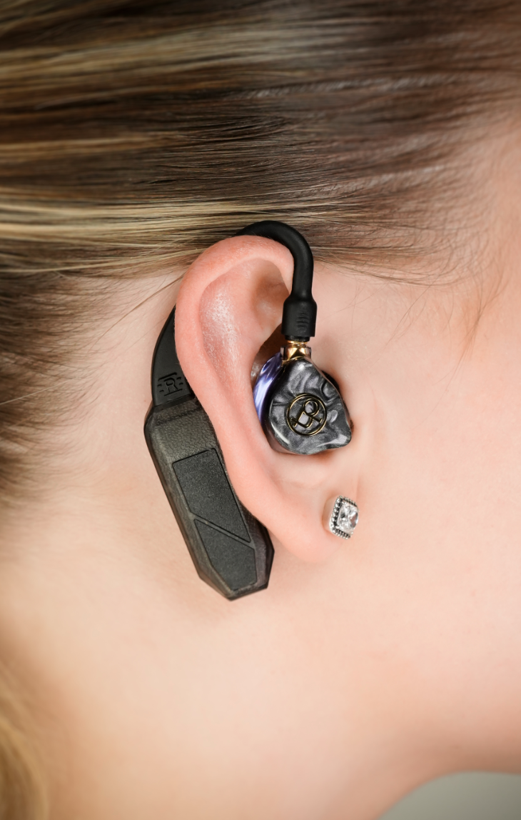

**Southport, UK** – iFi Audio, a trailblazer in audio innovation, is proud to announce the iFi GO Pod Air. More compact, more affordable, yet every bit as capable as its predecessor, the GO Pod Air delivers the same exceptional audio quality in a lighter, more travel-friendly form. Engineered to liberate your wired IEMs from their cables, it combines audiophile-grade architecture with a range of features for work and play - ensuring you’ll never have to leave your IEMs behind again.

While Bluetooth TWS (True Wireless Stereo) earbuds have become a lifestyle staple, many audiophiles are now faced with paying a premium for an inferior listening experience compared to their wired IEMs. iFi has crafted the perfect solution to this dilemma; simply connect your favourite IEMs to one of the many ear loop options, and transform them with Hi-Res Bluetooth compatibility, intuitive touch controls, and noise-free calls.

Despite their diminutive size, each pod features Hi-Fi inspired circuitry, balanced amplification, and intelligent impedance matching - ensuring that no matter what IEMs you’re using, the GO pod Air will make sure you’re hearing them at their best.

### 

**Key Features of the iFi GO pod Air include:**

* Turns IEMs into a Hi-Res Bluetooth System
* Supports 24/96kHz Hi-Res Wireless Audio
* Balanced Amplification with Auto Impedance Matching
* Hi-Fi Circuitry with Cirrus Logic DAC Chips
* Lightweight Case for Ultimate Portability
* Dual Mics with Noise Suppression Technology

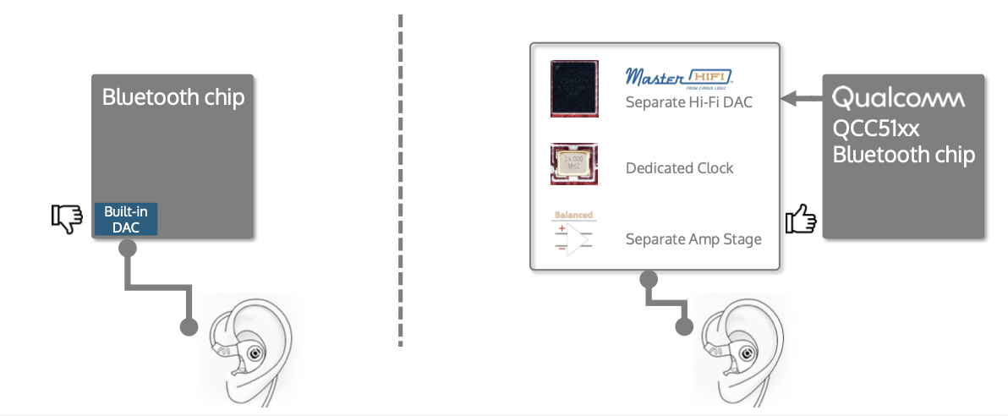

### **Same Magic. Now Lighter.**

Traditionally, Bluetooth audio has meant sacrificing sound quality for the sake of convenience. The GO pod Air breaks the mold, featuring iFi’s award-winning Bluetooth architecture to close the gap and deliver an exceptional audio experience that discerning music lovers seek.

Unlike typical wireless earphones, which rely on a single chip for connection, conversion, and amplification, the GO Pod series sets itself apart with true Hi-Fi architecture. Inspired by high-end Hi-Fi systems, iFi has meticulously designed and optimised each individual stage, using quality components throughout.

Each pod features a premium-tier Qualcomm QCC514x Series chip dedicated solely to Bluetooth reception, which then sends data to a Cirrus Logic MasterHIFI DAC - hand-selected by iFi for its dynamic, engaging sound with minimal battery drain. The signal is then sent to a balanced amplification stage, with a dedicated clock ensuring perfect harmony between all components.

The GO pod Air delivers this exact same audio ‘magic’ but in a lighter chassis - with each pod weighing just 10 grams - and with a case that is now over 40% lighter and nearly 20% more compact than the original.

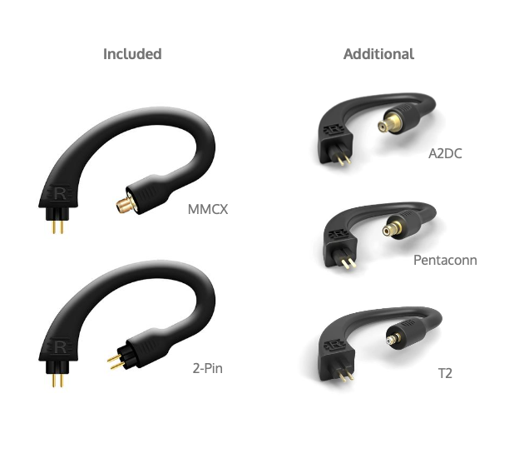

### **Switch and Sync.**

The GO pod Air sports innovative quality-of-life features to ensure maximum compatibility with the wide variety of IEMs on the market.

To start, iFi offers a selection of interchangeable ear loops to suit almost every IEM imaginable. 2-pin and MMCX ear loops are provided as standard, with T2, A2DP, and Pentaconn ear loop options also available.

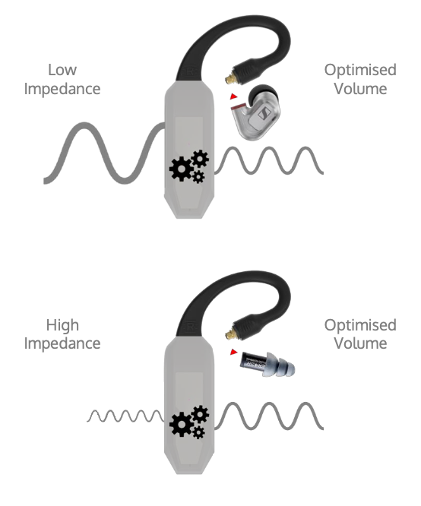

But it’s not just about the physical connection. The GO pod Air’s intelligent impedance matching is tailored to three different levels - 16, 32 and 64 ohms. Simply connect your IEMs, place the pods in their charging case for a moment, and the system will automatically detect the IEMs’ impedance and adjust to the best match for you - no manual setup required.

### **Codecs Without Compromise.**

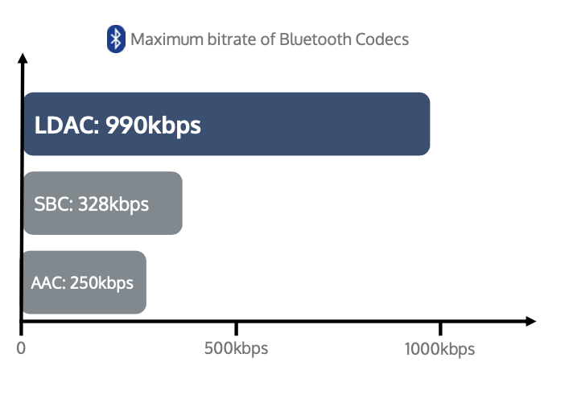

The Bluetooth ecosystem is highly competitive, and for consumers it can often mean that not all Bluetooth options are available on one product. This is certainly the case with Bluetooth earbuds and headphones, where manufacturers are often forced to choose between competing Bluetooth codec families. Depending on the codecs available on your source device, this can severely limit the options available.

iFi audio consistently bucks this trend in their products, and the GO pod Air is no exception. The GO pod Air incorporates a comprehensive suite of codecs – SBC, AAC, aptX (Classic, HD, Adaptive), LDAC and LHDC/HWA. No matter what phone, tablet or transmitter you choose, iFi guarantees there’ll be an option for you.

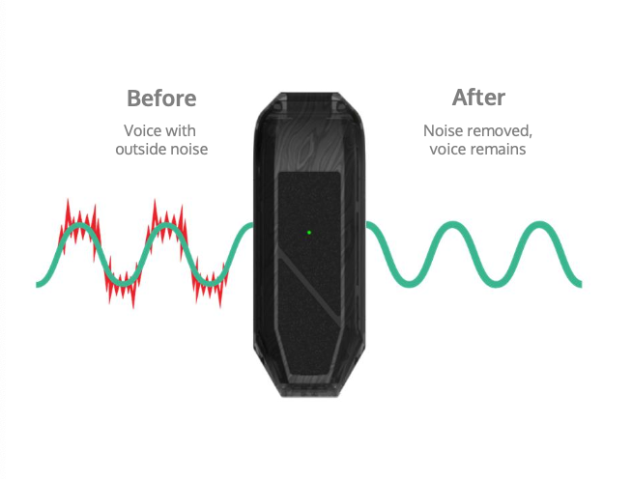

### **Wireless Workhorse.**

For those in need of earbuds for work and productivity, the GO pod Air has you covered. Designed to be your perfect everyday companion, each pod incorporates intuitive, responsive touch controls that put a range of features at your fingertips. Control calls, music, and volume, all with a touch, and even remotely activate voice assistants such as Siri and Google Assistant.

Crystal clear calls are provided by the GO pod Air’s dual microphones, and supported by Qualcomm’s cVc echo and noise suppression technology. Whether it’s an urgent business call or a busy video conference, the GO pod Air will cut through noise and ensure your voice is heard.

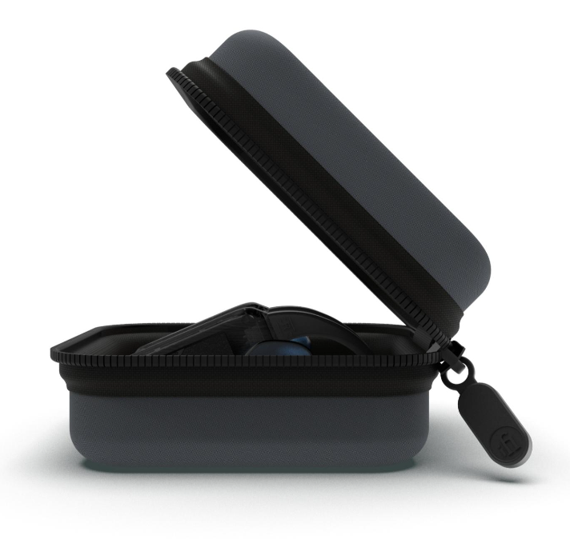

### **Go Adventuring.**

The GO pod Air is more than just a work tool - they’re also packed with features that will let you take your IEMs everywhere you find joy. The GO pod Air is IPX5 rated, ensuring they’ll always perform, whether you’re running on a rainy day, commuting during a downpour, or sweating it out in the gym.

Always keen to think ahead, iFi have incorporated the ability to disable the pods’ touch controls for these occasions, so you won’t have to worry about unwanted track changes during a walk or workout.

Designed for all-day use, the GO Pod Air offers an impressive 7 hours of playback on a single charge, with the lightweight travel case extending this to a total of 15 hours. From your morning commute to an evening gym session—and even long-haul flights—you’ll have no need for chargers or battery packs; just grab your case and seize the day.

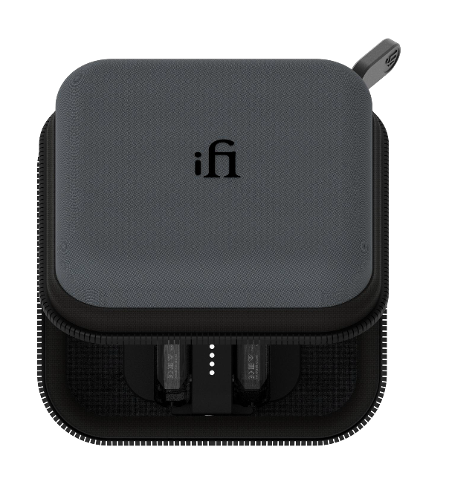

### **Pricing & Availability**

The **iFi GO Pod Air** is available to purchase at ifi-audio.com for £249/€249/$249.

**Media Contact:**[shelby@hummingbirdmedia.com](mailto:ifi@ranieri.agency)



iFi is the sister-brand of Abbingdon Music Research (AMR) and is headquartered in Southport, UK. The two brands respectively design and manufacture portable, desktop and lifestyle audio products and high-end hi-fi components. Combined in-house hardware and software development teams and a ‘music first’ approach enable iFi and AMR to create advanced audio products that deliver new levels of design, functionality and performance at their respective

price points. Since iFi’s formation in 2012, its products have earned many awards around the world, helping it to become one of the fastest-growing brands in its field.

[www.ifi-audio.com](http://www.ifi-audio.com)

# **Appendix**

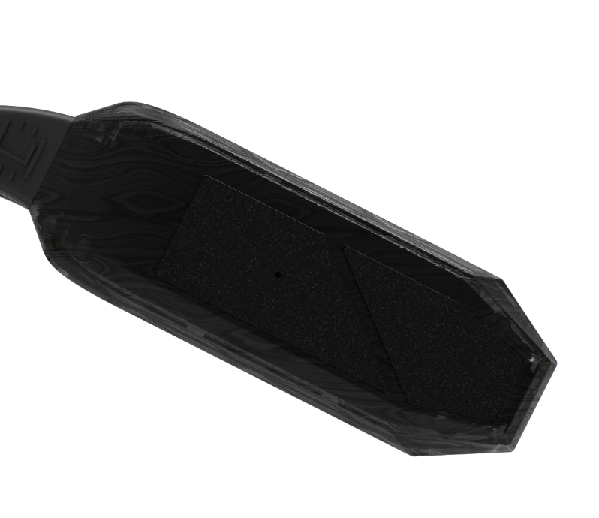

### **General Specification**

|  |  |  |
| --- | --- | --- |
|  | **GO pod Air** | **GO pod** |
| **Retail Price** | $299 | $399 |
| **Pod Chassis Material** | Textured Polymer | Textured Polymer |
| **Case Chassis Material** | Textured Polymer | Textured Polymer |
| **Bluetooth Version** | 5.2 | 5.2 |
| **Bluetooth Codecs** | LDAC, LHDC/HWA, aptX Adaptive, aptX HD, aptX, AAC, SBC | LDAC, LHDC/HWA, aptX Adaptive, aptX HD, aptX, AAC, SBC |
| **Bluetooth Chipset** | QCC5144 | QCC5144 |
| **Connection Types** | MMCX, 2-Pin, A2DC, T2, Pentaconn | MMCX, 2-Pin, A2DC, T2, Pentaconn |
| **Sound Processing** | - | - |
| **Ingress Protection Rating** | IPX5 | IPX5 |
| **Auto-Impedance Detection** | 16/32/64 Ohms | 16/32/64/300 Ohms |
| **Output Power** | ≥57mW/0.96V @ 16 Ohms | ≥120mW/1.96V @ 32 Ohms |
| **DNR** | ≥121dB(A) @ 32 Ohms | ≥129dB(A) @ 32 Ohms |
| **SNR** | ≥124dB(A) @ 64 Ohms | ≥130dB(A) @ 64 Ohms |
| **Battery Life** | 7 Hours; 15 Hours including Charging Case | 7 Hours; 35 Hours including Charging Case |
| **Net Weight** | 10g (Pods)  106g (Charging Case) | 12g (Pods)  126g (Charging Case) |
| **Case Dimensions** | 94 x 94 x 45 mm | 116 x 76 x 38.5mm |

|  |  |
| --- | --- |
| **GO pod Air** | |
| **Digital** |  |
| Bluetooth Formats | aptX Adaptive, aptX HD, aptX, LDAC, LHDC/HWA, AAC, SBC |
| **Output** |  |
| Connection Types | MMCX, 2-Pin; A2DC, T2, Pentaconn (Optional) |
| Output Power | ≥57mW/0.96V @ 16 Ohms  ≥30mW/1.38V @ 64 Ohms |
| Auto Impedance Matching | 16/32/64 Ohms |
| SNR | ≥124dB(A) @ 64 Ohms, 20-20kHz |
| DNR | ≥121dB(A) @ 32 Ohms, 20-20kHz |
| THD+N | 0.002% (20-20kHz) |
| **General** |  |
| Battery | 180mAh (Pods);  580mAh (Charging Case) |
| Charging | USB-C 5V/1A |
| Charging Time | <1.5 hours (Pods);  <2 hours (Charging Case) |
| Dimensions | 47.5 x 16.1 x 9.5mm (Pods);  94 x 94 x 45mm (Charging Case) |
| Net Weight | 10g (Each Pod);  106g (Charging Case) |

### **Connection Guide**

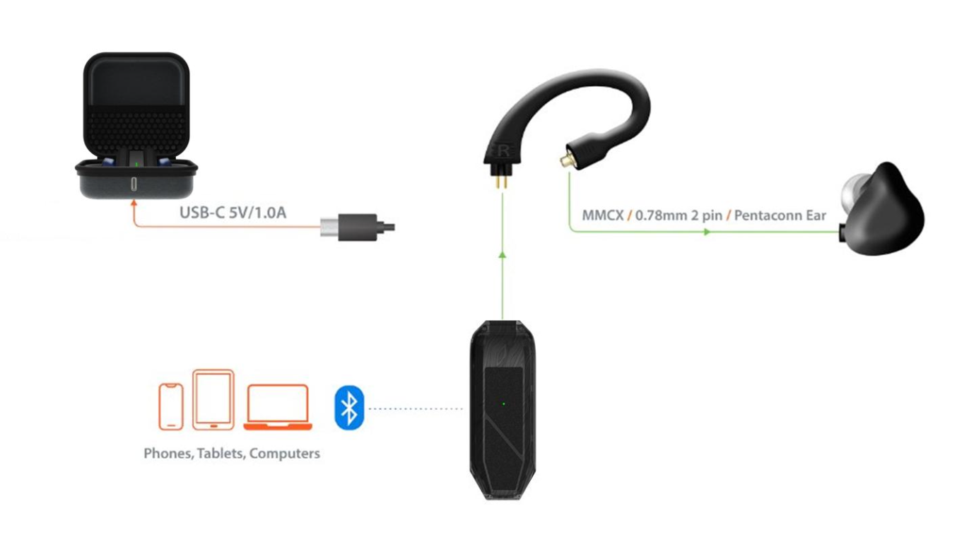

### **Pairing and Controls**

