Celebrating 75 years of putting sound first
Sennheiser presents MOMENTUM True Wireless 2 Anniversary Edition

Wedemark, Germany, August 25, 2020 – A special occasion deserves a special edition: Sennheiser is celebrating its 75th anniversary with a limited edition of earbuds that truly put sound first. The MOMENTUM True Wireless 2 Anniversary Edition comes in an exclusive all-black design featuring the original Sennheiser logo on the earbuds and case. Created as a thank you to Sennheiser’s customers, it pays tribute to the company’s heritage and reflects the audio specialist’s longstanding commitment to creating unique listening experiences.

When heritage meets the Future of Audio
It is 75 years since Prof. Dr. Fritz Sennheiser founded the “start-up” that would become Sennheiser in a farmhouse near Hanover, Germany. Today, the company he created is still driven by the same passion for sound and spirit of discovery. “Since our foundation in 1945, we have been setting standards in terms of audio quality and listening experiences that challenge the status quo. This was the ethos with which we created the second generation of our MOMENTUM True Wireless headphones”, said Daniel Sennheiser, co-CEO at Sennheiser, who alongside his brother Andreas Sennheiser is the third generation of the family to lead the company. “With the anniversary edition of these acclaimed headphones we are honoring our roots as well as offering a special thank you to our customers”, added Dr. Andreas Sennheiser, Co-CEO.

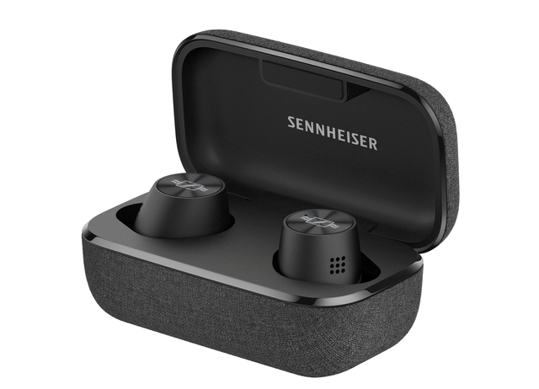

A tribute to the audio specialist’s heritage, the MOMENTUM True Wireless 2 Anniversary Edition comes in an exclusive all-black design featuring the original Sennheiser logo

A tribute to Sennheiser’s heritage, the MOMENTUM True Wireless 2 Anniversary Edition comes in an exclusive all-black design with the original Sennheiser logo on the earbuds’ iconic metallic spin ring and charging case.

Earbuds that put sound first
The ideal choice for the discerning listener, the MOMENTUM True Wireless 2 Anniversary Edition delivers exceptional sound quality. Sennheiser’s 7mm dynamic drivers, designed and manufactured at the company’s headquarters in Germany, create superior stereo sound with deep bass, natural mids and clear, detailed treble.

The built-in equalizer and Sennheiser’s Smart Control App make it possible to tailor the audio experience to individual taste, while even noisy surroundings won’t compromise the audio quality, thanks to Active Noise Cancellation that works in tandem with the excellent passive noise isolation. Additionally, the earbuds’ Transparent Hearing feature allows to blend in ambient sound at a touch to bring the listener’s focus back to their environment when needed.

All-day listening pleasure
With an outstanding 7-hour battery life, which can be extended to up to 28 hours by charging on the go using the supplied case, audio lovers can truly enjoy an all-day listening experience. Designed to offer excellent wearing comfort, the MOMENTUM True Wireless 2 Anniversary Edition impresses with excellent ergonomics that minimize fatigue.

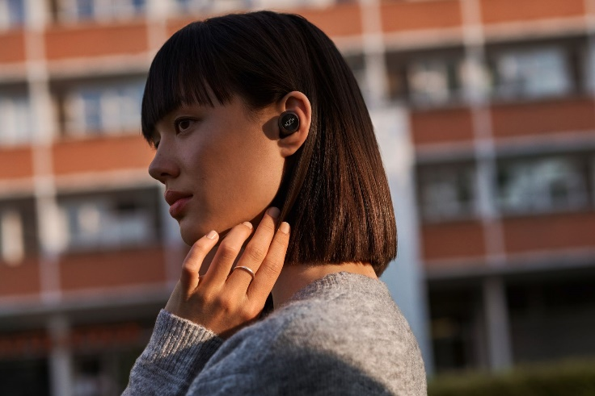

The special edition of MOMENTUM True Wireless 2 offers an outstanding 7-hour battery life, which can be extended to up to 28 hours by charging on the go using the premium charging case

Like the MOMENTUM True Wireless 2, the special edition ensures a seamless user experience, thanks to intuitive touch controls that can even be customized to personalize controls for audio, calls and interacting with voice assistants such as Google Assistant or Apple Siri. Just as intuitive is the Smart Pause feature that anticipates the listener’s needs by pausing the audio when the earbuds are taken out and seamlessly resumes when replaced in the ear.

The MOMENTUM True Wireless 2 Anniversary Edition will be available from September 8 at the Sennheiser stores and the Sennheiser webshop for 299 EUR (MSRP).

About Sennheiser
Founded in 1945, Sennheiser is celebrating its 75th anniversary this year. Shaping the future of audio and creating unique sound experiences for customers – this aim unites Sennheiser employees and partners worldwide. The independent family company, which is managed in the third generation by Dr. Andreas Sennheiser and Daniel Sennheiser, is today one of the world’s leading manufacturers of headphones, loudspeakers, microphones and wireless transmission systems. In 2019, the Sennheiser Group generated turnover totaling €756.7 million. www.sennheiser.com

Global Press Contact
Jacqueline Gusmag
Communications Manager Consumer
jacqueline.gusmag@sennheiser.com
T +49 (0)5130 600-1540

