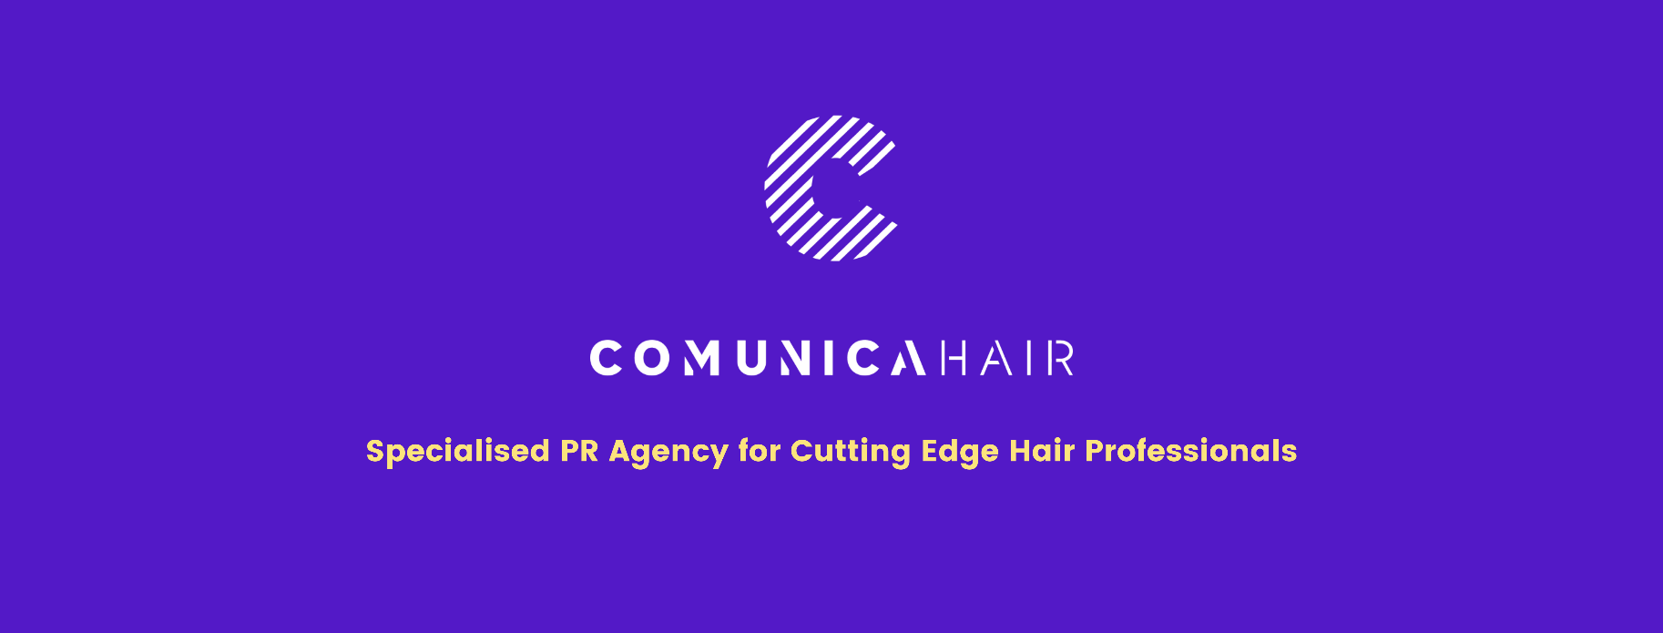

For more information, please contact Marta de Paco
On +34 670 780 664 or email press@comunicahair.com

Important:
These images are only available for editorial content.
Credits must be included.
Notification of their publication is expected.

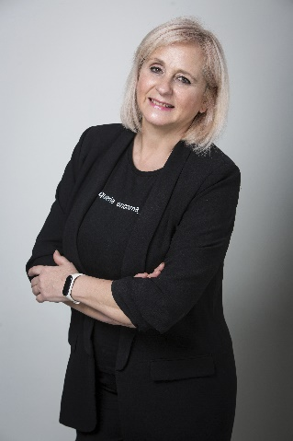
ENCARNA MORENO
ORIGINAL Collection

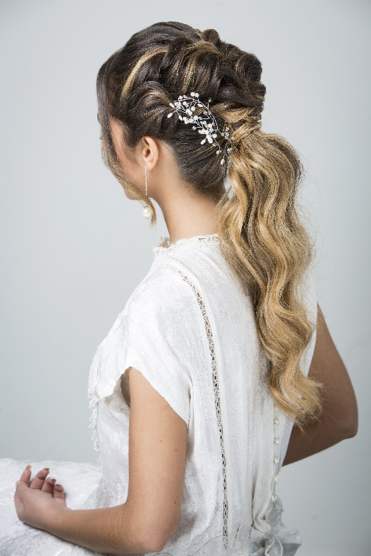
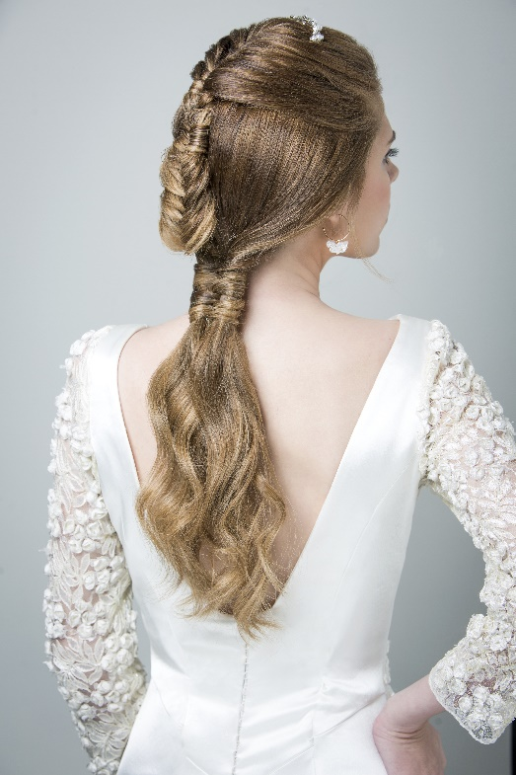
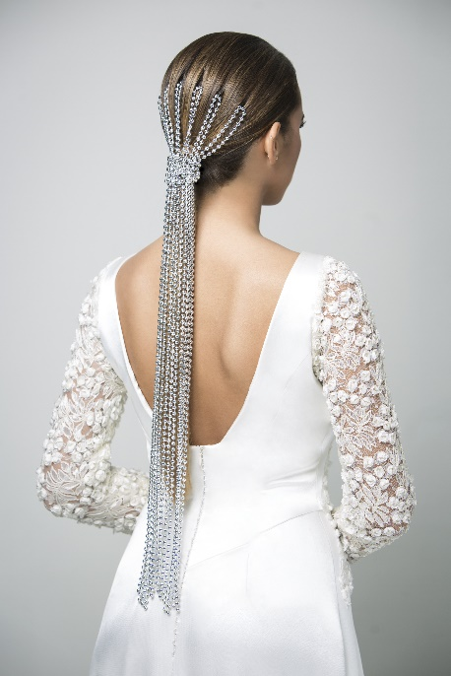

Hair: Encarna Moreno @ Peluquería Encarna Moreno
Hair Instagram: @peluqueria_encarna_moreno_
Hair Assistant: María Gómez / Assistant Instagram: @merygomezz8
Photography: Kike Miranda / Photography Instagram: @kike_miranda_beautyshots
MUA: Encarna Moreno
Styling: María Gómez / Styling Instagram: @merygomezz8
Designer: Ángela & Adela / Designer Instagram: @angelayadela
Products: L’Oréal Professionnel Paris
Products Instagram: @lorealpro_educacion_es
Models: María Rivero y María José Oliva
Models Instagram: @mariariverofdezz @mjoliva_
ENCARNA MORENO
ORIGINAL Collection

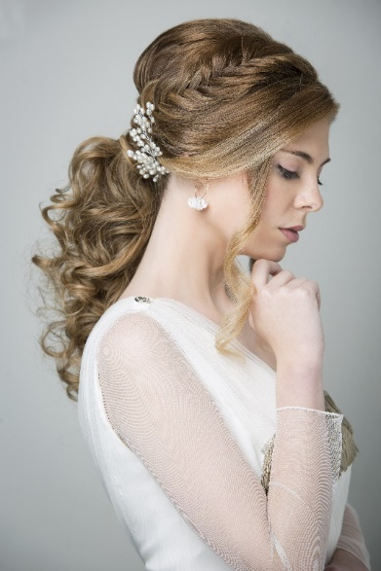
The brides of today have had to adapt to the context we live in with more intimate and informal ceremonies. However, that has not diminished the importance of weddings and, of course, brides. "Original" explores the naturalness of boho brides who do not forget details that remind them that they are living a great day. For this reason, the hair is treated like a jewel on which elaborate braids, waves and precious accessories are created, though the result seeks simplicity.
The collection welcomes the latest trends and recreates them thinking of current and non-traditional brides. Ponytails with waves or combined with braids are two of the looks that are most popular this year for bohemian brides, with a fresh but impeccable finish, since a wedding hairstyle must be well structured to last. As for accessories, tiaras, pearls, brooches and hairpins are simple, but original ornaments that further enhance the bride.
For loose hair, waves continue to add glamor, accompanied by a pearl headband for an elegant touch. A look that can be easily transformed for a guest if we comb it to the side. For guests looking for something more casual and carefree, surf waves are perfect.
As for color, it is one of the most important elements when creating a bridal look. It is necessary to personalize it with the style of the bride and the chosen hairstyle.
We propose warm colors for our boho brides such as caramel, gold and beige that add warmth to the face. The techniques we use are contouring to adapt the color to the characteristics of the face, balayage for its naturalness and babylights for its freshness.
Hair treatments cannot be absent so that the bride's look on her wedding day is perfect. With them we will make the hair look healthy and shiny and we will give each one what they need, be it hydration, nutrition or shine, always with natural taninoplasty products for straight, curly or highlighted hair.

