#DontStopTheMusic

… will rock you with new artists this week

Wedemark/Germany, June 9, 2020 – Sennheiser’s #DontStopTheMusic series is now on Facebook! Don’t miss a beat and connect to the next concerts in the series: Tom Wurth & John Ford Coley, Tuco Gadamn and Ludo Ji.

Live concert streams from Wednesday, June 10 to Monday, June 15
Sennheiser’s #DontStopTheMusic concerts are now being streamed on our Facebook channels, but we will also continue to keep you updated on our Instagram page @sennheiser.

- Tom Wurth & John Ford Coley (@tomwurth1):
Wednesday, June 10 at 24:00 UTC (20:00 New York time, 02:00 Berlin time)
- Tuco Gadamn (@tucogadamn):
Friday, June 12 at 16:00 UTC (12:00 New York time, 18:00 Berlin time)
- Ludo Ji (@ludojimusic):
Monday, June 15 at 15:00 UTC (11:00 New York time, 17:00 Berlin time)

More music
Please also check out http://www.sennheiser.com/anniversary for the next livestream dates and a great selection of music videos to watch and listen to. Just put on your headphones (or turn up the speakers) and immerse yourself in immersive jazz club recordings, electro sets, or live takes from recording studios.

It’s free but why not donate to fight the coronavirus?
At Sennheiser, we’re delighted to be working with these fantastic artists to help spread positivity by putting on exclusive concerts. They’re totally free, but if you do want to say thank you, do consider supporting the WHO in its fight against the coronavirus:
https://www.who.int/emergencies/diseases/novel-coronavirus-2019/donate

For your social media channels:
Enjoy your favorite artists at home and check out the live concerts on Sennheiser’s Facebook channels! #DontStopTheMusic

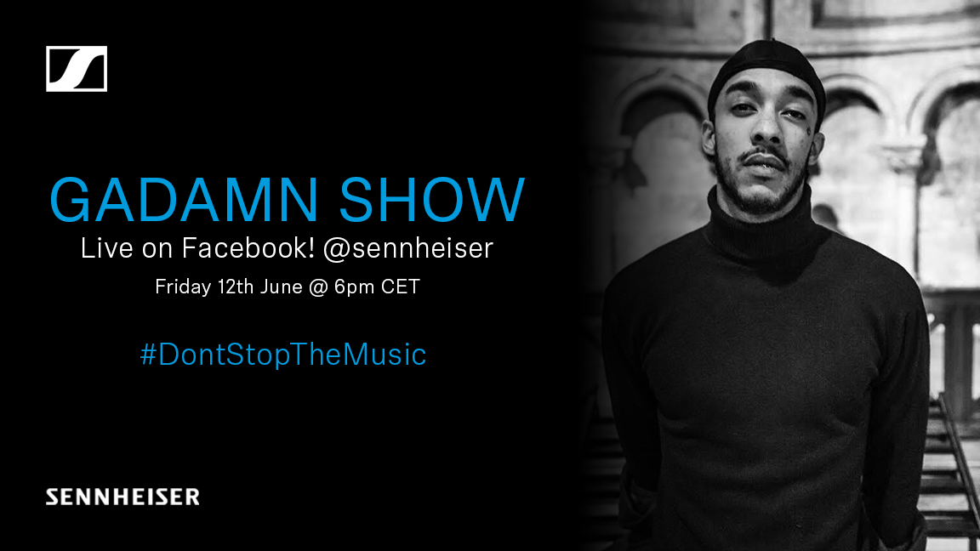 | 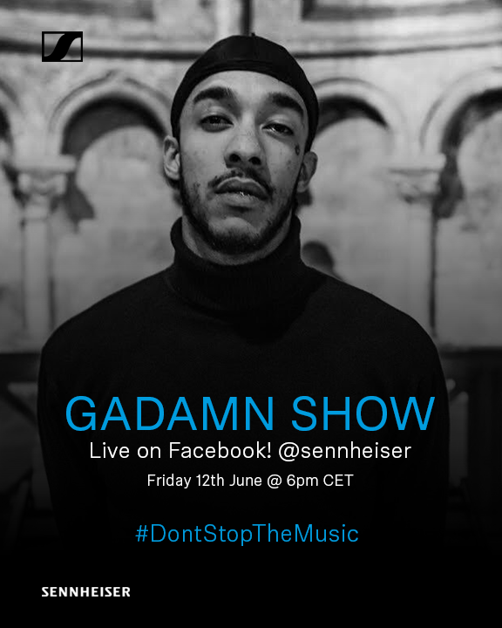 | 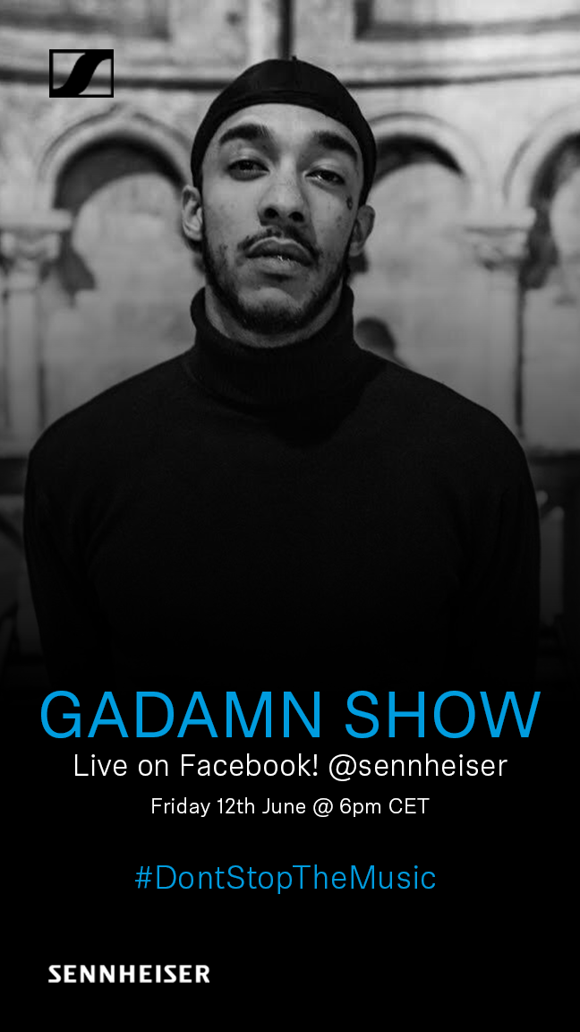

About Sennheiser
Founded in 1945, Sennheiser is celebrating its 75th anniversary this year. Shaping the future of audio and creating unique sound experiences for customers – this aim unites Sennheiser employees and partners worldwide. The independent family company, which is managed in the third generation by Dr. Andreas Sennheiser and Daniel Sennheiser, is today one of the world’s leading manufacturers of headphones, loudspeakers, microphones and wireless transmission systems. In 2018, the Sennheiser Group generated turnover totaling €710.7 million. www.sennheiser.com

Press Contacts

Mareike Oer Stephanie Schmidt
mareike.oer@sennheiser.com stephanie.schmidt@sennheiser.com
T +49 0(5130) 600 – 1719 T +49 0(5130) 600 – 1275

