Powerful Faith: St. Gabriel the sorrowful mother church updates Sound system with powersoft quattrocanali amplifiers
quattrocanali 1204s ensure reliable, trouble-free system for Growing Parish

Avondale, PA
September 11 2019

When St. Gabriel the Sorrowful Mother parish of Avondale, PA unveiled their brand-new church in 2002 it was to account for the steady growth they had seen since originally opening in 1988. Boasting 7,500 regular worshippers across their weekly services, the church expanded to meet this demand and installed a new sound system mounted in the church’s ceiling in order to reach all of its parishioners. Over the years however, the demands of a spoken liturgy required a different sonic touch which led church leadership to hire Monte Brothers Sound Systems to install a speaker and power amplifier system this year. The Ardlsey, New York-based company, which has made its name creating and building sound systems in places of worship across the country for the past fifty years, designed a system that would strike the delicate balance between volume and intelligibility– one powered by Powersoft Quattrocanali amplifiers.

A voice from above
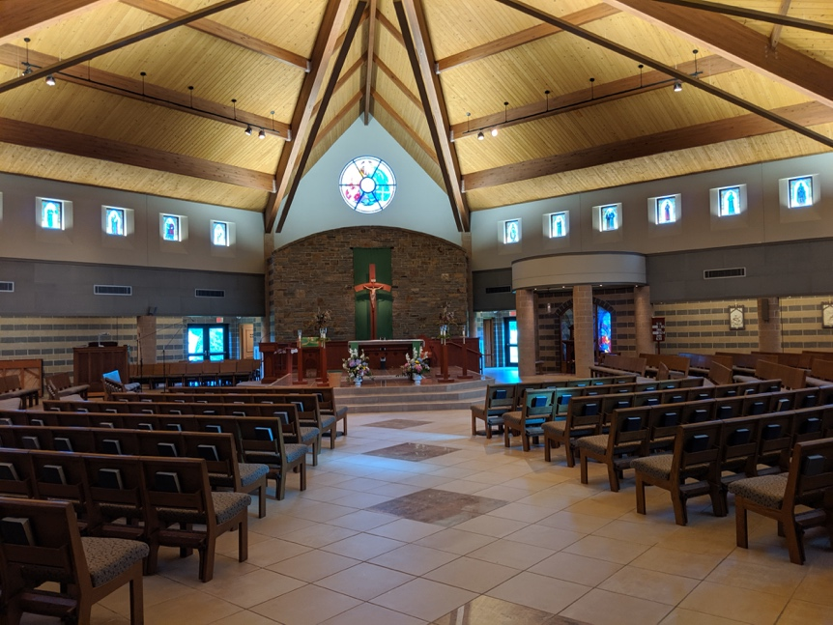
The church’s original system from 2002 favored a top-down approach, with a cluster of three speakers mounted overhead to deliver audio to the parishioners below. Although this achieved the intended effect, over time it became apparent that the setup struggled in a few key areas. “What makes these kinds of spaces difficult is the layout,” explained Monte Brothers Project Director Steve Minozzi. “The location of the pulpit strays into the center of the church which makes it hard to design a system that can be mounted up above without having sounds reflections that interact with the microphones.”

Aside from creating feedback at the high volumes required, the positioning of the ceiling-mounted speakers also resulted in dead spots where attendees had trouble hearing the mass due to their interactions with how the space had been acoustically treated when it was originally built. “There are vents and cushioning on the seats that were designed to try and help to account for reflections,” Minozzi said. “But no matter how much treatment you use, the position of the speakers was going to interact with them, and in the meanwhile it was also creating spots that made audibility difficult.”

Realizing that a different approach needed to be taken, Minozzi and his crew removed the ceiling speakers in favor of ones lining the side columns, using a pair CAMM CA-43Ls as the main line arrays and seven CAMM DT-200s as the fill speakers. They also made use of some of the church’s existing speakers as well as to ensure that work was done efficiently and cost-effectively. “The position of the main line arrays give us enough throw to have focused sound all the way to the center of the Church,” Minozzi said. “We use the DT-200s to fill out the rest of the sound for the seats not immediately in its path, ensuring that the sound is evenly distributed and audible without interacting with the pulpit whatsoever.” Sound professionals at the church are able to control the entire system with a simple control panel located behind the alter.

‘Powersoft was the amp for us’
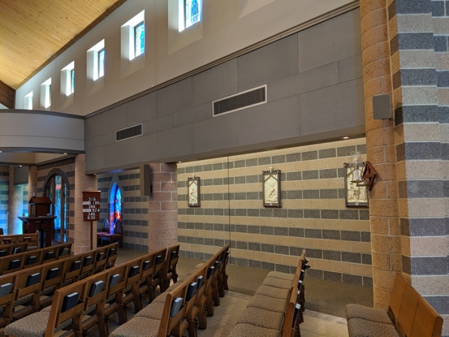
At the heart of the system is the Powersoft Quattrocanali 1204, one of several Powersoft amplifiers that Monte Brothers uses regularly in their worship space installs. Minozzi and his team selected them due to their high-power capacity and ability to handle multiple speaker types smoothly. “This church required very powerful amps because it’s an acoustically tight space,” he explained. “The 1204’s have SIGNIFIGANT power and run very smoothly with all of the different speakers in this setup, so they were exactly what was needed to get the job done.”

Minozzi went on to explain that he favors using Powersoft products because of their reliability, saying that once he uses them in an install he knows that they’re going to work. “Most of our installs use Powersoft amplifiers because they have a very low failure rate and we rarely have to replace them,” he said. “The fact that they are so dependable is why we know that Powersoft was the amp for us.”

For further information

Francesco Fanicchi  POWERSOFT FIRENZE  francesco.fanicchi@powersoft.com  +39 055 01 53 453 | Jeff Touzeau  Hummingbird Media  jeff@hummingbirdmedia.com  +1 (914) 602-2913

ABOUT POWERSOFT:
Powersoft is the world leader in lightweight, high power, single rack space, energy efficient amplifiers for the professional audio market. Founded in Italy in 1995, headquartered in Florence, Italy, with offices in Camarillo, CA, Powersoft couples the experience and precision of its production department with exceptional components to deliver products with perfect audio response and high-performance reliability. Its state-of-the-art amplifiers can be found in an array of markets, ranging from stadiums, sporting arenas, theme parks, performance venues and airports to convention centers, churches, and clubs, and are used by the world's leading tour sound companies. For more information, visit the Powersoft website: www.powersoft.com

