revolutionizing in-car audio
Sennheiser’s and Continental’s speakerless immersive audio system for vehicles selected as CES Innovation Awards 2021 Honoree

Wedemark, December 15, 2020 – Audio specialist Sennheiser and technology company Continental received a CES Innovation Award 2021 in the In-Vehicle Entertainment and Safety category for their premium in-car audio solution. The speakerless 3D immersive audio system delivers an incredibly lifelike in-car entertainment experience by integrating Sennheiser’s patented AMBEO 3D audio technology with Continental’s speakerless Ac2ated Sound system.

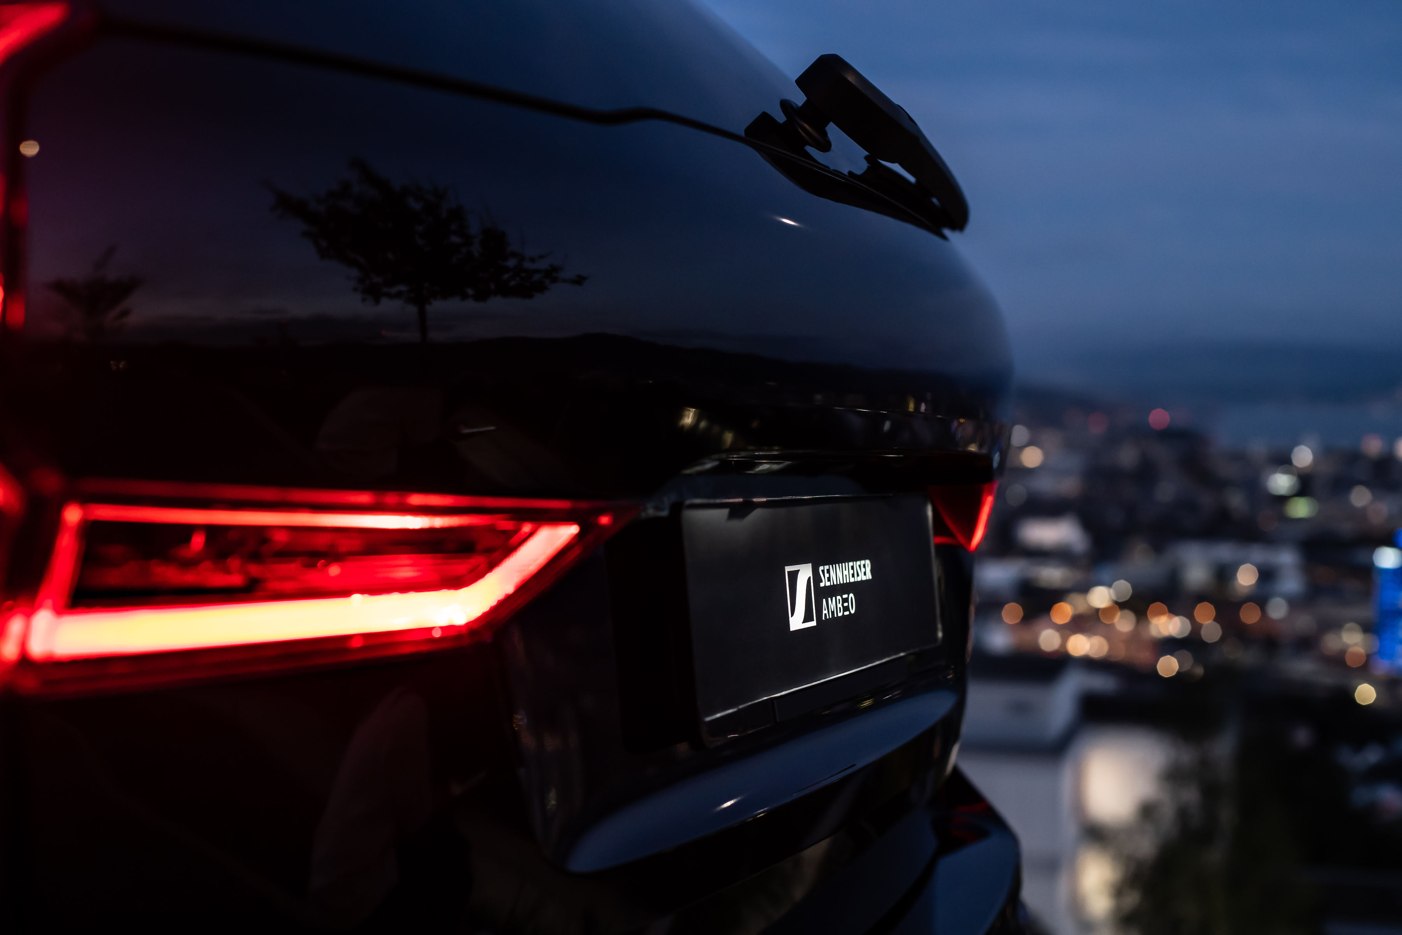

First announced at CES 2020, the award-winning partnership combines Sennheiser’s AMBEO Mobility technology with Continental’s Ac2ated Sound system to offer a speakerless in-car sound system that fills the vehicle interior with lifelike immersive sound. Scalable and adaptive, the joint solution supports the evolution of mobility towards an ever more autonomous and user experience-oriented future. “By integrating our AMBEO Mobility technology with Continental’s Ac2ated Sound system, we have sought to offer an incredibly lifelike sound experience which opens new perspectives for vehicle audio. We are very pleased for our joint solution to be recognized among the groundbreaking products in the CES Innovation Awards”, said Véronique Larcher, Director AMBEO Immersive Audio at Sennheiser.

Continental’s Ac2ated Sound abandons conventional loudspeaker technology, exciting selected surfaces in the vehicle interior to produce sound. In comparison to conventional audio systems, Ac2ated Sound enables a reduction of weight and space of up to 90 percent. In this way, the system not only produces highest audio quality but is also perfectly suited for electric vehicles, where saving space and weight is a priority. Combined with Sennheiser’s AMBEO Mobility, the concept achieves a breathtaking 3D sound reproduction that envelops passengers in an incredibly detailed and vivid soundscape and lets them enjoy their in-car entertainment to the fullest.

Sennheiser’s and Continental’s speakerless immersive audio solution received a CES Innovation Award 2021 in the In-Vehicle Entertainment and Safety category

The AMBEO Mobility software analyzes and distils the fundamental components of any native stereo music track and plays them back immersively through the appropriate actuator. From crystal-clear call quality to personalized content playback, the Sennheiser and Continental in-car sound system allows for full audio individualization for each seat. A key element in creating these personalized listening zones are the specially designed headrests with integrated high-fidelity transducers. By adding this personal near-field playback source close to the driver’s and passengers’ ears, the listening experience is augmented considerably.

The CES Innovation Awards are presented annualy by the Consumer Technology Association (CTA), honoring outstanding design and engineering in cutting-edge innovations across 28 categories. The submissions are reviewed by a panel of independent expert judges – including industrial designers, engineers and members of the trade media – based on innovation, engineering and functionality, aesthetic and design.

About Sennheiser
Founded in 1945, Sennheiser is celebrating its 75th anniversary this year. Shaping the future of audio and creating unique sound experiences for customers – this aim unites Sennheiser employees and partners worldwide. The independent family company, which is managed in the third generation by Dr. Andreas Sennheiser and Daniel Sennheiser, is today one of the world’s leading manufacturers of headphones, loudspeakers, microphones and wireless transmission systems. In 2019, the Sennheiser Group generated turnover totaling €756.7 million. www.sennheiser.com

Global Press Contact
Sennheiser electronic GmbH & Co. KG
Jacqueline Gusmag
Communications Manager Consumer
T: +49 (0)5130 600-1540
jacqueline.gusmag@sennheiser.com

