**Media release**

**22 June 2016**

**Is this the cleverest, cleanest vacuum ever produced?**

**-Brand behind cult kitchen gadget Thermomix launches hi-tech homecare system-**

The leading household appliance developer behind cult kitchen cooker/blender the Thermomix has launched a new, tech-stuffed vacuum cleaner in the UK known as the Ultimate Homecare System.

German brand Vorwerk has unveiled its new Kobold VK200 vacuum cleaner - a multi-functional upright vacuum cleaner that features a host of clever, interchangeable attachments to cut down on cleaning time that has taken the company’s designers over eight years to develop.

The vacuum, which commands a premium price tag of between £749 – £1,499, is based around a lightweight, central upright ‘vacuum body’ made from high quality, recyclable thermoformed plastic that uses deploys just 700Watts of power to operate the owner’s choice of no less than six interchangeable attachments that can be fitted at the flick of a wrist to deep clean a variety of surface types across the home.

***Maintenance-free motor and ‘A’ rated energy label***

Vorwerk’s engineers have designed the VK200 using a maintenance-free reluctance motor that boasts high levels of suction at the size of a small can, and the systems has been awarded with an ‘A’ rating for no less than four aspects of the EU energy label.

Innovations like the automatic start/stop feature mean that the vacuum also uses less energy by turning itself off automatically when in the park position, and sensors on the impressive EB400 electric brush detect the surface type being cleaned every 16 seconds, automatically adjusting suction power, brush speed and a change in floor type within 0.7 seconds.

Other advanced features include a handy mop and vacuum attachment known as the SP530 DuoClean, which is designed to use two suction channels to pick up large dirt particles and wipe away stubborn marks at the same time, and the PB400 Electric Upholstery Brush that rotates up to 4,000 times a minute to vibrate dust and dirt particles to the fabric surface and suck them away into the VK200’s three in one filter bag that is certified as suitable for allergy sufferers.

***Deep cleaning ability for mattresses***

Perhaps one of the most desirable features in the Kobold VK200’s repertoire is its ability to deep clean mattresses using a specialist MR440 mattress vacuum attachment. Used in conjunction with the brand’s Lavenia cleaning powder which is massaged into the bed with the PB400 Electric Upholstery Brush, the MR440 rapidly vibrates dead skin, dirt particles and dust mites droppings to the surface using hundreds of rubber strips and sucks them out of harm’s way.

Dr Thomas Rodemann, Chief Executive at Vorwerk Elektrowerke said:

“The biggest design challenge for the Kobold VK200 was combining our high technical standard in terms of performance, quality and energy efficiency with a design that was easy to use and met the needs of our customers.

“However, we haven’t made any compromises and have been awarded the ‘A’ rating for no less than four aspects of the EU energy label, and we also fulfil the expectations of people with house dust allergies thanks to our excellent filter performance and TUV accreditation.

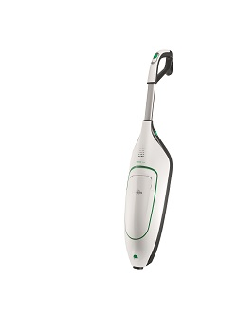“We want people to recognise that whilst the Kobold VK200 is a powerful, technologically advanced appliance, it is still extremely easy and convenient for them to use.”

**The ‘tech spec’**

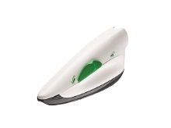

**Kobold VK200 body** – the main component of the upright system uses a series of optional attachments to deliver outstanding cleaning results across a range of surfaces.

**Kobold PB440 Electric Upholstery Brush –** the classic choice for cleaning upholstery with a highly effective approach that brushes and vacuums at the same time down to the very last fibre.

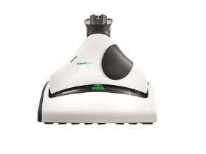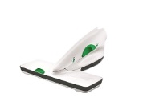

**Kobold MR440 Mattress vacuum** – perfect for deep-cleaning mattresses with a cleaning agent and brush which effectively ‘beats’ the mattress and immediately picks up the dirt.

**Kobold SP530** **DuoClean –** the hard floor cleaner uses just 100 millilitres of water to pick up debris and then mop up to 20 square metres of hard floor.

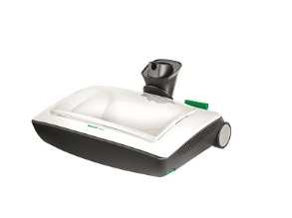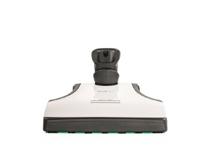

**Kobold VF200 Carpet Freshener** – a dual-action attachment which automatically sprinkles Kobosan Cleaning Agent and then works it into the carpet brushes the surface clean.

**Kobold EB400 Automatic Electric Brush** – including automatic floor detection which scans the floor 16 times per second to identify the surface and ensure each gets the right treatment.

**-ENDS-**

**For more information about the Vorwerk Kobold VK200 vacuum cleaner, go to** [**https://kobold.vorwerk.co.uk/home/**](https://kobold.vorwerk.co.uk/home/)

**To download this press release, go to** [**https://vorwerk-uk.prezly.com/**](https://vorwerk-uk.prezly.com/)

**To download hi-res images, go to** [**https://vorwerk-uk.prezly.com/media**](https://vorwerk-uk.prezly.com/media)

**For media enquiries or interviews with the Vorwerk UK team, please email** [**alex@faith-pr.co.uk/stefanie@faith-pr.co.uk**](mailto:alex@faith-pr.co.uk/stefanie@faith-pr.co.uk) **or call 01484 599 886**

**Follow Vorwerk UK on Twitter:** [**@VorwerkUK**](https://twitter.com/vorwerkuk)

**Find Vorwerk UK on Facebook:** [**Vorwerk UK**](https://www.facebook.com/KoboldVorwerkUK/)

**Cont.**

**Purchasing information**

**The Vorwerk VK200 can be purchased via an in-home demonstration booked online** [**here**](https://kobold.vorwerk.co.uk/demonstration/request-a-demonstration/?no_cache=1)**.**

**The Vorwerk VK200 ranges in price from £749 - £1,499 depending on specification, see below:**

**Specification and pricing information**

**Package One - £749**

* **Upright vacuum cleaner with EB400 Automatic Electric Brush**

**Package Two - £849**

* **Upright vacuum cleaner with EB400 Automatic Electric Brush & accessory pack including:**
* **Crevice nozzle set**
* **Flexo-nozzle**
* **Telescopic tube**
* **Soft nozzle**

**Package Three - £1,049**

* **The Standard Hard Floor System including:**
* **Upright vacuum cleaner with EB400 Automatic Electric Brush**
* **Accessory pack**
* **SP530 DuoClean**
* **PB440 Electric Upholstery Brush**
* **MR440 mattress vaccum**
* **Deep cleaning mattress attachment**

**Package Four - £1,199**

* **The Standard Carpet System including:**
* **Upright vacuum cleaner with EB400 Automatic Electric Brush**
* **Accessory pack**
* **PB440 Electric Upholstery Brush**
* **MR440 mattress vacuum**
* **Deep cleaning mattress attachment**
* **VF200 carpet freshener**

**Package Five - £1,499**

* **The Standard Carpet System including:**
* **Upright vacuum cleaner with EB400 Automatic Electric Brush**
* **Accessory pack**
* **SP530 DuoClean**
* **PB440 Electric Upholstery Brush**
* **MR440 mattress vacuum**
* **Deep cleaning mattress attachment**
* **VF200 carpet freshener**
* **SP530 DuoClean**

**The history of Vorwerk**

Vorwerk & Co. KG was founded in Wuppertal in 1883. During the course of its 130-year history, the company, originally a carpet factory, has grown into a highly diversified, global corporate group. Vorwerk nevertheless remains a family enterprise to this day.

Since 1930, Vorwerk’s core business has been the direct selling of high-quality products. The Vorwerk product range includes household appliances (the Kobold vacuum cleaner and the Thermomix kitchen appliance) and the first-class JAFRA cosmetics. The akf banking group, the Vorwerk carpet factories and the HECTAS Group as an associate company all belong to the Vorwerk entrepreneurial family. Superior products and a special customer approach are something all divisions have in common, and what makes Vorwerk so special.

Vorwerk provides jobs for 622,000 people worldwide, of whom 40,000 work as sales advisers and representatives in the household appliances segment, 570,000 as JAFRA Cosmetics consultants, and 12,545 as employees. Vorwerk generated a business volume totaling more than 3,1 billion euros in 2013 and operates in 70 countries.

Vorwerk products have been available in the UK market during the last 30 years.