For more information, please contact Marta de Paco
On +34 670 780 664 or email press@comunicahair.com

Important:
These images are only available for editorial content.
Credits must be included.
Notification of their publication is expected.

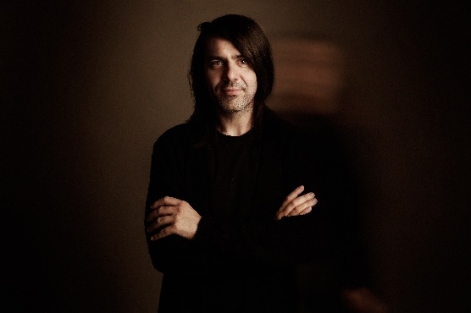
PELSYNERA
Mr. BOY Collection

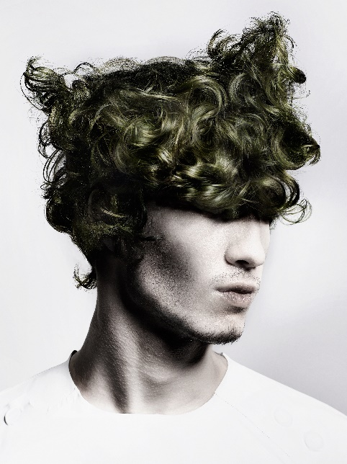
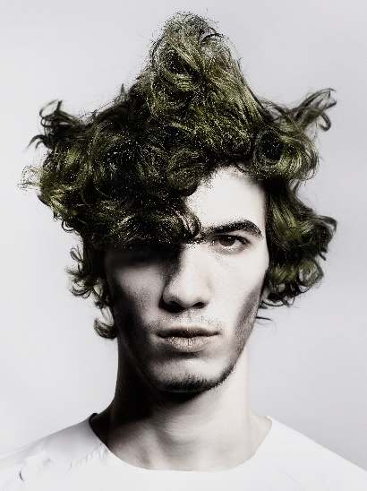
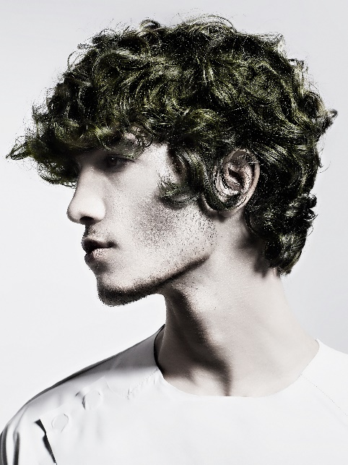

Hair: Pelsynera @pelsynera
Photographer: Oliver Viladoms studio @oliver_viladoms_studio
MUA: Pelsynera @pelsynera
Styling: Laura García Baena @baenalauragarcia

PELSYNERA
Mr. BOY Collection

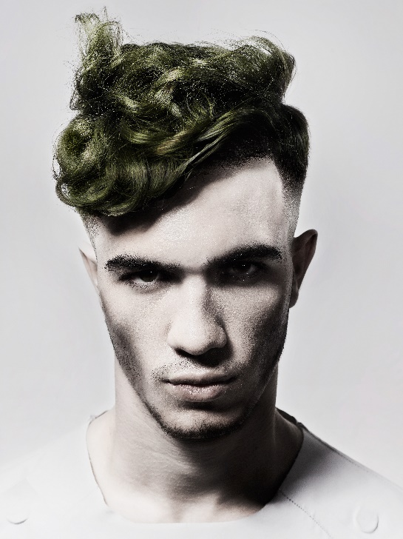

This collection reflects and seeks the diversity our personality hides, the capacity of oneself to show different selves. Because there is always someone different within us. For this reason, each look shows the same face from different perspectives, as if it was a polyhedral reflection, in which our personalities emerge liberated, as contradictory as they are true until we completely shape who we are.
All in all, these are the different profiles of the same man. The curly texture is like a polyphonic message in which the explores all communication possibilities with surprising and creative results, with a game of volumes, sometimes fickle, but always expressive. What we are is not static, and our hair either.

