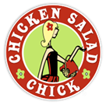
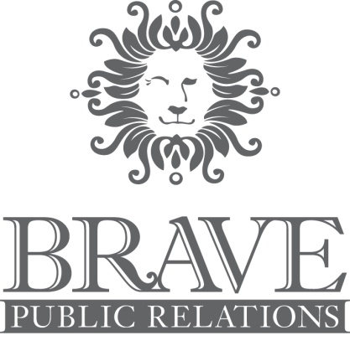

For more information:
Laurel Haislip/ Jennifer Walker
BRAVE Public Relations, 404.233.3993
lhaislip@bravepublicrelations.com/
jwalker@bravepublicrelations.com

FOR IMMEDIATE RELEASE

Origin Development Group Selects BRAVE Public Relations as Agency of Record for
Atlanta-area Chicken Salad Chick Franchise Locations

ATLANTA (April XX, 2017) – Origin Development Group announces its retainer of BRAVE Public Relations to promote its six Chicken Salad Chick restaurants as well as the grand openings of several new Georgia locations in 2017. Under the management of Lauren Fernandez and Darren DeVore, founders of Atlanta-based Origin Development Group, this new partnership with BRAVE Public Relations will help grow the brand’s mission of spreading joy, enriching lives and serving others. The nation’s only fast-casual chicken salad restaurant, Chicken Salad Chick is dedicated to providing a freshly made, Southern-style chicken salad experience to customers across the Southeast.

Chicken Salad Chick was established in 2008 in the kitchen of founder, Stacy Brown, and has now grown to over 65 locations. Origin Development Group is furthering the Southern sensation with plans to nearly double in size throughout the state this year. Under the leadership of Lauren Fernandez, Origin will be adding several locations to the brand’s existing six Atlanta-area locations in Peachtree City, Athens, Alpharetta, Roswell, Kennesaw and Augusta. The menu features over a dozen varieties of chicken salad flavors, sides, salads and soups made fresh daily in-house. Chicken Salad Chick offers Southern-inspired hospitality in dine-in, carry-out, delivery and full service catering to suit any guest occasion.
“We are pleased to announce our partnership with BRAVE Public Relations to allow us spread joy and enrich lives throughout the local Atlanta community,” said Lauren Fernandez, co-founder and president of Origin Development Group. “This partnership will continue to establish Chicken Salad Chick as the destination for delicious, fresh Southern fare in the Atlanta market. With a longstanding successful track record and an accomplished team, BRAVE will bring our marketing initiatives to the next level by helping us tell our story in an organic and honest way.”
Specializing in retail, entertainment and lifestyle brands, BRAVE Public Relations has a history of successfully promoting both new and existing venues in the Southeast. With a myriad of local and national lifestyle and hospitality clients, such as The Fresh Market, Room & Board, LEGOLAND Discovery Center and Pike Nurseries, BRAVE Public Relations will position Chicken Salad Chick as the ultimate destination for chicken salad to Atlanta area customers and guests.

About Origin Development Group
Origin Development Group is a privately held fund focused on brand growth in the restaurant industry. As a multi-unit developer, Origin serves as a strategic growth partner for new and established fast-casual restaurant brands. Origin also grows emerging restaurants brands through capital investment, creating licensing and franchise programs, managing operations or retaining rights as a franchisee or master franchisee. See www.origindevelopmentgroup.com for additional information.

About Chicken Salad Chick
Chicken Salad Chick puts an edgy twist on a Southern classic, offering guests a “custom fit” chicken salad experience, with over a dozen original flavors to choose from, as well as gourmet soups, flavorful side salads and freshly-baked desserts. Chicken Salad Chick serves southern style chicken salad with heart and strives to spread joy, enrich lives and serve others every day. Today, the brand has more than 65 locations across the Southeast, and has currently sold 146 franchises to be developed across the states of Alabama, Florida, Georgia, North and South Carolina, Tennessee, Louisiana and Texas. The brand was recently named as the top chicken salad in the country to try in the 2015 March/April issue of Cooking with Paula Deen, as well as one of FastCasual.com’s top Movers and Shakers and one of NRN’s 2015 Breakout Brands. Chicken Salad Chick also ranked #37 on Inc.'s annual list of the 500 fastest-growing companies in the U.S. Corporate offices are located at 724 North Dean Road in Auburn, Alabama. See www.chickensaladchick.com for additional information.

About BRAVE Public Relations
BRAVE Public Relations is a full-service lifestyle public relations firm specializing in the entertainment and retail industries. BRAVE PR clients include The Fresh Market (178 stores nationally), Simon (22 malls in the Mid-Atlantic region), Taste of Atlanta, Room & Board, The Children’s Museum of Atlanta, Center for Puppetry Arts and LEGOLAND Discovery Center Atlanta. Connect with BRAVE Public Relations on Facebook, Twitter and Instagram for the latest updates.

###

