Neumann Unveils the MT 48 Audio Interface:
The Perfect Link Between Microphones and Monitoring
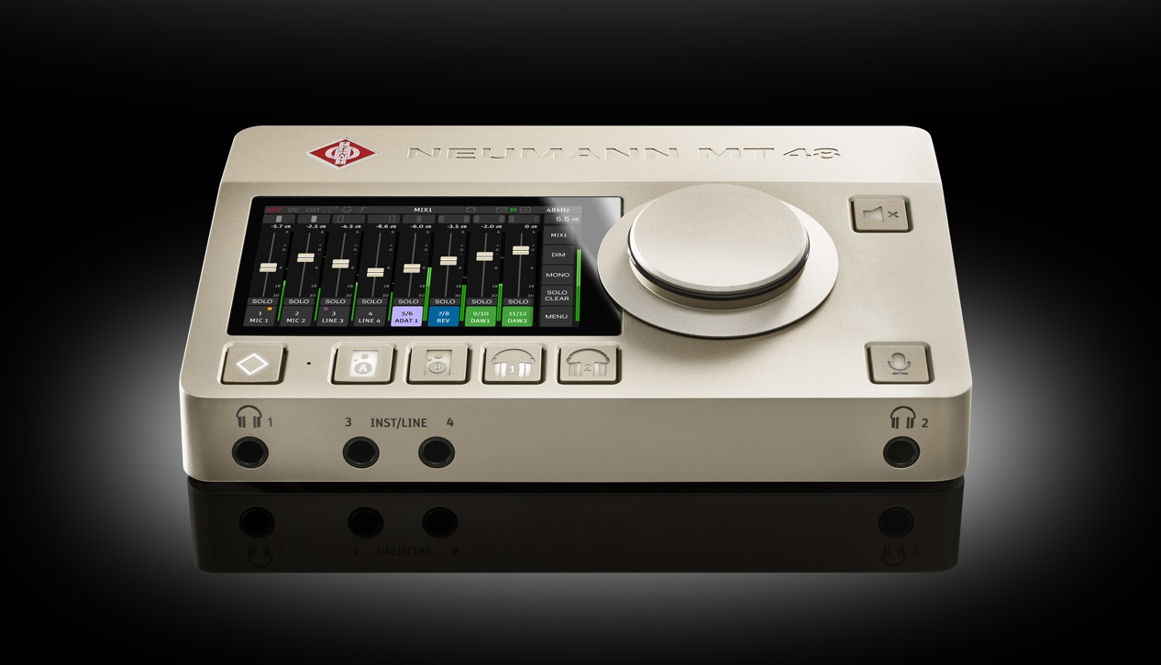
Berlin, Germany, 3 April, 2023 – Neumann, one of the world’s premier manufacturers of studio equipment, is proud to announce the launch of its first-ever audio interface, the MT 48. This innovative product represents a significant milestone in the company's nearly 100-year history, as Neumann expands its portfolio beyond microphones, loudspeakers, and headphones to include the crucial interaction with the digital realm. The MT 48 thus realizes reference class Neumann quality from input to output.

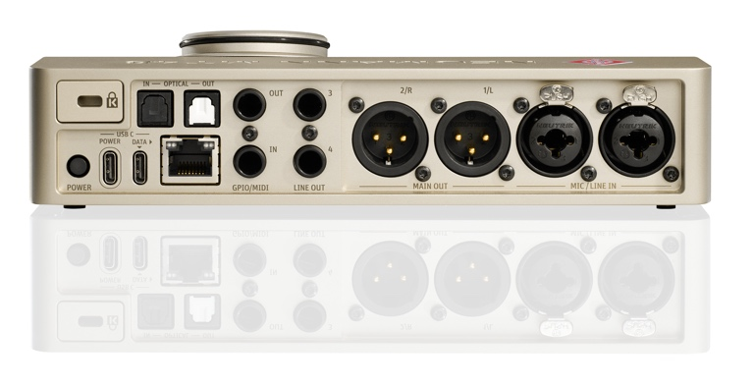
The MT 48 audio interface is the first product with Merging Technologies inside. The Swiss Brand is famous among audio professionals for its expertise in premium AD/DA conversion and networked audio. Based on the acclaimed Merging Anubis audio interface (which remains available), the MT 48 features additional USB and ADAT connectivity, as well as a new user interface, optimized for maximum ease of use in studio and home studio applications. With a dynamic range of 136 dB (A) and mic preamps with up to 78 dB gain, the MT 48 sets a new benchmark in audio quality. It thus captures the full sound potential of even the best microphones without any bottlenecks. The MT 48 has 4 analog inputs and 8 analog output channels (4 stereo outputs) and is expandable via ADAT (switchable to S/PDIF) and AES67. MIDI I/O is included as well.

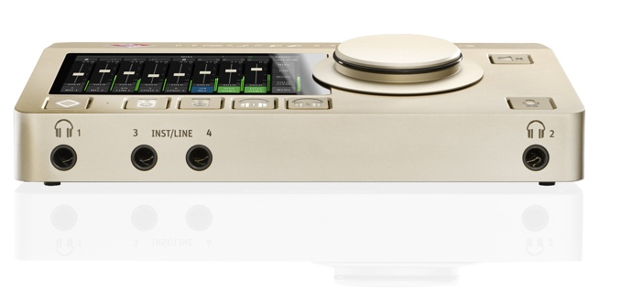
The interface also boasts two extremely powerful headphone amplifiers with ultra-low output impedance, driving any headphones to peak performance. Onboard DSP effects include sophisticated EQ, complex dynamics processing, and reverb. Additionally, the MT 48’s unique Dual Output Technology allows users to record the pre-FX and post-FX signal simultaneously. Four independent mixers, one for each stereo output, allow for perfect monitoring, thus fostering creativity for inspired performances. An intuitive touchscreen interface allows users to change mixer levels, pan positions, and other parameters with ease. Monitor mixes and all settings can be adjusted directly on the unit. For users wishing to operate the MT 48 from their computer or tablet, a Remote Control App and browser-based Web Control are available.

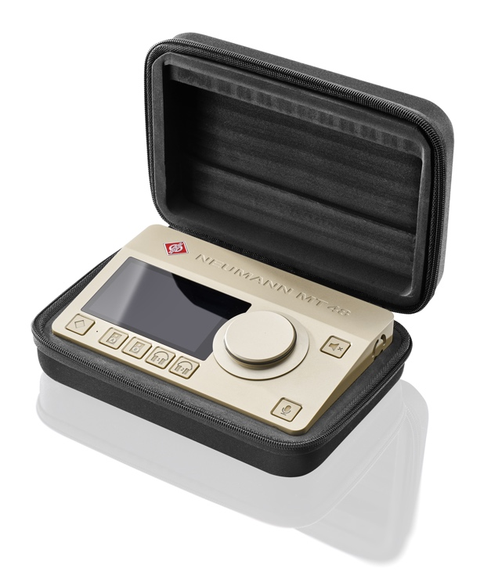
“The MT 48 represents a major step forward for Neumann,” states Portfolio Manager Sebastian Schmitz. “By adding Merging Technologies’ expertise in AD/DA conversion and digital audio to Neumann’s deep knowledge in microphones and monitoring, we have created a product that is truly exceptional in terms of sound quality, functionality, and ease of use.”

Neumann’s CEO Ralf Oehl adds: “As a legendary microphone manufacturer, Neumann has always been synonymous with excellence in recording technology. Over the past decade, we have shown that Neumann can bring the same uncompromising quality to loudspeakers and headphones. The MT 48 completes the ideal signal chain: Finally, you can have Neumann quality throughout, from the sound source to your ear.”

The MT 48 audio interface will be on display at NAMM 2023 (Demo room Anaheim Convention Center 17400) and will be available from Neumann dealers worldwide in a few weeks. For more information on this groundbreaking product, please visit the Neumann websites mt48.neumann.com or www.neumann.com/en-en/products/audiointerfaces/mt-48
List price: EUR 1,995 / USD 1,850

Features:
• Class-leading AD/DA converters with enormous dynamic range
• Intuitive touchscreen user interface
• DSP processing (EQ, dynamics, reverb)
• 4 independent mixers with integrated talkback
• USB, MIDI, ADAT and AES67 connectivity

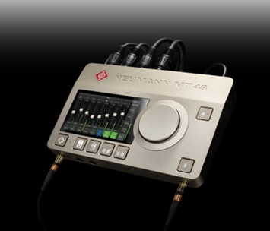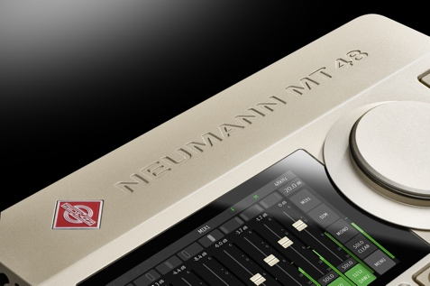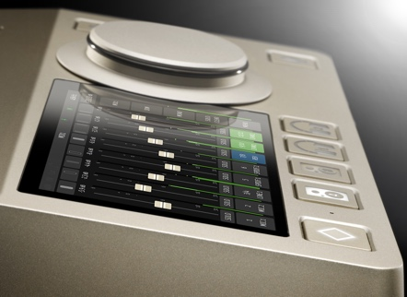
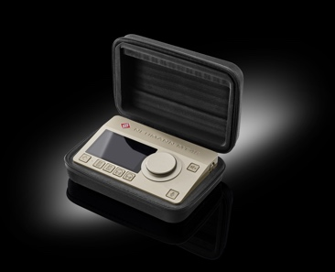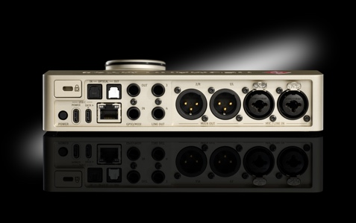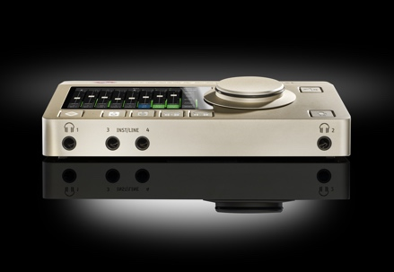

About Neumann
Georg Neumann GmbH, known as “Neumann.Berlin”, is one of the world’s leading manufacturers of studio-grade audio equipment and the creator of recording microphone legends such as the U 47, M 49, U 67 and U 87. Founded in 1928, the company has been recognized with numerous international awards for its technological innovations. Since 2010, Neumann.Berlin has expanded its expertise in electro-acoustic transducer design to also include the studio monitor market, mainly targeting TV and radio broadcasting, recording, and audio production. The first Neumann studio headphones were introduced in 2019, and since 2022, the company has put an increased focus on reference solutions for live audio. Georg Neumann GmbH has been part of the Sennheiser Group since 1991, and is represented worldwide by the Sennheiser network of subsidiaries and long-standing trading partners.

Press Contact Neumann:
Andreas Sablotny
andreas.sablotny@neumann.com
T +49 (030) 417724-19

