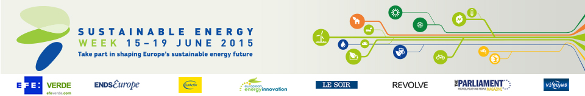

Energy Days in Cyprus (4)
- The importance of synergies between the private and the public sector for promoting optimised energy policies
Date: 05/06/2015
Time: From 9:00 to 13:00
Location: Nicosia

- Build Up Skills Cyprus
Date: 10/06/2015
Time: From 9:30 to 12:30
Location: Strovolos

- Amazing energy!
Date: 17/06/2015
Time: From 17:00 to 18:00
Location: Larnaka

- Energy fun fair
Date: 20/06/2015
Time: From 18:00 to 22:00
Location: Paralimni (Protaras)

