Photo by Luke Besley on Unsplash
The Sennheiser Group is giving back this holiday season

Wedemark, December 2022 – To mark the festive season, the Sennheiser Group will once again be supporting various audio and digital media organizations and associations that rely on the power of audio and music in their valuable work. Learn more about these outstanding non-profit organizations below – and maybe consider lending them your support, too?

In 2022, the Sennheiser Group, which includes Sennheiser, Neumann, Dear Reality and Merging Technologies, will support eight organizations around the world. In the APAC region, four associations have been chosen which have been vital resources for the local creative industries: the Japan Association of Stage Sound Creators, the Stage Sound Association of Japan, Star Association (Singapore), and the China Association for Recording Engineers. In EMEA and the Americas, the organizations supported include Open Up Music, Second Chance Studios, habitat4music, and Immersive and Inclusive Audio.

Open Up Music is a charity based in the UK, whose mission is to open up music to young disabled musicians. Through its ground-breaking National Open Youth Orchestra and Open Orchestras programmes, the charity works alongside young disabled musicians to tackle inequality and inspire exciting new music for the 21st century. It has also developed the Clarion, an accessible electronic instrument that can be played with any movement of the body including eye movement. Open Up Music’s work is delivered in partnership with special schools, Music Services and some of the UK’s leading arts and cultural organizations.

Open Up Music’s mission is to open up music to young disabled musicians  (Image courtesy of Open Up Music) | 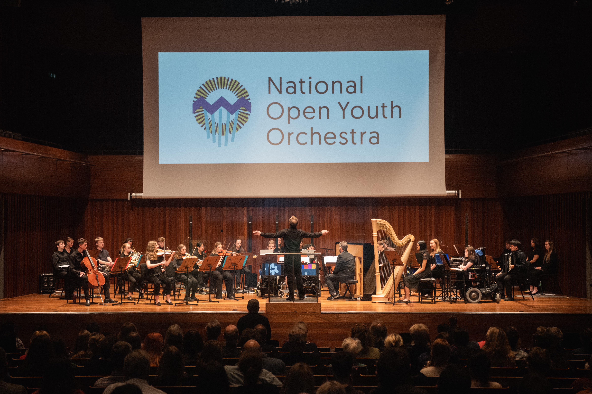

Second Chance Studios economically empowers people who were formerly incarcerated by employing and training them in one of the fastest-growing industries in the digital era – digital media. The non-profit digital media company hosts a Digital Media Fellowship to provide returning citizens with the skills and support needed to build a sustainable career for themselves and their families.

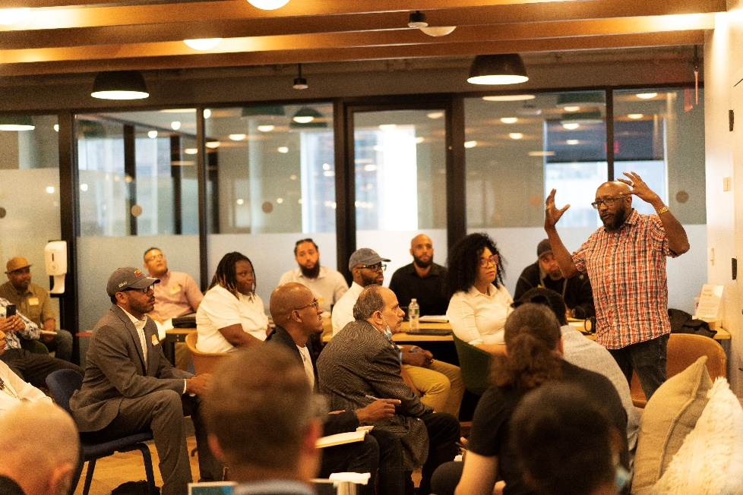 | Second Chance Studios unlocks careers in digital media for the formerly incarcerated  (Image courtesy of Second Chance Studios)

The aim of habitat4music is to support deprived children and young musicians in their musical education. First projects like the instrument carousel to support children in finding the right musical instrument have already been implemented, but there are more projects planned, such as a mobile music school / mobile studio, a tour bus with integrated stage, and affordable accommodation for music students that allows them to practice their instrument 24/7.

The instrument carousel helps children find ‘their’ instrument

(Image courtesy of habitat4music)

Immersive and Inclusive Audio began as part of a PhD by Leslie Gaston-Bird (CAS, AMPS, MPSE). With funding from Innovate UK and support from the industry, the project has expanded to include Avid Pro Tools and Dolby Atmos certification. The research aspect of the initiative aims to uncover what impact workshops can have on the experience of underrepresented groups in immersive audio, and the long term goal is to improve diversity and representation in the field. The donation will go towards the scholarship funds for members of Audio Girl Africa and SoundGirls.org.

2022 Audio Girl Africa Scholarship recipients and staff (l/r) Glory Rex, Abigael Seun Akintola, founder & director Phebean Adedamola Oluwagbemi, Adetutu Idris Halimat, Idono Onyemunosa-Ibeabuchi, Audio Girl EA Jennifer Okotie-Eboh  (Image courtesy of Audio Girl Africa) | 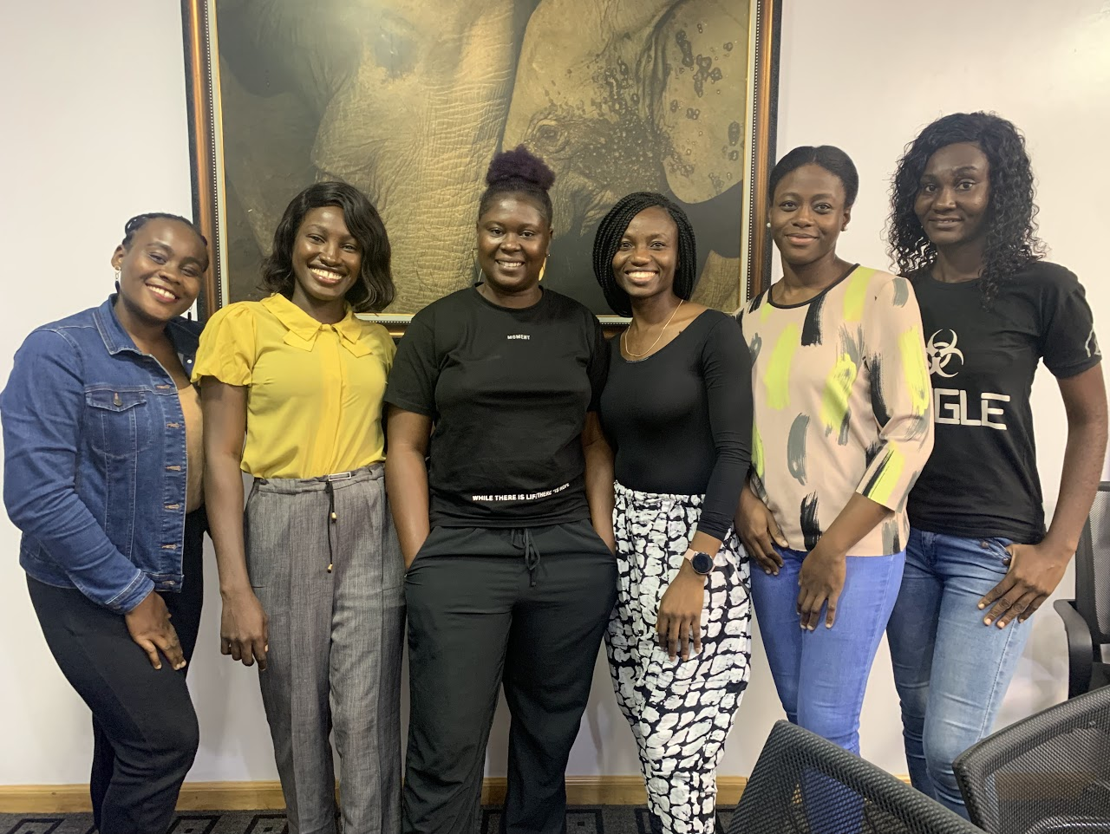

“We are deeply humbled by the great work done by these organizations and the lasting change they bring to individuals of all age groups who share our deep passion for audio,” said Daniel Sennheiser, co-CEO of the Sennheiser Group. Andreas Sennheiser added: “We wish everyone a happy, healthy, and joyous holiday season. We also send our best wishes for the New Year and look forward to working with more companies that make a significant impact in the industry in 2023.”

Links to the organisations
https://habitat4music.org/
https://www.openupmusic.org/
https://www.secondchancestudios.org/
https://www.immersiveandinclusive.com/
https://www.starsg.org/
https://www.jassc.com/mt/
http://www.ssa-j.or.jp/modules/ssaj/index.php?content_id=1
https://mp.weixin.qq.com/s/kIAugGAllIwLW1MpAzGbzQ

Intro photo by Luke Besley on Unsplash
The high-resolution images provided by the organizations can be downloaded here.

About the Sennheiser Group

Building the future of audio and creating unique sound experiences for our customers - this is the aspiration that unites the employees of the Sennheiser Group worldwide. The independent family-owned company Sennheiser was founded in 1945. Today, it is managed in the third generation by Dr. Andreas Sennheiser and Daniel Sennheiser, and is one of the leading manufacturers in the field of professional audio technology. Within the Sennheiser Group are Georg Neumann GmbH (Berlin, Germany), manufacturer of studio-grade audio equipment; Dear Reality GmbH (Düsseldorf, Germany), known for its binaural, Ambisonics, and multichannel encoders with realistic room virtualization; and Merging Technologies SA (Puidoux, Switzerland), specialist in high-resolution digital audio recording systems.
sennheiser.com | neumann.com | dear-reality.com | merging.com

