For immediate distribution

DEVA Platform to Be Showcased by Powersoft at
California Park and Recreation Society Conference & Expo

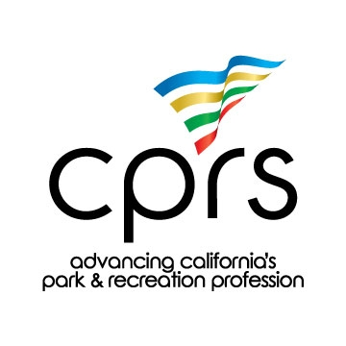
Long Beach, CA – March 12, 2018 – The cutting-edge DEVA multimedia platform will be on show at the California Park and Recreation Society Conference & Expo (CPRS) at the Long Beach Convention Center on March 14th and 15th. Designed by Italian company Powersoft, DEVA is a powerful and networkable information and safety tool for use in indoor and outdoor spaces of all sizes. The sold-out conference is celebrating its 70th year of advancing California’s park and recreation profession.

CPRS 2018 marks the first DEVA-exclusive trade show appearance by its manufacturer and the booth experience will focus on the unit’s flexibility and how its wide-ranging functionality can revolutionize the way the public spaces are administered.

Laurence Turner and Karl Kahlau, DEVA’s Regional Area Manager and Executive Director respectively, will be on hand to elucidate DEVA’s numerous applications, walk attendees through the range of features DEVA provides via demonstrations, and answer questions. The DEVA booth will be open on Wednesday, March 14 from noon until 5:00 p.m. and Thursday, March 15 from 9:00 a.m. to 3:00 p.m.

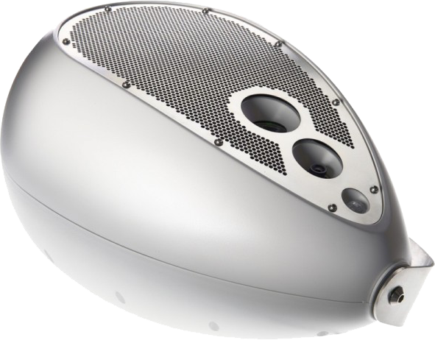
“We could not be more pleased to bring DEVA to this year’s CPRS conference,” says Turner, “The unique combination of features DEVA provides, from emergency communication to lighting to surveillance, melds with its unparalleled wireless integration and remote-control capabilities to make it a versatile solution for a wide range of indoor and outdoor spaces. Its very feature set enables DEVA to replace legacy one-task systems with a versatile, flexible multimedia system that can be used in a multitude of ways and evolve with the needs of the venue. The state of California has many spaces, among the most beautiful, functional, and well utilized in the United States. We are eager to show the state’s leading park and recreation professionals how DEVA can enhance their ability to provide a flexible and safe experience for their visitors.”

All Eyes on the DEVA
DEVA combines the best features in information, entertainment, safety and data gathering into a single elegantly shaped, networked multimedia device.

At the core of the device, is a powerful and efficient Powersoft-designed Class-D amplifier that gives DEVA a direct Sound Pressure Level (dSPL) of approximately 85 dB at 100 ft / 30 m, making the integrated woofer capable of delivering anything from ambient sound and music to emergency announcements with quiet subtlety or attention-grabbing authority as the case requires.

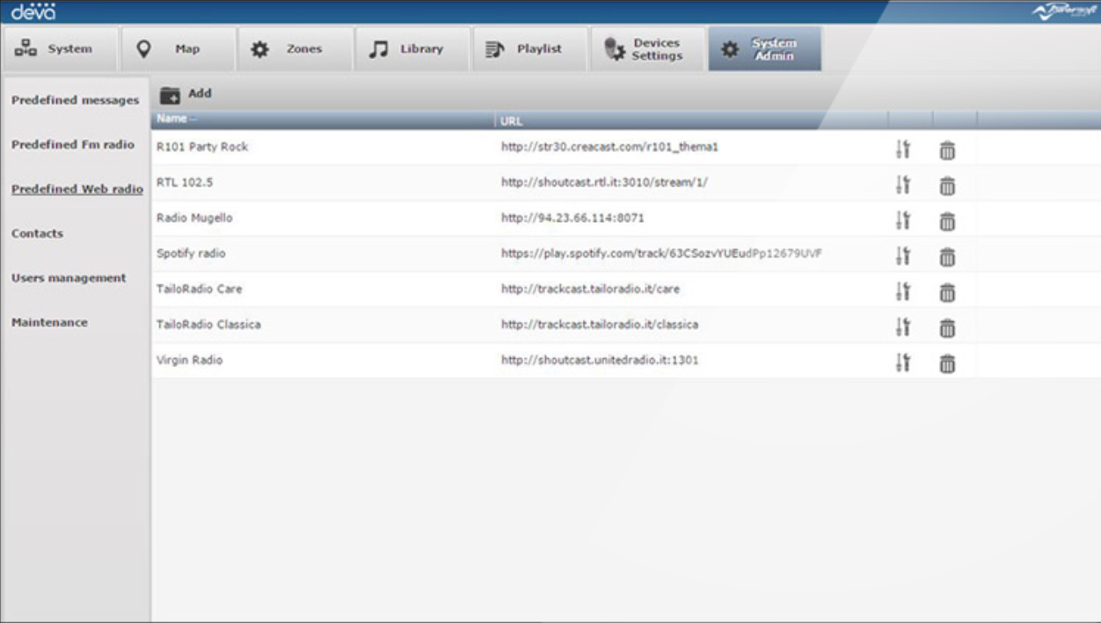
Seamless WiFi Ethernet and cellular connectivity integration enables easy and cost-efficient installation in any environment, where hard-wired connections would be expensive, unsightly, or impractical. DEVA’s advanced networking capabilities combine with the DEVA System Manager (DSM) web application to provide fully featured remote operation of all DEVA units for unprecedented centralized control. A user App (iOS / Android) is available for operators to securely control and navigate the site-wide DEVA installation in a decentralized way, to ensure maximum flexibility and user friendliness.

Tools of the Trade
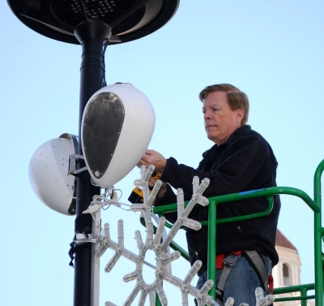
DEVA’s small size belies its myriad functions. Given its potential role as part of critical security infrastructure, a rechargeable battery and optional remote solar charging panel ensure reliable and energy-efficient performance even in the event of sudden power loss. A 4,000 K white LED light can provide lighting or optical signaling triggered either by motion or infrared detection or controlled remotely via network. A built-in camera provides instantaneous visual feedback and surveillance capabilities, while automatic aperture adjustment insures clarity and visibility. Built-in environmental sensors even allow DEVA to gather weather data such as temperature, humidity, barometric pressure and light intensity, providing highly localized environmental information. Location and data for each DEVA unit is shown on Google Maps™ for maximum visibility and overview.

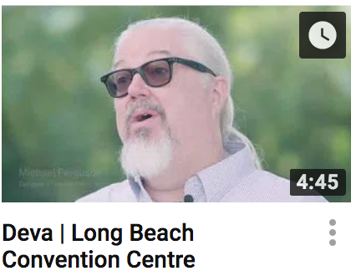
In addition to the booth, DEVA can also be seen and heard in action at the Long Beach Performing Arts Center’s main plaza, part of the Long Beach Convention & Entertainment Center complex, where several units were recently installed as part of the complex’s audio modernization initiative, enriching the on-site sensory experience for millions of visitors and guests each year.

For more information please visit DEVA at CPRS Booth 173 or deva.powersoft.it

###
Captions:
1) DEVA is a powerful multimedia information, entertainment, safety, and data gathering device.
2) Specially designed software allows remote control of multiple DEVA units over a wireless or wired network.
3) DEVA units are installed at the Long Beach Convention Center.
4) Michael Ferguson, designer – Theater DNA Creative, speaks about the decision to specify DEVA for the Long Beach Convention Center’s Promenade Lobby & Plaza.

For further information, contact:

Jeff Touzeau (media contact)  Hummingbird Media  Tel : +1 (914) 602 2913  Email: jeff@hummingbirdmedia.com | Francesco Fanicchi  Powersoft (Florence, Italy)  Tel: +39 346 9719798  Email: francesco.fanicchi@powersoft.com

Or visit www.powersoft.com
About Powersoft:
Powersoft is the world leader in lightweight, high power, single rack space, energy efficient amplifiers for the professional audio market. Founded in Italy in 1995, headquartered in Florence, Italy, with offices in Camarillo, CA, Powersoft couples the experience and precision of its production department with exceptional components to deliver products with perfect audio response and high-performance reliability. Its state-of-the-art amplifiers can be found in an array of markets, ranging from stadiums, sporting arenas, theme parks, performance venues and airports to convention centers, churches, and clubs, and are used by the world's leading tour sound companies. For more information, visit the Powersoft website @ www.powersoft.com

