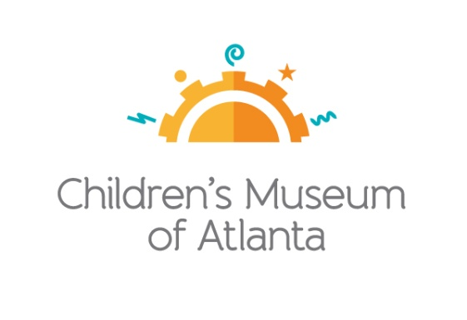

CONTACT
Becca Meyer/Jennifer Walker
BRAVE Public Relations, 404.233.3993
bmeyer@bravepublicrelations.com/
jwalker@bravepublicrelations.com

*MEDIA ADVISORY*
First Lady of Atlanta Sarah-Elizabeth Reed to kick off Read for the Record at Children’s Museum of Atlanta on October 19
Little ones are invited to be immersed in a fun-filled day of reading

ATLANTA (September 29, 2017) – Little bookworms are invited to experience Read for the Record at Children’s Museum of Atlanta! On Thursday, October 19, First Lady of Atlanta Sarah-Elizabeth Reed will host a Special Story Time at 10:30 a.m., featuring “Quackers” by Liz Wong – a story about a cat who thinks it’s a duck – with a lesson about standing out, fitting in and building a life with room for everyone. Throughout the day, little ones can celebrate “Quackers” by dancing with the Imaginators, creating a puppet, watching Professor Labcoat’s Super Spectacular Science Show and more!

Read for the Record is in support of Jumpstart’s mission to work toward the day every child in America enters kindergarten prepared to succeed.

WHAT: Read for the Record
First Lady of Atlanta Sarah-Elizabeth Reed to kick off celebration with Special Story Time

WHEN: Thursday, October 19 from 10:30 a.m.-3:30 p.m.
The schedule is as follows:
- Special Story Time: 10:30 a.m., 11:30 a.m. and 3 p.m.
First Lady of Atlanta Sarah-Elizabeth Reed will host Special Story Time at 10:30 a.m.
- Art Studio: 10:30 a.m.-3:30 p.m.
- Build It Lab: 10:30 a.m.-3:30 p.m.
- Science Bar: 10:30 a.m.-3:30 p.m.
- Super Spectacular Science Show: 1 p.m.
- Music and Movement: 2 p.m.

WHERE: Children’s Museum of Atlanta
275 Centennial Olympic Park Drive, NW
Atlanta, GA 30313

HOW: General Admission is $15.95 (plus tax) for anyone 1 – 100 years old. Babies and members are admitted for free.

MORE INFO: To learn more or to register, visit bit.ly/CMAReadForTheRecord

For more information or to support Children's Museum of Atlanta, visit childrensmuseumatlanta.org
or call 404.659.KIDS [5437]

###

