Flock Audio Named as Finalist for Outstanding Technical Achievement at 38th Annual TEC Awards for Both PATCH XT and PATCH APP DX
Products nominated in the Computer Audio Hardware and Audio Apps/Hardware Peripherals for Smartphones and Tablets categories

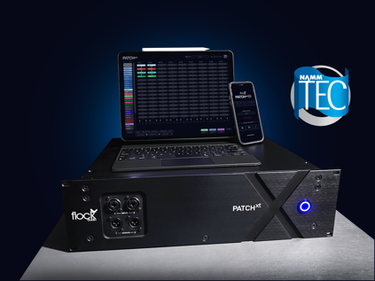
Anaheim, California, October 31, 2022 - Flock Audio, the innovative total hardware control and management company best known for its PATCH Series digitally controlled analog patchbays, has been named as finalist by the NAMM Foundation for awards for Outstanding Technical Achievement awards for their PATCH XT and PATCH APP DX products in the Computer Audio Hardware and Audio Apps/Hardware Peripherals for Smartphones and Tablets categories respectively.

“We are honored to be recognized by the NAMM Foundation for our work on PATCH XT and PATCH APP DX,” said Flock Audio founder and CEO Darren Nakonechny. “PATCH XT brings the efficiency and functionality of the PATCH Series to the most advanced hybrid studios and live environments with its extensive connectivity and feature set, while PATCH APP DX marks Flock Audio’s transition from a focus on digitally controlled analog routing to a more expansive purview, encompassing total hardware management.”

PATCH XT
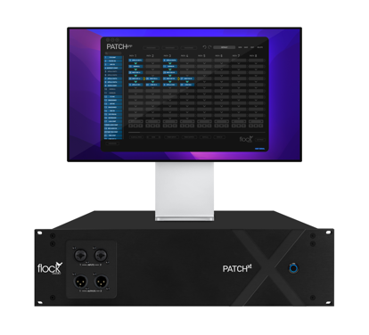
PATCH XT brings the same digitally controlled fully analog routing technology that debuted in Flock Audio’s TEC Award-nominated flagship PATCH hardware to its most expansive format yet, with 96 ins and 96 outs on DB25 connectors and dual front-panel XLR I/O. Instantaneously save, swap, and store routings via the user-friendly PATCH APP desktop application, marrying the efficiency of a DAW-based workflow with the uncontested sonic primacy of outboard hardware. Mults and A/B comparisons are promptly facilitated with a single mouse click, and time saving preferred routings can be stored as presets. PATCH XT also debuted some features new to the PATCH Series, including a Sleep/Wake Mode, internal power supply, and CAT6 control connectivity. Like all PATCH Series hardware, PATCH XT is expandable further via multi-unit configurations of up to 10 units, handled intelligently behind the scenes by PATCH APP.

PATCH APP DX
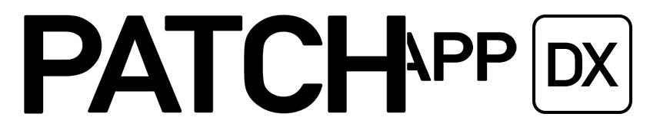
PATCH APP DX expands upon the functionality of the PATCH APP Classic software included with every PATCH Series hardware unit with additional functionality tailored to PATCH power users who need even deeper control of their hardware and more precise recall. This includes multi-device integration and network interconnectivity for iPhone, iPad, and desktop. Knob and switch settings on individual hardware units in your rack can be photographed on your devices, annotated, and attached to your routings within PATCH APP DX for speedy and accurate recall of every detail without the morass of recall sheets, sticky notes, or a disorganized iPhone photo gallery. PATCH APP DX also provides user interface enhancements for color coding and additional Quickstrip slots for most-used routings, among other upgrades. Windows compatibility and BRIDGE, a DAW-hosted recall plug-in for PATCH APP DX users, are slated to arrive in 2023.

For online voting details, please visit: http://tecawards.org/

For more information on PATCH XT, please visit: https://www.flockaudio.com/patchxt

For more information on PATCH APP DX, please visit: https://www.flockaudio.com/patchappdx

About Flock Audio
Flock Audio Inc. is a pro audio manufacturer based in Kelowna, Canada, founded in 2017. The company is best known for its PATCH System Series, which is a Digitally controlled, 100% Analog Patch bay routing solution for professional audio environments. For more information on Flock Audio and its products, please visit the company website at http://www.flockaudio.com.

Media Contact:
Shelby Coppola
Hummingbird Media
+1 (203) 598-8167
shelby@hummingbirdmedia.com

