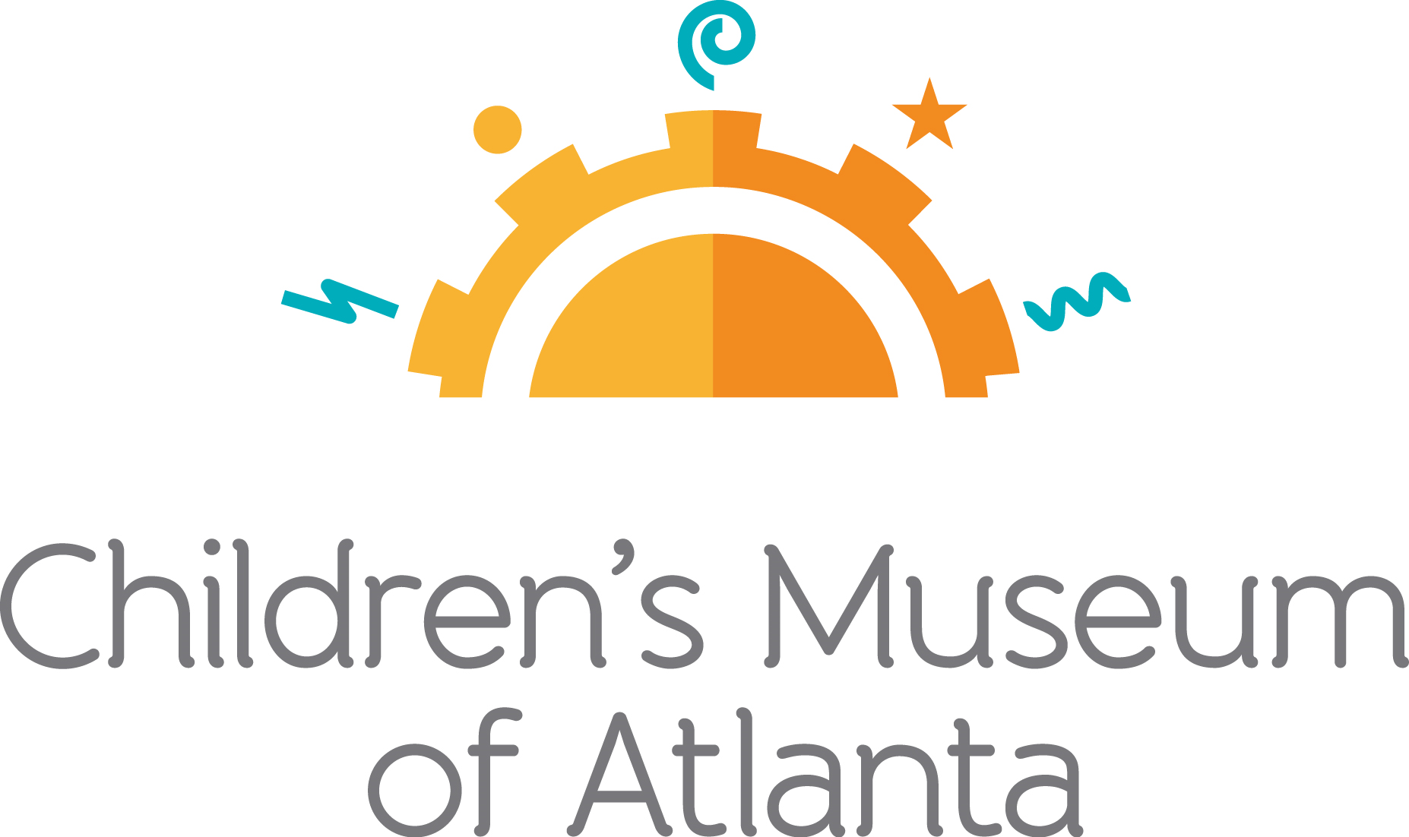
+++
FOR MORE INFORMATION:
Julia Murphy / Jennifer Walker
BRAVE Public Relations
404.233.3993
jmurphy@emailbrave.com /
jwalker@emailbrave.com

FOR IMMEDIATE RELEASE

Children’s Museum of Atlanta welcomes back guests with a
limited July programming schedule filled with summer fun
Kids can celebrate National Ice Cream Day, National Space Exploration Day and more!

ATLANTA (July 9, 2020) — Welcome back to the Children’s Museum of Atlanta! Families are invited to celebrate the Museum’s reopening with a programming schedule filled with all kinds of fun for the little ones. On National Ice Cream Day, youngsters will have the chance to make their own ice cream in a bag and get messy with ice cream sundae artwork. On National Space Exploration Day, kids can feel like an astronaut for a day when they design their own rockets and experiment with levitation. The Museum will also launch its newest programming space, Creativity Cafe, which will host both art studio and Build It! lab projects. CMA On Stage, Creativity Café and Science Bar programs will be available to little ones.

National Ice Cream Day
July 12
It's National Ice Cream Day, and the Museum is celebrating this delicious treat all day long! Kids are invited to the Science Bar to make their own ice cream in a bag. After making their own ice cream, youngsters can wander over to the Creativity Cafe to continue the ice cream fun with colorful ice cream sundae artwork during all sessions.

CMA On Stage
July 12
Session A: 10 a.m., 11 a.m. / Session B: 1 p.m., 2 p.m. / Session C: 4 p.m., 5 p.m.
Storytime: “Jabari Jumps” by Gaia Cornwall
Game Time Classics

National Space Exploration Day
July 20
On National Space Exploration Day, kids are invited to celebrate with out-of-this-world activities! At the Creativity Cafe, little ones can create planet marble art, design their own rockets and build tiny aliens. The Science Bar will feature experiments with levitation, combustion and creating constellation cards. Future astronauts can explore the new frontiers of outer space with the help of the Museum’s resident scientists in each session.

CMA On Stage
July 20
Session A: 10 a.m., 11 a.m. / Session B: 1 p.m., 2 p.m. / Session C: 4 p.m., 5 p.m.
Storytime: “Small World” by Ishta Mercurio
Galactic Dance Party

Science Bar / Creativity Café Times:
Session A (10-11:15 a.m.), Session B (1-2:15 p.m.) Session C (4-5:15 p.m.)

Children’s Museum of Atlanta has implemented new procedures to promote an enjoyable and safe visit:
- Limited capacity in each session to encourage social distancing
- Deep cleaning will occur between each session and high touchpoints throughout the Museum will be cleaned during sessions
- Museum staff will wear masks on the floor at all times
- Face masks are required for everyone 5 years and older; masks will be available for purchase
- Open air space on the patio will be designated for guests to take PPE breaks
- Art Studio and Build It! Lab projects will take place in open spaces
- Additional hand sanitizing stations have been installed throughout the Museum
- No food will be allowed inside the Museum
- No cash will be accepted at the Museum Store or during Membership purchases
- Sneeze-guards will be in place at store check-out, member desk, and security with credit card machines and ticket scanners facing guests
###
About Children’s Museum of Atlanta:
Children’s Museum of Atlanta is the only educational venue of its kind in Atlanta, presenting educational programs and exhibits designed for young children ages 0-9. The mission of Children's Museum of Atlanta is to change the world by sparking every child's imagination, sense of discovery and learning through the power of play. With six permanent learning zones consisting of bright, creative and hands-on exhibits, the Museum supports inventive play-based exploration and experiential learning focused on the whole child. Core competencies for literacy, math and science are promoted throughout all exhibits and programming in alignment with the state and national Core Performance Standards. Children’s Museum of Atlanta also offers parties, memberships, field trips, summer camp and private events. For more information or to support Children's Museum of Atlanta, visit childrensmuseumatlanta.org or call 404.659.KIDS [5437].
Museum Admission: Online ticketing only is available at this time. Phone booking is available with ample notice and will be booked via online reservation. Members must pre-book and will be able to get their $5 voucher online. Babies under 12 months and members are admitted for free. All daily programs are included in price of admission. Group rates and military discounts are available. For more information regarding ticket and membership options, visit childrensmuseumatlanta.org.
Museum Hours: The Museum will operate in 3 two-hour sessions daily with one-hour cleaning in between sessions. Hours of operation for the month of July are 9:30 – 11:30 a.m., 12:30 – 2:30 p.m. and 3:30 – 5:30 p.m. Please check the Museum website to confirm hours of operation.

