

Sennheiser TeamConnect Bars Recognized With Award by Readers of Sound & Video Contractor Magazine

The UCC Solution Was Honored With an Innovative Product Awards: Readers’ Choice for 2024 in the Conferencing/Collaboration Category

Old Lyme, Connecticut — Feb. 18, 2025 — Sennheiser, the first choice for advanced audio technology that makes collaboration and learning easier, today announced that its TeamConnect (TC) Bars were recognized by Sound & Video Contractor as a winner of the SVC Innovative Product Awards: Readers’ Choice for 2024 in the Conferencing/Collaboration category. The TC Bars were previously recognized at InfoComm 2024 by Systems Contractor News as a winner of the Installation Product Award in the Most Innovative Collaboration Product category.

The SVC Innovative Product Awards honor and celebrate the best in class within the Pro AV industry. Voted upon exclusively by the Sound & Video Contractor readers and subscribers, this achievement highlights which companies are pushing the boundaries within electronic and mechanical innovation in relation to Pro AV.

“We are deeply grateful to have the TC Bars receive this award from SVC and their readership,” said Ronja Harste, Senior Product Manager for Business Communication at Sennheiser. “The recognition of the TC Bars by the AV community is an affirmation of the company’s commitment to superior audio innovation. The goal is to ensure that Sennheiser customers reap the benefits of technology that focuses on high quality audio and ease of use.”

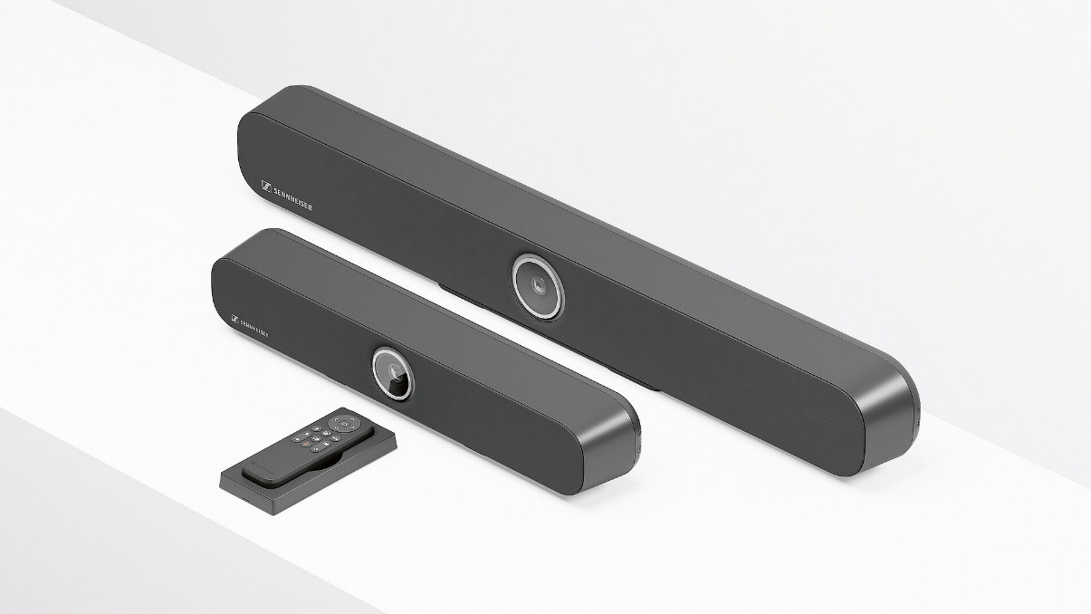

Sennheiser’s TC Bars are available in two models to suit varying meeting room sizes — the TeamConnect Bar S, featuring four microphones and two speakers, and the TeamConnect Bar M, equipped with six microphones and four speakers. TC Bars are plug-and-play devices, enabling users to start meetings quickly via USB. Integrated beamforming technology, the same technology found in the TCC solutions, allows freedom of movement and seamless transitions between presenters. The full-range stereo speakers ensure natural speech and outstanding intelligibility. Superior audio is complemented by a camera with advanced AI features, including autoframing and person tiling. Additionally, the TC Bars offer flexible and scalable room setups with an onboard Dante port for extension mics and an option to add an external USB camera, catering to rooms requiring broader coverage. Multiple mounting options and remote management via Sennheiser Control Cockpit simplify integration into any space.
For more information about Sennheiser and its solutions, visit www.sennheiser.com.
###

About the Sennheiser brand
We live and breathe audio. We are driven by the passion to create audio solutions that make a difference. Building the future of audio and bringing remarkable sound experiences to our customers – this is what the Sennheiser brand has represented for more than 75 years. While professional audio solutions such as microphones, meeting solutions, streaming technologies and monitoring systems are part of the business of Sennheiser electronic GmbH & Co. KG, the business with consumer devices such as headphones, soundbars and speech-enhanced hearables is operated by Sonova Holding AG under the license of Sennheiser.

www.sennheiser.com
www.sennheiser-hearing.com

Global Press Contact
Jeff Horan
jeffrey.horan@sennheiser.com
+1 860-598-7539

